ATIS-1000087.v002

ATIS Technical Report on

Mechanism for Cross-Border Signature-based Handling of Asserted information using toKENs (SHAKEN)

Alliance for Telecommunications Industry Solutions

Approved December 16, 2019

Abstract
The Signature-based Handling of Asserted information using toKENs (SHAKEN) standard “ATIS-1000074” specifies operation within the domain of a single national or regional regulatory authority - in most cases this means within a single country. This was a conscious decision by the joint Alliance for Telecommunications Industry Solutions (ATIS) and SIP Forum IP-NNI Task Force (IP-NNI TF) in order to more quickly develop a solution that explicitly addressed U.S. requirements. However, SHAKEN does not assume unique U.S. attributes, and therefore should be equally applicable to other countries. Calls that originate in one country and terminate in another country, are not explicitly addressed in the existing SHAKEN standard. This document provides a mechanism to extend the SHAKEN trust environment to include more than one.

Foreword
The Alliance for Telecommunications Industry Solutions (ATIS) serves the public through improved understanding between carriers, customers, and manufacturers. The Packet Technologies and Systems Committee (PTSC) develops and recommends standards and technical reports related to services, architectures, and signaling, in addition to related subjects under consideration in other North American and international standards bodies. PTSC coordinates and develops standards and technical reports relevant to telecommunications networks in the U.S., reviews and prepares contributions on such matters for submission to U.S. International Telecommunication Union Telecommunication Sector (ITU-T) and U.S. ITU Radiocommunication Sector (ITU-R) Study Groups or other standards organizations, and reviews for acceptability or per contra the positions of other countries in related standards development and takes or recommends appropriate actions.
The SIP Forum is an IP communications industry association that engages in numerous activities that promote and advance SIP-based technology, such as the development of industry recommendations, the SIPit, SIPconnect-IT, and RTCWeb-it interoperability testing events, special workshops, educational seminars, and general promotion of SIP in the industry. The SIP Forum is also the producer of the annual SIP Network Operators Conference (SIPNOC), focused on the technical requirements of the service provider (SP) community. One of the Forum's notable technical activities is the development of the SIPconnect Technical Recommendation – a standards-based SIP trunking recommendation for direct IP peering and interoperability between IP Private Branch Exchanges (PBXs) and SIP-based service provider networks. Other important Forum initiatives include work in Video Relay Service (VRS) interoperability, security, Network-to-Network Interoperability (NNI), and SIP and IPv6.
The mandatory requirements are designated by the word shall and recommendations by the word should. Where both a mandatory requirement and a recommendation are specified for the same criterion, the recommendation represents a goal currently identifiable as having distinct compatibility or performance advantages. The word may denotes an optional capability that could augment the standard. The standard is fully functional without the incorporation of this optional capability.
Suggestions for improvement of this document are welcome. They should be sent to the Alliance for Telecommunications Industry Solutions, PTSC, 1200 G Street NW, Suite 500, Washington, DC 20005.
The ATIS/SIP Forum IP-NNI Task Force under the ATIS Packet Technologies and Systems Committee (PTSC) and the SIP Forum Technical Working Group (TWG) was responsible for the development of this document.

Table of Contents
1 Scope, Purpose, & Application 1
1.1 Scope 1
1.2 Purpose 1
1.3 Application 1
2 References 1
3 Definitions, Acronyms, & Abbreviations 2
3.1 Definitions 2
3.2 Acronyms & Abbreviations 2
4 Overview 3
4.1 Cross-Border Framework Criteria 3
4.2 Cross-Border Architecture 4
4.2.1 The Cross-Border Trust List 6
4.2.2 The Cross-Border Trust List support of a Non-Jurisdictional STI-GA/PA 8
4.3 Cross-Border Procedures 10
4.3.1 Establishing a Cross-Border SHAKEN Agreement 10
4.3.2 Coordinating Cross-Border Information Exchange with STI-PA Certificate Lifecycle 11
4.3.3 Terminating a Cross-Border SHAKEN Agreement 13
5 Cross-Border Trust List Data Structure 14
6 Cross-Border Trust List Procedures 15
6.1 STI-PA Procedures 15
6.1.1 Generating the Cross-Border Trust List 15
6.1.2 Downloading the Cross-Border Trust List and its Referenced Resources 16
6.1.3 STI-PA Certificate Rollover 16
6.1.4 STI-PA Resources that require Public Access 16
6.1.5 STI-PA Certificate Profile 17
6.2 STI-CA Procedures 17
6.3 Authentication and Verification Service (STI-AS/VS) Procedures 17

Table of Figures
Figure 4-1: SHAKEN Trust Model 4
Figure 4-2: Trusted STI-CA List and CRL Maintained by STI-PA 5
Figure 4-3: Independent lists of Trusted STI-CAs and CRLs 6
Figure 4-4: Cross-Border Trust List 7
Figure 4-5: Cross-Border SHAKEN 8
Figure 4-6: Support for Non-Jurisdictional STI-GA/PA 9
Figure 4-7: Obtaining Cross-Border Trusted STI-CA List and CRL 10
Figure 4-8: Updating Cross-Border Information when STI-PA Root Certificate Renewed 12
Figure 4-9: Terminating a Cross-Border SHAKEN Agreement 13

Scope, Purpose, & Application

Scope
This document provides telephone service providers with a framework and guidance on how to use Secure Telephone Identity (STI) technologies on IP-based service provider voice networks (also to be referred to as Voice over Internet Protocol [VoIP] networks) in scenarios where a call originates in one country and terminates in a different country. The primary focus of this document is to detail how the trust environment created by Signature-based Handling of Asserted information using toKENs (SHAKEN) in a single country can be extended to include other countries. This document does not require any changes to the existing SHAKEN specifications but does identify new interfaces and functions to exchange information between countries.

Purpose
The purpose of this document is to extend the SHAKEN trust environment to encompass more than one country. This document will detail how calls authenticated in one country can be successfully verified in a second country.

Application
The mechanism specified in this technical report will allow countries with similar interests and regulatory environments to federate their SHAKEN infrastructure and extend the trust environment to include both countries. This specification only considers a bilateral arrangement between two jurisdictions, although it may be possible to extend this to include a limited number of additional countries.

References
The following standards contain provisions which, through reference in this text, constitute provisions of this technical report. At the time of publication, the editions indicated were valid. All standards are subject to revision, and parties to agreements based on this technical report are encouraged to investigate the possibility of applying the most recent editions of the standards indicated below.
IETF RFC 4648, The Base16, Base32, and Base64 Date Encodings.
RFC 4949, Internet Security Glossary, Version 2.
RFC 5217, Memorandum for Multi-Domain Public Key Infrastructure Interoperability.¹
RFC 7519, JSON Web Token (JWT).¹
RFC 7231, Hypertext Transfer Protocol (HTTP/1.1): Semantics and Content.¹
ISO 3166-1: Codes for the Representation of Names of Countries and Their Subdivisions.
RFC 3326, The Reason Header Field for the Session Initiation Protocol (SIP).¹
ATIS-1000074, Signature-based Handling of Asserted information using toKENs (SHAKEN).
ATIS-1000080, SHAKEN: Governance Model and Certificate Management.³
ATIS-1000084, Technical Report on Operational and Management Considerations for SHAKEN STI Certification Authorities and Policy Administrators.³
ATIS-1000092, Signature-based Handling of Asserted information using toKENs (SHAKEN): Delegate Certificates.³
CATA-WG Report, Adoption of Caller ID Authentication Technology and Other Techniques to Combat Robocalls by Policymakers and Providers in Countries outside the United States [link]
ISO 3166-1, Codes for the Representation of Names of Countries and Their Subdivisions.

Definitions, Acronyms, & Abbreviations
For a list of common communications terms and definitions, please visit the ATIS Telecom Glossary, which is located at < http://www.atis.org/glossary >.

Definitions
Caller ID: The originating or calling party telephone number used to identify the caller carried either in the P-Asserted Identity or From header.
Cross-Border Trust List: A list of the STI-PA root (signing) certificate and the URLs to the Trusted STI-CA List and CRL hosted by the local STI-PA and each trusted cross-border STI-PA.
Subordinate CA: A CA whose public-key certificate is issued by another (superior) CA [RFC 4949]. In the context of SHAKEN, a Subordinate CA is an STI-SCA or V-SCA as defined in [ATIS-1000092].
Trusted CA: A CA upon which a certificate user relies for issuing valid certificates; especially a CA that is used as
a trust anchor CA [RFC 4949]. In the context of SHAKEN, a Trusted CA is an STI-CA and its Subordinate CAs approved to operate in the SHAKEN PKI [ATIS-1000084].
Trust List: A set of one or more trust anchors used by a relying party to explicitly trust one or more PKIs [RFC 5217]. The Trust List is the Trusted STI-CA List which contains the root certificates of all approved STI-CAs within a jurisdiction [ATIS-1000084].

Acronyms & Abbreviations

ATIS |  | Alliance for Telecommunications Industry Solutions
CC |  | Country Code
CP |  | Certificate Policy
CRL |  | Certificate Revocation List
HTTPS |  | Hypertext Transfer Protocol Secure
IETF |  | Internet Engineering Task Force
IP |  | Internet Protocol
JSON |  | JavaScript Object Notation
JWT |  | JSON Web Token
NNI |  | Network-to-Network Interface
PASSporT |  | Personal Assertion Token
PBX |  | Private Branch Exchange
SHAKEN |  | Signature-based Handling of Asserted information using toKENs
SIP |  | Session Initiation Protocol
SP |  | Service Provider
STI |  | Secure Telephone Identity
STI-AS |  | Secure Telephone Identity Authentication Service
STI-CA |  | Secure Telephone Identity Certification Authority
STI-CR |  | Secure Telephone Identity Certificate Repository
STI-PA |  | Secure Telephone Identity Policy Administrator
STIR |  | Secure Telephone Identity Revisited
URL |  | Uniform Resource Locator
VoIP |  | Voice over Internet Protocol

Overview
SHAKEN specifications state that the Secure Telephone Identity-Policy Administrator (STI-PA) approves Secure Telephone Identity-Certificate Authorities (STI-CAs) using criteria established by the stakeholders, and then distributes the list of “Trusted STI-CAs” (or Trusted STI-CA List) to all service providers in the SHAKEN ecosystem. The SHAKEN governance model only considers a single country, but nothing in the existing technical specification precludes the respective authorities in two countries from agreeing they will recognize each other’s STI-CAs and share each other’s Certificate Revocation Lists (CRL). Calls authenticated in one country would then successfully verify in the other country. This document captures requirements for cross-border SHAKEN standards, and then specifies the architecture and interfaces for two countries to exchange their trusted STI-CA lists and CRLs.

Cross-Border Framework Criteria
The cross-border architectures and interfaces in this document are based on the following:
- A terminating service provider’s STI-VS needs access to the certificate used to sign the originating call from the other country,
- A terminating service provider’s STI-VS needs access to the approved list of STI-CAs in the other country, as maintained by their policy administrator,
- A terminating service provider’s STI-VS needs access to the indirect Certificate Revocation List (CRL) in the other country, as maintained by their policy administrator and referenced in the certificate used to sign the originating call, and
- A terminating service provider’s STI-VS needs access to the root certificate used by a country’s policy administrator to sign both the approved list of STI-CAs and indirect CRL (this allows the STI-VS to validate authenticity).
- Solutions minimize the Post Dial Delay (PDD) caused by retrieving resources (e.g., CA lists, CRLs, etc.).
- Solutions minimize the amount of time it takes for a TSP to become aware that a certificate has been revoked.
- Solutions minimize the amount of time it takes for a TSP to become aware that a new root certificate has been added to a CA list.
- Solutions minimize the amount of time it takes for a TSP to become aware that a root certificate has been removed from a CA list.
- Solutions do not leverage external (e.g., TLS) PKI in the chain of trust.
- Information exchanged between STI-PAs to enable cross-border SHAKEN are exchanged in a mutually agreed to manner to ensure the information was received from a trusted source and was integrity protected in transit.
- Solutions allow the STI-PA to unambiguously identify the STI-CAs it has directly approved, and distinguish them from the STI-CAs that were approved by a different STI-PA. When an STI-PA agrees with another STI-PA to create a “Cross-Border Trust List” it is able to identify which STI-CAs were approved by each STI-PA.

Cross-Border Architecture
At a high level, the SHAKEN trust model is illustrated in Figure 4-1. The STI Governance Authority (STI-GA) establishes the policies within the SHAKEN PKI of a jurisdiction, and the STI Policy Administrator enforces those policies.
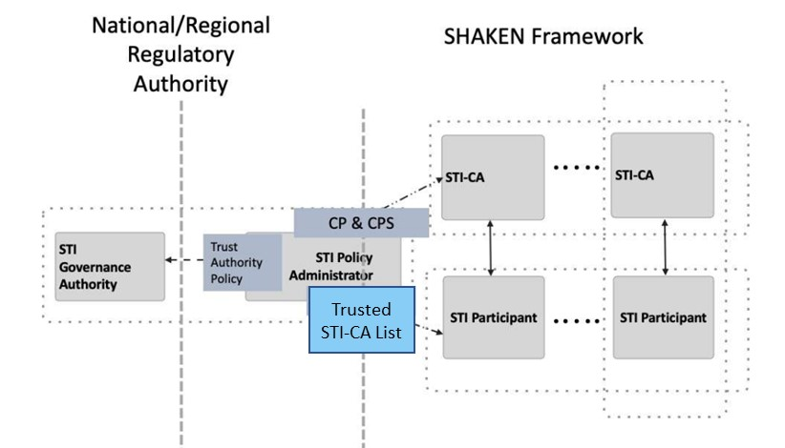
Figure 4-1: SHAKEN Governance Model

The STI-PA maintains two resources that are used by verification services during the PASSporT verification procedure:
- A Trusted STI-CA List containing the root certificate of each approved STI-CA in the local jurisdiction. This list is defined in ATIS-1000084.
- An indirect Certificate Revocation List (CRL) that lists all revoked certificates issued by STI-CAs in the local jurisdiction. The CRL is defined in ATIS-1000080.
The Trusted STI-CA List and CRL hosted by the STI-PA are shown in Figure 4-2 below:

Figure 4-2: Trusted STI-CA List and CRL Maintained by STI-PA

The Trusted STI-CA List in the above figure is explicitly a list of the root certificates of STI-CAs that were approved and controlled by this STI Policy Administrator, and as such, the scope of the CAs is limited to the scope of the GA/PA (e.g., a single country). Likewise, the CRL lists only revoked certificates that were issued by STI-CAs approved by the GA/PA in the local jurisdiction. Therefore, if two countries implement SHAKEN independently, they will have separate Trusted STI-CA Lists and separate CRLs, as shown in Figure 4-3. In the example in Figure 4-3 the originating service provider (OSP) generates a PASSporT signed with the credentials of an STI certificate issued by an STI-CA in the Trusted STI-CA List for "country x”, but when the terminating service provider (TSP) verifies the PASSporT, it uses the Trusted STI-CA List for “country y” and verification fails for the cross-border call.

Figure 4-3: Independent lists of Trusted STI-CAs and CRLs

Figure 4-2, which is taken from ATIS-1000084, shows the service provider directly accessing the Trusted STI-CA List hosted by the STI-PA using an HTTPS URL. Figure 4-3 in this document illustrates why this approach does not automatically work for cross-border SHAKEN. For verification to pass, the TSP in “country y” needs access to three country x resources; the Trusted STI-CA List, the CRL, and the STI-PA root certificate whose credentials were used to digitally sign the Trusted STI-CA List and CRL of “country x”.

The Cross-Border Trust List
To support cross-border SHAKEN, the STI-PA hosts a new table called the “Cross-Border Trust List”. This table provides a single location within each jurisdiction where verification services local to that jurisdiction can obtain the following information associated with each trusted cross-border jurisdiction:
- Their STI-PA root certificate,
- Their URL reference to the Trusted STI-CA List, and
- Their URL reference to the CRL
The Cross-Border Trust List table is shown in figure 4-4 below:

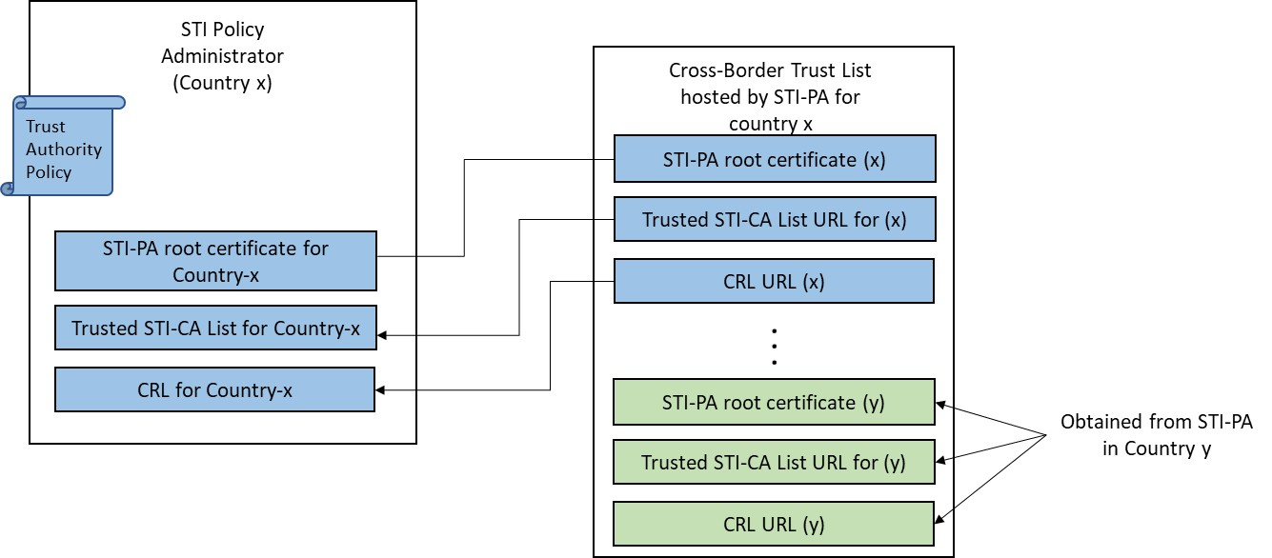
Figure 4-4: Cross-Border Trust List

As shown in Figure 4-5, with the Cross-Border Trust List, calls authenticated in one jurisdiction can be successfully verified in another jurisdiction because the Cross-Border Trust List provides URL references that the TSP verification service can use to download the Trusted STI-CA List and CRL hosted by the cross-border STI-PA in the originating jurisdiction.

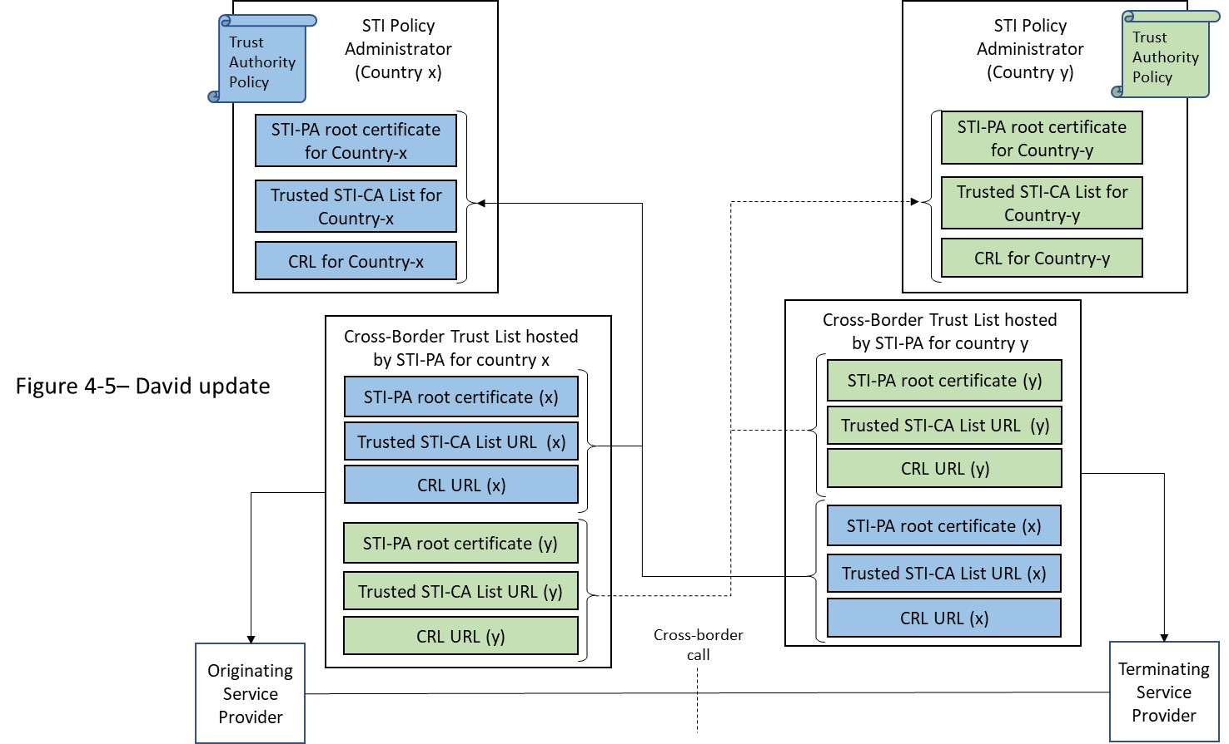
Figure 4-5: Cross-Border SHAKEN
The format of the Trusted STI-CA List and the CLR hosted by the STI-PA remains as specified in ATIS-1000084 and ATIS-1000080 respectively. No changes to the existing SHAKEN specifications are required. However, to enable support for cross-border SHAKEN, verification services will need to be updated to download the “Cross-Border Trust List” hosted by the local STI-PA, and then download the Trusted STI-CA List and CRL of each jurisdiction listed in the Cross-Border Trust List. The additional functionality is discussed in the clause 4.2.

The Cross-Border Trust List support of a Non-Jurisdictional STI-GA/PA
The previous diagrams all show Trusted CA Lists for STI-PAs associated with an individual country (e.g., one STI-CA list for “country x” and another for “country y”), but the CATA WG report Adoption of Caller ID Authentication Technology and Other Techniques to Combat Robocalls by Policymakers and Providers in Countries outside the United States [ref:xxx] also recognizes the possibility of an STI-GA/PA that is not limited to a single country (i.e., a non-jurisdictional STI-GA/PA). The mechanism described in this document can support a combination of Trusted CA Lists from several individual countries or groups of countries (i.e., jurisdictional STI-PAs) as well as non-jurisdictional STI-PAs, as shown in Figure 4-6 below:

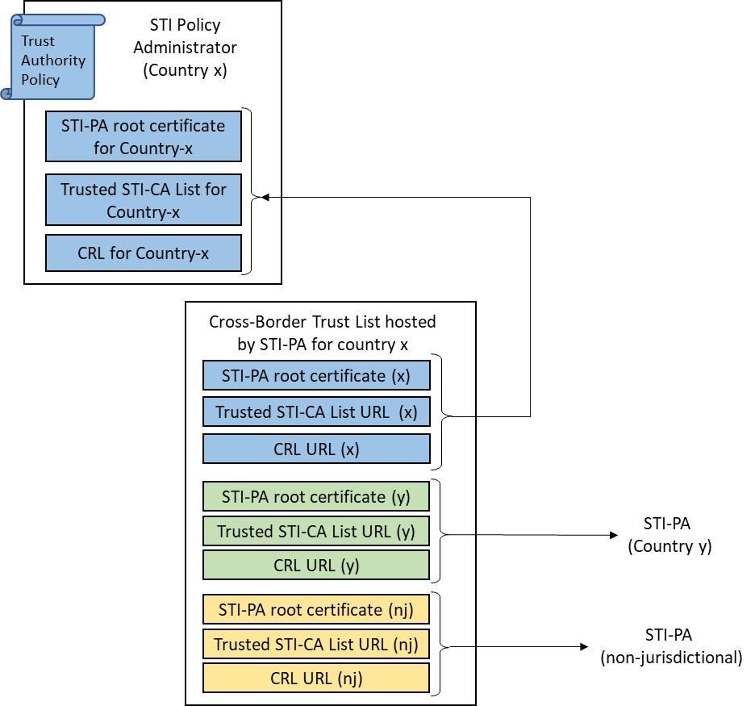
Figure 4-6: Support for Non-Jurisdictional STI-GA/PA

Cross-Border Procedures

Establishing a Cross-Border SHAKEN Agreement
Figure 4-7 shows the procedure for establishing a cross-border SHAKEN agreement between two countries: Country-x and Country-y. For simplicity, the diagram shows the information flow only from Country-x to Country-y. Since these are bi-lateral agreements, the information flow from Country-y to Country-x would be symmetrical.
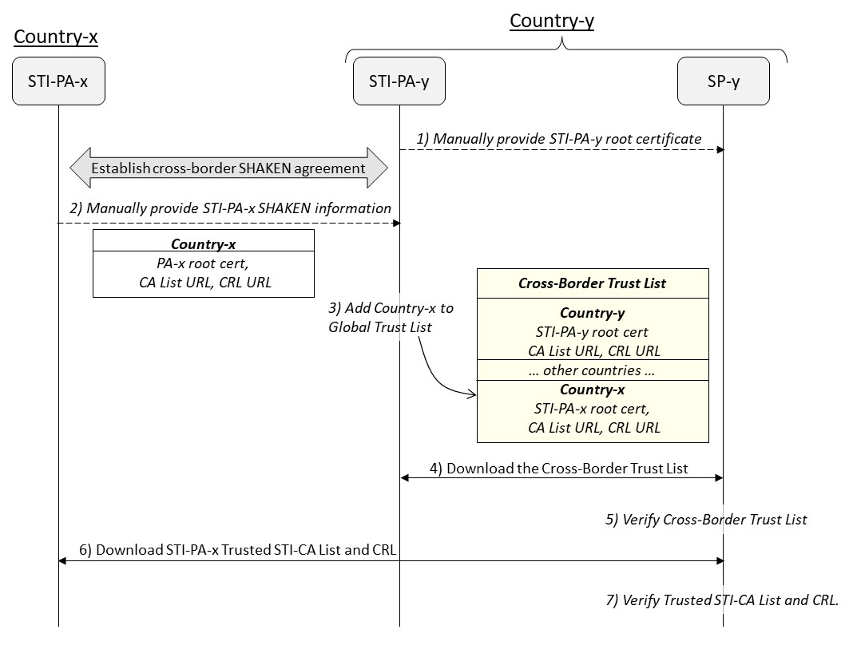
Figure 4-7: Obtaining Cross-Border Trusted STI-CA List and CRL
The procedure is as follows:
- The SPs in the jurisdiction of Country-y obtain the STI-PA-y root certificate(s) used to sign the in-jurisdiction Trusted STI-CA List, CRL, and Cross-Border Trust List hosted by STI-PA-y.
- When the cross-border SHAKEN agreement is established between Country-x and Country-y, STI-PA-x provides the URL references to its Trusted STI-CA List and CRL to STI-PA-y, along with the root certificate needed for path validation of the certificate(s) used to sign these two lists.
- STI-PA-y adds an entry for Country-x to its Cross-Border Trust List, based on the information received in step-2, and signs the list with the credentials of a certificate whose certification path chains to one of the root certificates conveyed to SP-y in step-1.
- SP-y in Country-y downloads a new version of STI-PA-y's Cross-Border Trust List at some short interval before the current version of the list expires (this document recommends a Cross-Border Trust List lifetime of 24 hours).
- SP-y verifies the Cross-Border Trust List, including validation that the certification path of the signing certificate chains to a trusted STI-PA root certificate obtained in step-1.
- If the Cross-Border Trust List is valid, then SP-y uses the URL references for Country-x to download the Trusted STI-CA List and CRL from STI-PA-x.
- SP-y verifies the two lists are valid, including validation that the certification path of the signing certificate of each list chains to the root certificate identified for Country-x in the Cross-Border Trust List. If both lists are valid, then SP-y incorporates the information contained on the lists into its PASSporT verification procedures, as follows:
  - SP-y adds the root certificates from the STI-PA-x Trusted STI-CA List to its local trusted root store,
  - SP-y PASSporT verification service uses the STI-PA-x CRL during its certificate revocation checking procedure. Specifically, if a certificate on the certification path referenced by the PASSporT’s "x5u" URL contains a CRL Distribution Point extension that references the STI-PA-x CRL, then the verification service checks the certificate’s revocation status against that CRL.
The Cross-Border Trust List, Trusted STI-CA List and CRL are digitally signed with the credentials of an STI-PA certificate that chains to a trusted STI-PA root certificate. This enables Service Providers to verify that a downloaded list came from a trusted source. Before an SP can verify one of these signed lists, it needs to be in possession of the root certificate of the local or cross-border STI-PA certificate whose credentials were used to sign the list. This exchange of STI-PA root certificates between two STI-PAs, or the distribution of an STI-PA root certificate to its in-jurisdiction Service Providers cannot be similarly protected since the STI-PA root certificate serves as the trust anchor within each jurisdiction (i.e., there is no “higher authority” to serve as a trust anchor for secure exchange of the STI-PA root certificate in these cases). Therefore, the exchange of STI-PA root certificates between cross-border STI-PAs, and the distribution of an STI-PA root certificate to its in-jurisdiction SPs must be done via a secure manual process (e.g., steps 1 and 2 in Figure 4-7).

Coordinating Cross-Border Information Exchange with STI-PA Certificate Lifecycle
As part of normal certificate lifecycle procedures, a new STI-PA root certificate must be issued at some interval before the current STI-PA root certificate expires. STI certificates (used to sign PASSporTs) contain a CRL Distribution Point extension that references the in-jurisdiction CRL hosted by the STI-PA. Therefore, as the expiration date of the STI-PA root certificate approaches, the STI-PA must perform the following procedure:
- Issue a new STI-PA root certificate,
- Create a new CRL that is signed with the credentials of an STI-PA end-entity certificate with a certification path that is anchored at the newly issued root certificate,
- Distribute the new CRL URL to in-jurisdiction Service Providers (in the SPC Token response) so that the CRL Distribution Point extension of newly issued STI certificates references the new CRL URL.
- Manually provide the new root certificate, CA List URL, and CRL URL to cross-border STI-PAs as illustrated in step 2 of Figure 4-8 below. The cross-border STI-PAs will use this information to update their Cross-Border Trust List with the updated SHAKEN information. This will allow service providers in other countries to download the new Trusted STI-CA list that chains to the new STI-PA root certificate, so cross-border verification services can validate STI certificates and reference the new CRL.
Editor’s note: Explain why the CRL URL is distributed.

At the completion of this process, there would still be many valid in-jurisdiction STI certificates referencing the old CRL. Therefore, the STI-PA must select the timing at which the above procedure is executed to ensure that the old root certificate does not expire before any in-jurisdiction STI certificate (including intermediate certificates) referencing the old CRL expires.
Figure 4-8 describes the above procedure in more detail. The initial conditions of this diagram are the final conditions of Figure 4-7, where SP-y has downloaded local, verified copies of the Cross-Border Trust List from STI-PA-y and the Trusted STI-CA List and CRL from STI-PA-x.

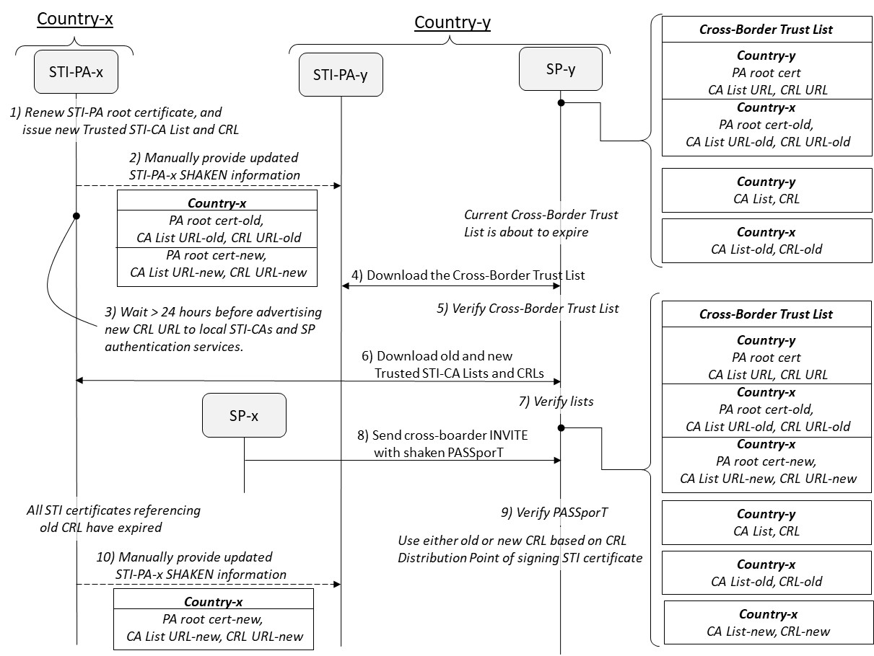
Figure 4-8: Updating Cross-Border Information when STI-PA Root Certificate Renewed
The procedure is as follows:
- A new root certificate is issued for STI-PA-x. STI-PA-x creates a new Trusted STI-CA List and a new CRL that are signed with an STI-PA certificate that chains to the new root certificate. The STI-PA assigns new URLs to the stores holding the new lists and their signing certificates.
- STI-PA-x provides two sets of cross-border information to STI-PA-y, one set for the old root certificate and one for the new root certificate. STI-PA-y updates its Cross-Border Trust Table with the new information.
- After it has passed its new information to all cross-border STI-PAs, STI-PA-x continues to return the old CRL URL in the SPC Token response to local SPs for a period of 24 hours. Once 24 hours have elapsed, STI-PA-x begins distributing the new CRL URL to local STI-CAs and SPs, so that going forward all newly issued STI certificates will reference the new CRL. This 24-hour delay ensures that all local and cross-border verification services are in possession of the new STI-PA-x root certificate before it is needed to support validation of STI certificates referencing the new CRL.
4), 5), 6) and 7) SP-y downloads and verifies a new copy of the Cross-Border Trust List, and based on the new information contained on the list, downloads and verifies two sets of the Trusted STI-CA List and CRL from STI-PA-x.
8) and 9) At this point, SP-y could receive a signed INVITE from SP-x in Country-x. During PASSporT verification, SP-y must select either the old or new CRL previously downloaded from STI-PA-x, based on the contents of the CRL Distribution point extension of the STI certificates in the certification path referenced by the PASSporT’s "x5u" parameter.
- Once all in-jurisdiction STI certificates referencing the old CRL have expired, STI-PA-x deletes the old root certificate and lists and provides STI-PA-y with a single set of cross-border information associated with the new root certificate.
The above procedure applies to the “graceful” root certificate renewal case where a new STI-PA root certificate is issued because the current root certificate is approaching end-of life. For cases where a new STI-PA root certificate is issued because the current root certificate has been compromised (e.g., private key was leaked), the STI-PA will create a new Trusted STI-CA List and CRL signed with an end-entity certificate chained to the new root certificate, as described above. However, there will be no grace period where both the old and new root certificates and CRLs co-exist. Instead, the STI-PA will immediately update its cross-border information to remove all data associated with the compromised root certificate. The STI-PA will also inform all in-jurisdiction STI-CAs and Service Providers to replace their existing STI certificates with new STI certificates that reference the new CRL.

Terminating a Cross-Border SHAKEN Agreement
Figure 4-9 shows the procedure for terminating a cross-border SHAKEN agreement.
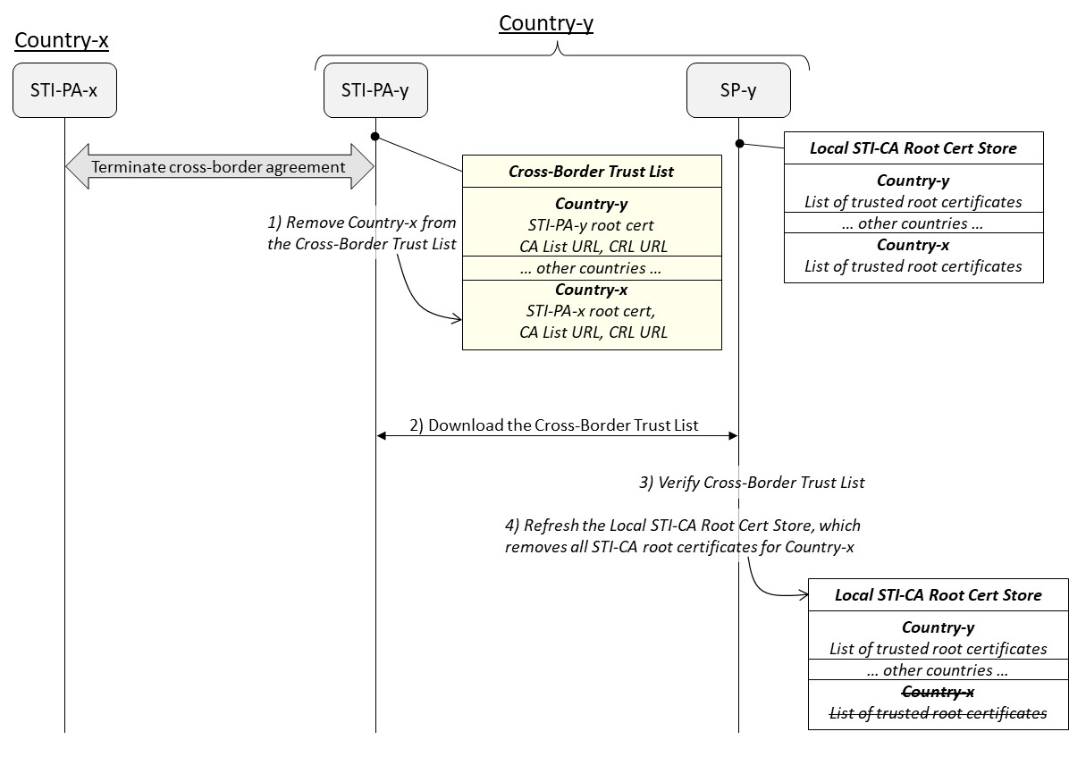
Figure 4-9: Terminating a Cross-Border SHAKEN Agreement
The procedure is as follows:
- If Country-y decides to terminate its cross-border SHAKEN agreement with Country-x, then STI-PA-y removes all entries associated with Country-x from its Cross-Border Trust List.
- and 3) On its next 24-hour polling interval, SP-y downloads and verifies the Cross-Border Trust List.
- SP-y refreshes its Local STI-CA trust store based on the CA List URLs contained in the newly downloaded Cross-Border Trust List. Since there are no entries associated with Country-x on the Cross-Border Trust List, all STI-CA root certificates associated with Country-x are removed from SP-y’s Local STI-CA trust store.

Cross-Border Trust List Data Structure
This section specifies the structure of the Cross-Border Trust List. The Cross-Border Trust List shall be encoded as a JSON Web Token (JWT) [Ref xx], with the following Protected Header fields:
- "alg": Identifies the algorithm used to generate the JWT signature. Algorithm "ES256" shall be used.
- "typ": Identifies the object type. Value "jwt" shall be used.
- "x5u": Identifies the URL of the STI-PA certificate whose credentials were used to generate the signature of the Cross-Border Trust List JWT. The URL shall have a protocol of “https”. The URL shall either not contain a port or contain a port of “443”. The URL shall not contain a userinfo subcomponent, query component, or fragment identifier component as described in [RFC 3986]. The URL path shall end with “.pem”.
The Cross-Border Trust List JWT payload shall contain the following claims:
- "version" (string): Version number of this list format. Cross-Border Trust Lists compliant with this specification shall have a version number of “1.0”. Subsequent specifications that change or extend the Cross-Border Trust List JWT shall update the version number accordingly.
The next three claims contain a timestamp encoded in NumericDate format as defined in [RFC7519]:
- "exp": Timestamp after which this JWT is no longer valid.
- "iat": Timestamp at which this JWT was generated.
- "nbf": Timestamp before which this JWT shall not be accepted for processing.

- "sequence" (int): Sequence number is incremented by one each time a new list is provided by the STI-PA. A 64-bit integer is recommended.
- "crossBorderTrustList": A JSON array. The first array entry contains information associated with the local jurisdiction. Each subsequent array entry contains information associated with a trusted cross-border jurisdiction. Each array entry contains the following key/value pairs:
  - "countries": an array of strings where each string is an ISO 3166-1 alpha-2 country code [ISO 3166-1, Codes for the Representation of Names of Countries and Their Subdivisions]. When the STI-PA associated with a "crossBorderTrustList" array entry serves multiple countries, the "countries" array contain multiple entries identifying those countries. The "countries" key is not intended to be used by an SP verification service. It is only intended to make it easier for humans to understand the contents of the "crossBorderTrustList".
  - "stiPaRootCert": a pem-encoded root certificate of the STI-PA associated with this "crossBorderTrustList" array entry.
  - "caListUrl": a URL reference to the Trusted STI-CA List of the STI-PA associated with this "crossBorderTrustList" array entry. The Trusted STI-CA List shall be signed by a certificate that chains up to the "stiPaRootCert" of this "crossBorderTrustList" array entry.
  - "crlUrl": a URL reference to the CRL of the STI-PA associated with this "crossBorderTrustList" array entry. This URL shall match the URL identified by the CRL Distribution Point extension of certificates issued by STI-CAs in the jurisdiction associated with this "crossBorderTrustList" array entry. The CRL shall be signed by a certificate that chains up to the "StiPaRootCert" of this "crossBorderTrustList" array entry.
An example HTTP request/response to obtain the Cross-Border Trust List from the STI-PA in the local jurisdiction is as follows:
GET /CrossBorderTrustList HTTP/1.1
Host: https://example-us.sti-pa.com
Accept: application/jose+json

HTTP/1.1 200 OK
Content-Type: application/jose+json

{"protected": base64url({
"alg": "ES256",
"typ": "JWT",
"x5u": " https://sti-pa.com/Cross-Border-trust-list/cert.pem"})
"payload": base64url({
"version": 1.0,
"sequence": 1,
"exp": 1300819380,
"iat": 1300819380,
"nbf": 1300819380,
"crossBorderTrustList": [
{
"countries": ["US"],
"stiPaRoot": "PEM_UNITED_STATES_STI-PA_ROOT_CERTIFICATE_HERE",
"caListUrl": "https://example-us-sti-pa.com/caList.pem",
"crlUrl": "https://example-us-sti-pa.com/crl.pem"
},
{
"countries": ["CA"]
"stiPaRoot": "PEM_CANADA_STI-PA_ROOT_CERTIFICATE_HERE",
"caListUrl": "https://example-ca-sti-pa.com/caList.pem",
"crlUrl": "https://example-ca-sti-pa.com/crl.pem"
},
{
"countries": ["IT", "VA"]
"stiPaRoot": "PEM_ITALY_STI-PA_ROOT_CERTIFICATE_HERE",
"caListUrl": "https://example-it-sti-pa.com/caList.pem",
"crlUrl": "https://example-it-sti-pa.com/crl.pem"
}
]
})
"signature": /* signed using STI-PA end-entity certificate private key */
}

Cross-Border Trust List Procedures
This section contains the normative requirements to be supported by an STI-PA, STI-AS and STI-VS to enable cross-border SHAKEN.

STI-PA Procedures

Generating the Cross-Border Trust List
The STI-PA shall host the Cross-Border Trust List defined in clause 4.2. The "iat" claim shall be populated with a timestamp value for the current time. The "exp" claim shall be populated with a timestamp value that is 24 hours later than the timestamp value of the "iat" claim. The "nbf" claim shall be populated with a timestamp value that indicates the time before which the information in this Cross-Border Trust List should not be used.
The STI-PA shall populate the first array entry of the "crossBorderTrustList" claim with information related to the STI-PA itself. The STI-PA shall populate additional "crossBorderTrustList" array entries with information received from its trusted cross-border STI-PAs. The STI-PA shall obtain this information from each trusted cross-border STI-PA using a secure, mutually agreed to manual process.
The list shall be signed with the credentials of an STI-PA end-entity certificate whose certification path is anchored at the root certificate of the STI-PA.

Downloading the Cross-Border Trust List and its Referenced Resources
Service provider verification services shall use the information returned by the Cross-Border Trust List to query local and cross-border STI-PAs. An in-jurisdiction or cross-border STI-PA shall respond to HTTPS requests to the Cross-Border Trust List "crossBorderTrustList" claim "caListUrl" URL as specified in ATIS-1000084, where only root certificates for SHAKEN-approved STI-CAs local to that STI-PA are included in the Trusted STI-CA List returned in the response. Likewise, the STI-PA shall respond to HTTPS requests to the "crossBorderTrustList" claim "crlUrl" URL as specified in ATIS-1000080, where only revoked certificates issued by STI-CAs local to the responding STI-PA are included in the CRL returned in the response. This is shown in figure 6-1 below.
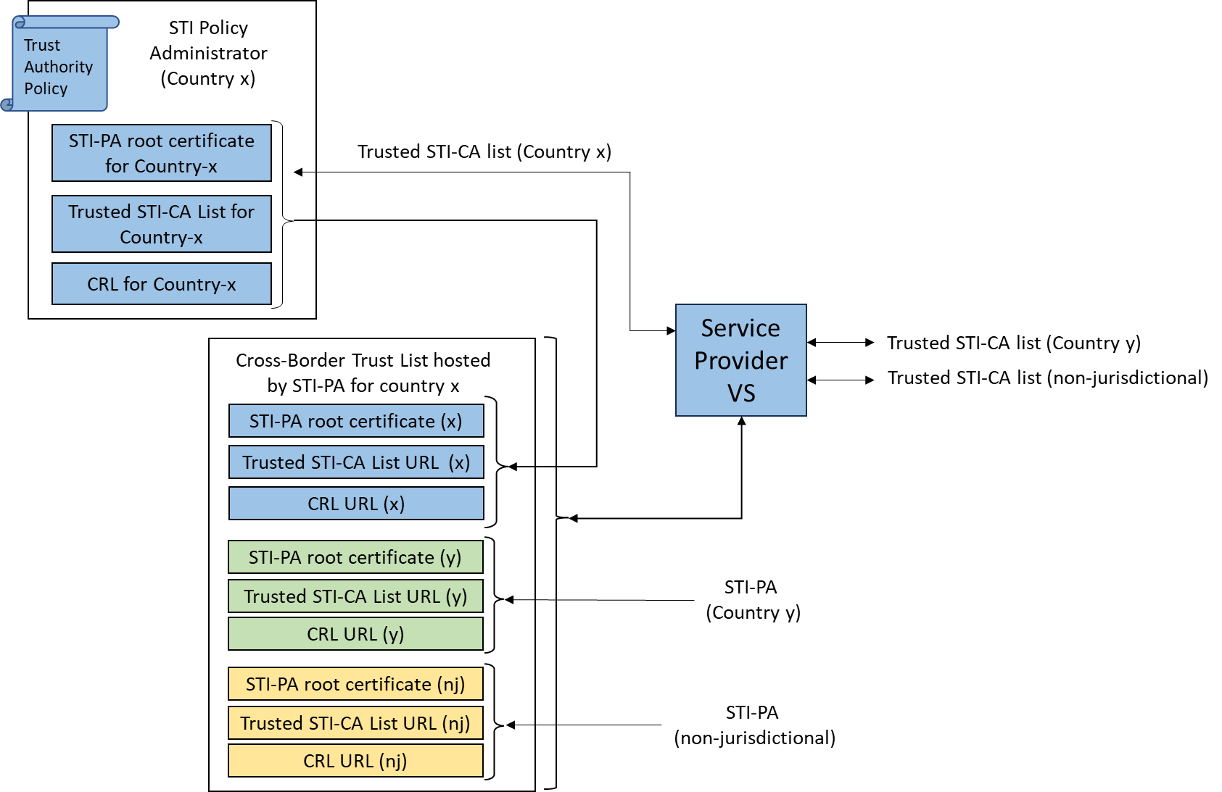
Figure 6-1: Downloading Cross-Border Trust List

An STI-PA shall not include its root certificate in the certification path that is provided to local or cross-border verification services dereferencing the Trusted STI-CA List "x5u" URL or the CRL Authority Information Access URL. An STI-PA shall not include its root certificate in the certification path that is provided to local verification services dereferencing the Cross-Border Trust List "x5u" URL.

STI-PA Certificate Rollover
When a new STI-PA root certificate is issued because the current root certificate is approaching its expiration date, the STI-PA shall construct a new CRL signed with the credentials of an end-entity certificate whose certification path is anchored at the new root certificate. The STI-PA shall perform a similar procedure for the Trusted STI-CA List (i.e., construct a new CA trust list signed with the credentials of an end-entity certificate that chains to the new STI-PA root certificate). The STI-PA shall store the newly created CRL and Trusted STI-CA List in globally publicly accessible repositories. The STI-PA shall ensure that the URL references to these two new lists and their signing certificates are different than the set of URL references to the lists and signing certificates associated with the old root certificate.
Once the new Trusted STI-CA List and CRL are uploaded to their local repositories, the STI-PA shall include two entries in the "crossBorderTrustList" claim of the Cross-Border Trust List sent to in-jurisdiction verification services, one containing the old STI-PA root certificate and CRL and Trusted STI-CA lists, and one containing the new root certificate and lists. Likewise, the STI-PA will convey two sets of STI-PA root certificates, and two sets of lists to its trusted cross-border STI-PAs. The STI-PA shall continue to provide the old root certificate and lists (along with the new root certificate and lists) to in-jurisdiction verification services and cross-border STI-PAs until all in-jurisdiction STI certificates referencing the old CRL expire, at which point the STI-PA shall stop distributing the old root certificate and lists.
As specified in ATIS-1000080, the STI-PA distributes a CRL URL to in-jurisdiction STI-CAs and SP authentication services (for example, the URL is passed to SP authentication services in the SPC Token response from the STI-PA). STI-CAs and SPs use this URL to populate the CRL Distribution Point extension of STI end-entity and intermediate certificates. When a new CRL is created during STI-PA root certificate renewal, the STI-PA shall continue to distribute the URL for the old CRL to in-jurisdiction STI-CAs and SP authentication services for a duration of 24 hours after the STI-PA has completed providing its root certificate and list information to all trusted cross-border STI-PAs. Once this 24-hour interval has ended, the STI-PA shall start distributing the new CRL URL to in-jurisdiction STI-CAs and SP authentication services. Inserting a 24-hour delay before the new CRL URL is referenced in STI certificates will ensure that local and cross-border verification services are in possession of the new STI-PA root certificate which is required for certificate path validation of the certificate referenced by the Authority Information Access extension of the new CRL.
The detailed steps for updating cross-border information when the STI-PA root certificate is renewed is illustrated in figure 4-8.

STI-PA Resources that require Public Access
The Cross-Border Trust List and its referenced resources shall be distributed using HTTPS. An STI-PA shall make URL references publicly available and such URL references shall match their Trusted STI-CA List "x5u" URL and their CRL Authority Information Access URL. For further clarity, globally public access shall mean:
- Available globally (e.g., no geofencing);
- Does not require an account with a cross-border STI-PA; and
- Available without IP address whitelisting.
The STI-PA shall make the following resources globally publicly accessible:
- The Cross-Border Trust List URL (response is a JWT)
- The Cross-Border Trust List certificate URL (the URL included in the x5u claim of the Cross-Border Trust List JWT)
- The CRL URL (response is a PEM CRL)
- The CRL certificate URL (the URL included in the Authority Information Access extension of the CRL)
- The Trusted STI-CA List URL (response is a JWT)
- The Trusted STI-CA List certificate URL (the URL included in the "x5u" claim of the Trusted STI-CA List JWT)

STI-PA Certificate Profile
STI-PA root certificates shall support the following X.509 certificate profile:
- Shall include a Basic Constraints extension with CA attribute set to “true”
- Shall include a Key Usage extension set to Certificate Sign and CRL Sign only
- Shall not include a Certificate Policy extension identifying the OID of the Certificate Policy supported by the STI-PA CA
- Shall not include a CRL Distribution Point extension

STI-PA intermediate certificates shall support the following X.509 certificate profile:
- Shall include a Basic Constraints extension with CA attribute set to “true”
- Shall include a Key Usage extension set to Certificate Sign and CRL Sign only
- Shall include a Certificate Policy extension identifying the OID of the Certificate Policy supported by the STI-PA CA
- Shall include a CRL Distribution Point extension referencing the indirect CRL hosted by the STI-PA for revoked certificates issued by the STI-PA CA

STI-PA end-entity certificates used to sign CRLs shall support the following X.509 certificate profile:
- Shall include a Basic Constraints extension with CA attribute set to “false”
- Shall include a Key Usage extension set to CRL Sign only
- Shall include a Certificate Policy extension identifying the OID of the Certificate Policy supported by the STI-PA CA
- Shall include a CRL Distribution Point extension referencing the indirect CRL hosted by the STI-PA for revoked certificates issued by the STI-PA CA

STI-PA end-entity certificates used to sign JWTs shall support the following X.509 certificate profile:
- Shall include a Basic Constraints extension with CA attribute set to “false”
- Shall include a Key Usage extension set to Digital Signature only
- Shall include a Certificate Policy extension identifying the OID of the Certificate Policy supported by the STI-PA CA
- Shall include a CRL Distribution Point extension referencing the indirect CRL hosted by the STI-PA for revoked certificates issued by the STI-PA CA

The Certificate Policy extension of STI-PA intermediate and end-entity certificates shall not identify the OID of the Certificate Policy of the STI-CA.

STI-CA Procedures
When issuing STI certificates to a Service Provider, the STI-CA shall ensure that the CRL Distribution Point extension of the issued certificate contains the current CRL URL value the STI-CA received from the STI-PA. The STI-CA shall also ensure that all STI intermediate certificates in the certification path of the issued certificate contain that same CRL URL value.

Authentication and Verification Service (STI-AS/VS) Procedures
SP verification services shall no longer directly download the Trusted STI-CA List or CRL directly from the local (in-jurisdiction) STI-PA. Instead, SP verification services shall download the cross-Border Trust List from the local STI-PA. The local Trusted STI-CA List and CRL will then be downloaded through the same process that non-local Trusted STI-CA List(s) and CRL(s) are downloaded.
Specifically, SP verification services shall download a new version of the Cross-Border Trust List from the local STI-PA at some short interval before the current list expires as indicated by the "exp" claim (an interval of one hour is recommended). A verification service shall not use the root certificate identified in the "stiPaRoot" key value of the local STI-PA when validating the certification path of the STI-PA certificate referenced by the Cross-Border Trust List "x5u" parameter. Instead, the verification service shall obtain the STI-PA root certificate by some secure manual out-of-band mechanism.
If a newly downloaded Cross-Border Trust List is valid, and the current time is between the times indicated by the "nbf" claim and the "exp" claim, then the verification service shall download the Trusted STI-CA List referenced by the "caListUrl" key value of each array entry in the "crossBorderTrustList" claim. The verification service shall verify the newly downloaded Trusted STI-CA List of each array entry as specified in ATIS-1000084, with the exception that during certificate path validation of the "x5u" certificate it shall use the root certificate contained in the "stiPaRoot" key of the same "crossBorderTrustList" array entry. The verification service shall ignore any root certificate returned when dereferencing the "x5u" claim. If the Trusted STI-CA List is valid, then the verification service shall add the root certificates to its local trust store.
When a newly downloaded Cross-Border Trust List indicates that a previously downloaded "crossBorderTrustList" array entry has been removed, the verification service shall ensure that all trusted root certificates associated with that previous array entry are removed from its local root certificate store.
The verification service shall also download the CRL referenced by the "crlUrl" key value of each "crossBorderTrustList" array entry and validate the CRL as specified in ATIS-1000074, with the exception that during certificate path validation it shall use the root certificate contained in the "stiPaRoot" key of the same "crossBorderTrustList" array entry. If the CRL is valid, then the verification service shall include any revoked certificates listed on the CRL when checking for revoked certificates during PASSporT verification.
SP verification services shall not dereference URLs in the Cross-Border Trust List that meet any of the following conditions:
- URLs that use a scheme other than “https” or a port other than 443,
- URLs that contain a userinfo subcomponent, query component, or fragment identifier component as described in RFC 3986 [Ref 7],
- URLs with a host component that resolves to a special-purpose IP address described in RFC 6890, Special-Purpose IP Address Registries, or
- URLs that appear to be part of a Server-Side Request Forgery (SSRF) attack.
The verification service shall not follow HTTP redirections (i.e., the Location header of a 3xx HTTP response). The verification service may make an HTTP HEAD request to check the Content-Type or other headers before making an HTTP GET request to dereference a URL.
SP authentication services shall not use the CRL URL identified in the Cross-Border Trust List to populate the CRL Distribution Point extension of an STI certificate. Instead, as specified in ATIS-1000080, the CRL URL returned by the STI-PA in an SPC Token response shall be used for this purpose. This enables the STI-PA to control when a newly issued STI certificate starts referencing the new CRL during the STI-PA root certificate renewal process.
Note that this approach provides a degree of backward compatibility with legacy VS functions, which will not be able to access cross-border STI-CA lists but will be able to continue directly accessing the in-jurisdiction STI-CA Trust List, exactly as they have in the past. This is illustrated below.
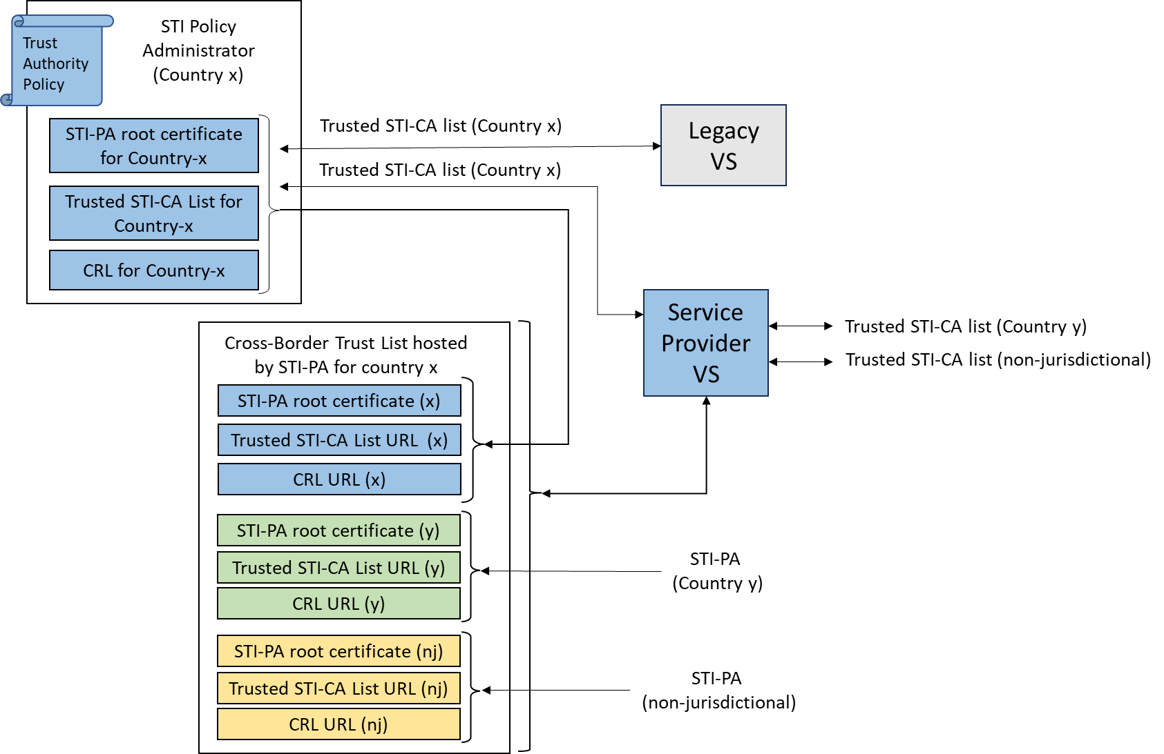
Figure 6-2: Backward Compatibility

Available from the Internet Engineering Task Force (IETF) at: < https://www.ietf.org/ >.
Available from the International Organization for Standardization (ISO) at: < https://www.iso.org/ >.
This document is available from the Alliance for Telecommunications Industry Solutions (ATIS) at < www.atis.org >.
This document is available from the International Organization for Standardization (ISO) at: < https://www.iso.org/ >.
Both CRLs will contain the same set of revoked certificates, and both Trusted STI-CA Lists will contain the same set of STI-CA root certificates.

