ATIS-1000087

ATIS Technical Report on

Mechanism for Initial Cross-Border Signature-based Handling of Asserted information using toKENs (SHAKEN)

Alliance for Telecommunications Industry Solutions

Approved December 16, 2019

Abstract
The Signature-based Handling of Asserted information using toKENs (SHAKEN) standard “ATIS-1000074” specifies operation within the domain of a single national or regional regulatory authority - in most cases this means within a single country. This was a conscious decision by the joint Alliance for Telecommunications Industry Solutions (ATIS) and SIP Forum IP-NNI Task Force (IP-NNI TF) in order to more quickly develop a solution that explicitly addressed U.S. requirements. However, SHAKEN does not assume unique U.S. attributes, and therefore should be equally applicable to other countries. Calls that originate in one country and terminate in another country, are not explicitly addressed in the existing SHAKEN standard. This document provides a mechanism to extend the SHAKEN trust environment to include more than one country without requiring service providers to make changes to their current standard SHAKEN interfaces.

Foreword
The Alliance for Telecommunications Industry Solutions (ATIS) serves the public through improved understanding between carriers, customers, and manufacturers. The Packet Technologies and Systems Committee (PTSC) develops and recommends standards and technical reports related to services, architectures, and signaling, in addition to related subjects under consideration in other North American and international standards bodies. PTSC coordinates and develops standards and technical reports relevant to telecommunications networks in the U.S., reviews and prepares contributions on such matters for submission to U.S. International Telecommunication Union Telecommunication Sector (ITU-T) and U.S. ITU Radiocommunication Sector (ITU-R) Study Groups or other standards organizations, and reviews for acceptability or per contra the positions of other countries in related standards development and takes or recommends appropriate actions.
The SIP Forum is an IP communications industry association that engages in numerous activities that promote and advance SIP-based technology, such as the development of industry recommendations, the SIPit, SIPconnect-IT, and RTCWeb-it interoperability testing events, special workshops, educational seminars, and general promotion of SIP in the industry. The SIP Forum is also the producer of the annual SIP Network Operators Conference (SIPNOC), focused on the technical requirements of the service provider community. One of the Forum's notable technical activities is the development of the SIPconnect Technical Recommendation – a standards-based SIP trunking recommendation for direct IP peering and interoperability between IP Private Branch Exchanges (PBXs) and SIP-based service provider networks. Other important Forum initiatives include work in Video Relay Service (VRS) interoperability, security, Network-to-Network Interoperability (NNI), and SIP and IPv6.
The mandatory requirements are designated by the word shall and recommendations by the word should. Where both a mandatory requirement and a recommendation are specified for the same criterion, the recommendation represents a goal currently identifiable as having distinct compatibility or performance advantages. The word may denotes an optional capability that could augment the standard. The standard is fully functional without the incorporation of this optional capability.
Suggestions for improvement of this document are welcome. They should be sent to the Alliance for Telecommunications Industry Solutions, PTSC, 1200 G Street NW, Suite 500, Washington, DC 20005.
The ATIS/SIP Forum IP-NNI Task Force under the ATIS Packet Technologies and Systems Committee (PTSC) and the SIP Forum Technical Working Group (TWG) was responsible for the development of this document.

Table of Contents
1 Scope, Purpose, & Application 1
1.1 Scope 1
1.2 Purpose 1
1.3 Application 1
2 References 1
3 Definitions, Acronyms, & Abbreviations 2
3.1 Definitions 2
3.2 Acronyms & Abbreviations 2
4 Overview 3
4.1 Cross-Border Architecture 3
4.2 Scope of Trusted STI-CA 5
4.3 Combined Trusted STI-CA Lists 6
4.3.1 Server 7
4.3.2 Interface to Server 8
4.3.3 Procedures to Update Server 8
4.4 Compatible Implementations 8

Table of Figures
Figure 4-1: SHAKEN Trust Model 3
Figure 4-2: List of Trusted STI-CAs 4
Figure 4-3: Independent lists of Trusted STI-CAs 4
Figure 4-4: Independent Deployments of SHAKEN 4
Figure 4-5: Merged Trusted STI-CA Lists at each STI-PA 5
Figure 4-6: Merged Trusted STI-CA Lists at each STI-PA (Network Context) 5
Figure 4-7: Mutual Exchange 6
Figure 4-8: Trusted STI-CA Server 7
Figure 4-9: Trusted STI-CA Servers 7

Scope, Purpose, & Application

Scope
This document provides telephone service providers with a framework and guidance on how to use Secure Telephone Identity (STI) technologies on IP-based service provider voice networks (also to be referred to as Voice over Internet Protocol [VoIP] networks) in scenarios where a call originates in one country and terminates in a different country. The primary focus of this document is to detail how the trust environment created by Signature-based Handling of Asserted information using toKENs (SHAKEN) in a single country can be extended to include other countries. This document does not require any changes to the existing SHAKEN specifications but does identify new interfaces and functions to exchange information between countries.

Purpose
The purpose of this document is to extend the SHAKEN trust environment to encompass more than one country. This document will detail how calls authenticated in one country can be successfully verified in a second country.

Application
The mechanism specified in this technical report will allow countries with similar interests and regulatory environments to federate their SHAKEN infrastructure and extend the trust environment to include both countries. This specification only considers a bilateral arrangement between two jurisdictions, although it may be possible to extend this to include a limited number of additional countries. The more general solution for global interworking requires further study.

References
The following standards contain provisions which, through reference in this text, constitute provisions of this technical report. At the time of publication, the editions indicated were valid. All standards are subject to revision, and parties to agreements based on this technical report are encouraged to investigate the possibility of applying the most recent editions of the standards indicated below.
IETF RFC 4648, The Base16, Base32, and Base64 Date Encodings
IETF RFC 7519, JSON Web Token (JWT) ¹
IETF RFC 7231, Hypertext Transfer Protocol (HTTP/1.1): Semantics and Content¹
ISO 3166-1: Codes for the Representation of Names of Countries and Their Subdivisions
IETF RFC 3326, The Reason Header Field for the Session Initiation Protocol (SIP).¹
ATIS-1000074, Signature-based Handling of Asserted information using toKENs (SHAKEN)
ATIS-1000080, SHAKEN: Governance Model and Certificate Management^{Error! Bookmark not defined.}
ATIS-1000084, Technical Report on Operational and Management Considerations for SHAKEN STI Certification Authorities and Policy Administrators^{Error! Bookmark not defined.}
CATA-WG Report, Adoption of Caller ID Authentication Technology and Other Techniques to Combat Robocalls by Policymakers and Providers in Countries outside the United States [link]

Definitions, Acronyms, & Abbreviations
For a list of common communications terms and definitions, please visit the ATIS Telecom Glossary, which is located at < http://www.atis.org/glossary >.

Definitions
Caller ID: The originating or calling party telephone number used to identify the caller carried either in the P-Asserted Identity or From header.
Global Trust List: A list of URLs to the Trusted STI-CA list and CRL hosted by the local STI-PA and each trusted cross-border STI-PA.
Trusted CA: A CA upon which a certificate user relies for issuing valid certificates; especially a CA that is used as
a trust anchor CA [Ref 9].
Trust List: A set of one or more trust anchors used by a relying party to explicitly trust one or more PKIs [Ref 10].

Acronyms & Abbreviations

ATIS |  | Alliance for Telecommunications Industry Solutions
CC |  | Country Code
CP |  | Certificate Policy
CRL |  | Certificate Revocation List
HTTPS |  | Hypertext Transfer Protocol Secure
IETF |  | Internet Engineering Task Force
IP |  | Internet Protocol
JSON |  | JavaScript Object Notation
JWT |  | JSON Web Token
NNI |  | Network-to-Network Interface
PASSporT |  | Personal Assertion Token
PBX |  | Private Branch Exchange
SHAKEN |  | Signature-based Handling of Asserted information using toKENs
SIP |  | Session Initiation Protocol
STI |  | Secure Telephone Identity
STI-AS |  | Secure Telephone Identity Authentication Service
STI-CA |  | Secure Telephone Identity Certification Authority
STI-CR |  | Secure Telephone Identity Certificate Repository
STI-PA |  | Secure Telephone Identity Policy Administrator
STIR |  | Secure Telephone Identity Revisited
URL |  | Uniform Resource Locator
VoIP |  | Voice over Internet Protocol

Overview
SHAKEN specifications state that the Secure Telephone Identity-Policy Administrator (STI-PA) approves Secure Telephone Identity-Certificate Authorities (STI-CAs) using criteria established by the stakeholders, and then distributes the list of “Trusted STI-CAs” to all service providers in the SHAKEN ecosystem. The SHAKEN governance model only considers a single country, but nothing in the existing technical specification precludes the respective authorities in two countries from agreeing they will recognize each other’s STI-CAs and instructing their respective STI-PAs to merge their “Trusted STI-CA” lists. The merged trusted STI-CA list could then be distributed to all service providers in both participating countries, using existing interfaces and procedures. Calls authenticated in one country would then successfully verify in the other country. This document specifies the architecture and interfaces for two countries to exchange their trusted STI-CA lists.
Initial deployment of cross-border SHAKEN using this model is likely to be based on direct bilateral agreement between two STI-PAs, at the direction of their respective authorities. This could be extended through additional bilateral agreements, but as deployment increases, other mechanisms could also be introduced. For example, several countries could appoint an entity to act on their behalf, with a single agreement covering all the countries. Alternatively, an industry association could act as a central clearing house, allowing new participants to sign a single agreement with the association to gain access to all other members of the association. All these arrangements (i.e., bilateral agreements, regional organization, and industry association) could coexist using the mechanism defined in this standard, depending on the circumstances of the participating countries.

Cross-Border Architecture
Editor’s Note: the text and diagrams in this section need to be updated to align with the Global Trust List definition in section 4.2.1. Specifically, update text/diagrams to show that each entry in the Global Trust List contains three pieces of information associated with a local or trusted cross-border STI-PA:
- The trusted root certificate of the STI-PA
- A URL reference to the Trusted STI-CA List hosted by the STI-PA
- A URL to the CRL hosted by the STI-PA
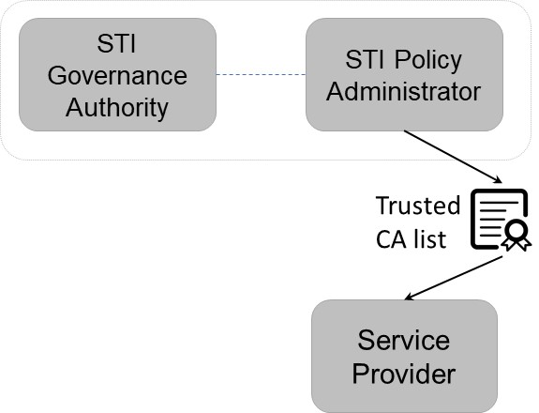
At a high level, the SHAKEN trust model is illustrated below:

Figure 4-1: SHAKEN Trust Model

ATIS-1000084, Technical Report on Operational and Management Considerations for SHAKEN STI Certification Authorities and Policy Administrators specifies that the “Trusted STI-CA List” is maintained by the STI-PA. This is shown in figure 4-2 below.

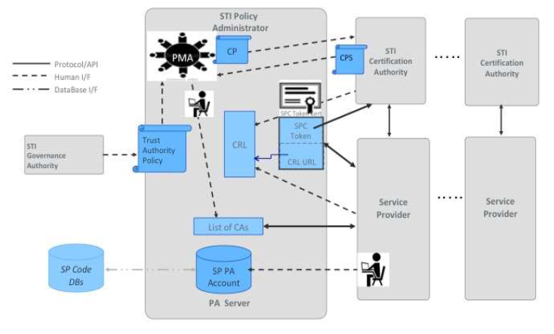

Figure 4-2: List of Trusted STI-CAs Maintained by STI-PA

The list of trusted STI-CAs in the above figure is explicitly a list of the root certificates of STI-CAs that were approved and controlled by this STI Policy Administrator, and as such, the scope of the CAs is limited to the scope of the GA/PA (e.g., a single country). Therefore, if two countries implement SHAKEN independently, they will have separate “Trusted STI-CA Lists”, as shown below. In the example in figure 4-3 the originating service provider will generate a PASSporT using an STI certificate issued by a CA in the “Trusted STI-CA List” for "country x”, but when the terminating service provider verifies the PASSporT, it will use the “Trusted STI-CA List” for “country y” and verification will fail for the cross-border call.

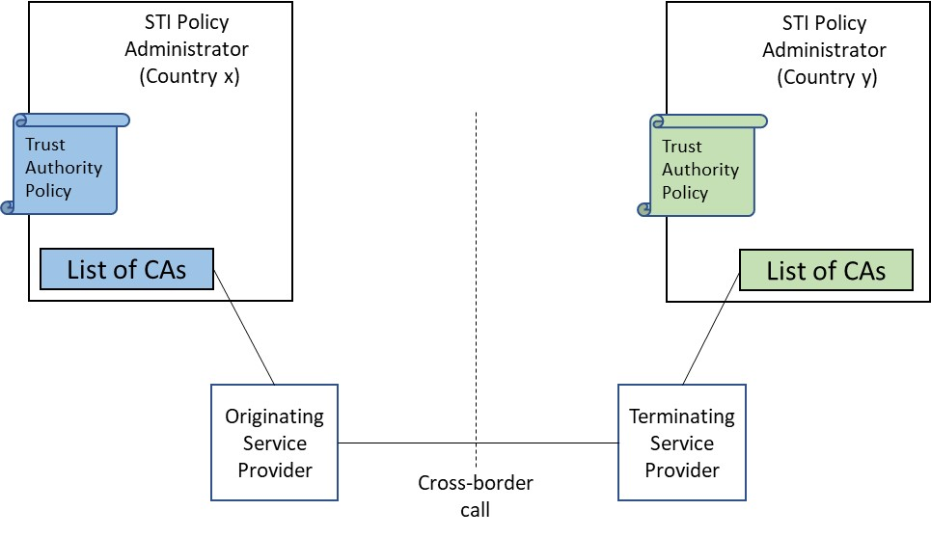
Figure 4-3: Independent lists of Trusted STI-CAs

Figure 4-2 from ATIS-1000084 shows the service provider directly accessing the Trusted STI-CA List hosted by the STI-PA using an HTTPS URL. Figure 4-3 illustrates why this approach does not automatically work for cross-border SHAKEN. To support cross-border SHAKEN, a “Global Trust List” is defined to provide a single location where service providers can access the URL for the local Trusted STI-CA List (i.e., the same URL that was directly accessed by service providers before cross-border SHAKEN), as well as the URL(s) for the Trusted STI-CA list(s) maintained by any other STI-PA(s) that the local STI-GA has approved to be included in the zone of trust. When cross-border SHAKEN is supported, service providers use the “Global Trust List” for PASSporT verification. This is shown in figure 4-4 below.

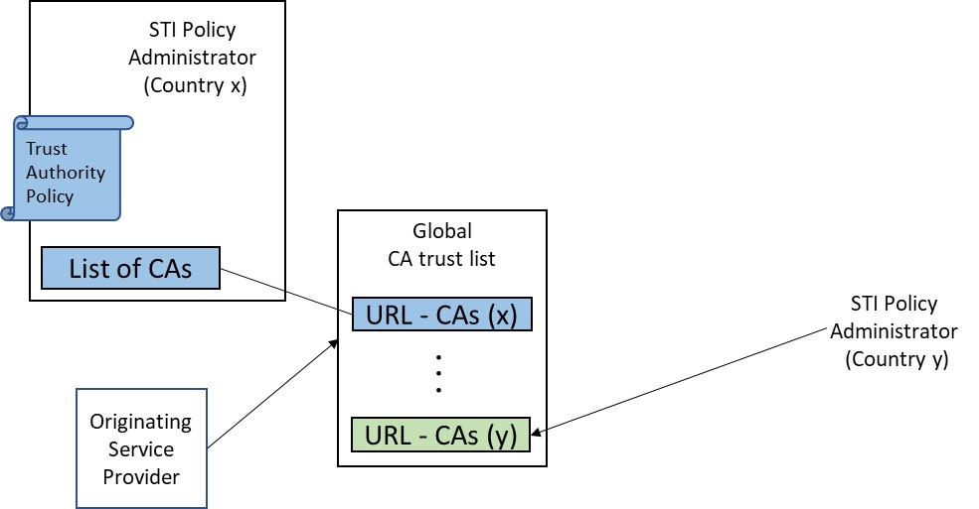
Figure 4-4: Global Trust List

The “Global Trust List” includes the Trusted CA list from “Country X” and “Country Y”, allowing cross-border SHAKEN to be successfully verified, as shown in figure 4-5.

In this case, calls authenticated in one network could successfully verify in the other network because the “Global Trust List” is the same for both the OSP and TSP.

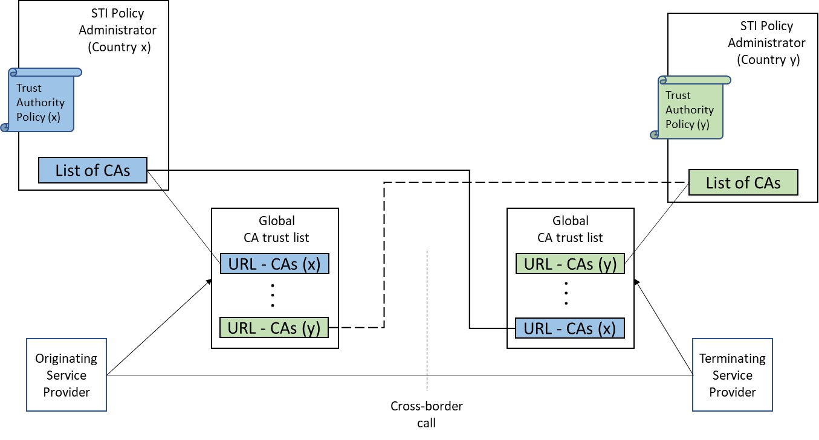
Figure 4-5: Cross-Border SHAKEN

The format of the Trusted STI-CA List in the STI-PA remains as specified in ATIS-1000080, Signature-based Handling of Asserted information using toKENs (SHAKEN): Governance Model and Certificate Management and ATIS-1000084, Technical Report on Operational and Management Considerations for SHAKEN STI Certification Authorities and Policy Administrators. No changes to the existing SHAKEN specifications are required. However, an additional interface and function will be required for the “Global Trust List” that will be used when cross-border SHAKEN is supported. The additional functionality is discussed in the clause 4.2.

The previous diagrams all show Trusted CA Lists for STI-PAs associated with a individual countries (e.g., one CA list for “country x” and another for “country y”), but the CATA WG report Adoption of Caller ID Authentication Technology and Other Techniques to Combat Robocalls by Policymakers and Providers in Countries outside the United States [ref:xxx] also recognizes the possibility of an STI-GA/PA that is not limited to a single country (i.e., a non-jurisdictional STI-GA/PA). The mechanism described in this document can support a combination of Trusted CA Lists from several individual countries (i.e., “jurisdictional STI-PAs) as well as non-jurisdictional STI-PA(s), as shown below.

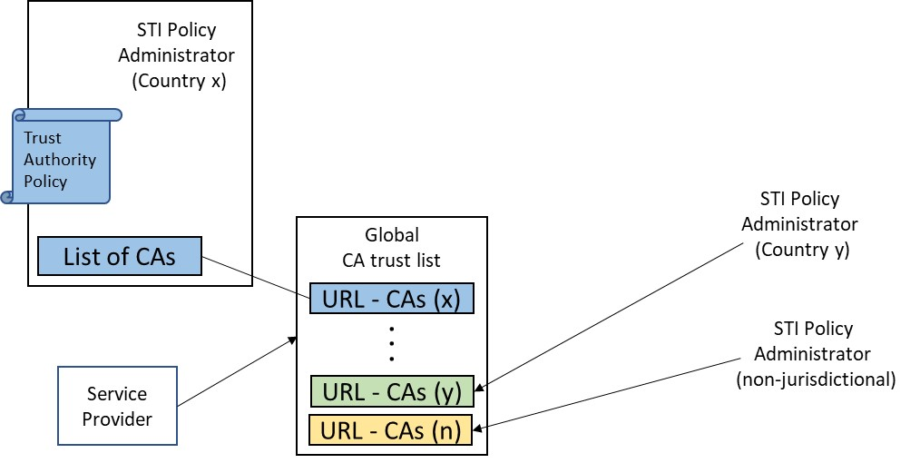
Figure 4-6: Support for Non-Jurisdictional STI-GA/PA

Global Trust List Structure

The Global Trust List shall be encoded as a JSON Web Token (JWT) [Ref xx], with the following Protected Header fields:
- "alg": Identifies the algorithm used to generate the JWT signature. Algorithm "ES256" shall be used.
- "typ": Identifies the object type. Value "jwt" shall be used.
- "x5u": Identifies the URL of the STI-PA certificate whose credentials were used to generate the signature of the Global Trust List JWT. The URL shall have a protocol of “https”. The URL shall either not contain a port or contain a port of “443”. The URL shall not contain a userinfo subcomponent, query component, or fragment identifier component as described in [RFC 3986]. The URL path shall end with “.pem”.
The Global Trust List JWT payload shall contain the following claims:
- “version” (string): Version number of this list format. Global Trust Lists compliant with this specification shall have a version number of “1.0”. Subsequent specifications that change or extend the Global Trust List JWT shall update the version number accordingly.
The next three claims contain a timestamp encoded in NumericDate format as defined in [RFC7519]:
- "exp": Timestamp after which this JWT is no longer valid.
- "iat": Timestamp at which this JWT was generated.
- "nbf": Timestamp before which this JWT shall not be accepted for processing.

- sequence (int): Sequence number is incremented by one each time a new list is provided by the STI-PA. A 64-bit integer is recommended.
- "trustList": A JSON array. The first array entry contains information associated with the local jurisdiction. Each subsequent array entry contains information associated with a trusted cross-border jurisdiction. Each array entry contains the following key/value pairs:
  - "country": an array of strings where each string is an ISO 3166-1 alpha-2 country code [ISO 3166-1, Codes for the Representation of Names of Countries and Their Subdivisions. When the STI-PA associated with a "trustList" array entry serves multiple countries, the "country" array contain multiple entries identifying those countries.
  - "stiPaRootCert": a pem-encoded root certificate of the STI-PA associated with this "trustList" array entry.
  - "caList": a URL reference to the Trusted STI-CA List of the STI-PA associated with this "trustList" array entry.
  - "crl": a URL reference to the CRL of the STI-PA associated with this "trustList" array entry. This URL shall match the URL identified by the CRL Distribution Point extension of certificates issued by STI-CAs in the jurisdiction associated with this "trustList" array entry.
An example HTTP request/response to obtain the Global Trust List from the STI-PA in the local jurisdiction is as follows:
GET /globalTrustList HTTP/1.1
Host: https://example-us.sti-pa.com
Accept: application/jose+json

HTTP/1.1 200 OK
Content-Type: application/jose+json

{"protected": base64url({
"alg": "ES256",
"typ": "JWT",
"x5u": " https://sti-pa.com/global-trust-list/cert.pem"})
"payload": base64url({
"version": 1.0,
"sequence": 1,
"exp": 1300819380,
"iat": 1300819380,
"nbf": 1300819380,
"trustList": [
{
"country": ["us"],
"stiPaRoot": "PEM_UNITED_STATES_STI-PA_ROOT_CERTIFICATE_HERE",
"caList": "https://example-us-sti-pa.com/caList.txt",
"crl": "https://example-us-sti-pa.com/crl.pem"
},
{
"country": ["ca"]
"stiPaRoot": "PEM_CANADA_STI-PA_ROOT_CERTIFICATE_HERE",
"caList": "https://example-ca-sti-pa.com/caList.txt",
"crl": "https://example-ca-sti-pa.com/crl.pem"
},
{
"country": ["IT", "VA"]
"stiPaRoot": "PEM_ITALY_STI-PA_ROOT_CERTIFICATE_HERE",
"caList": "https://example-it-sti-pa.com/caList.txt",
"crl": "https://example-it-sti-pa.com/crl.pem"
}
]

Global Trust List Procedures

STI-PA Procedures
The STI-PA shall host the Global Trust List defined in clause 4.2. The list shall be distributed using HTTPS. The STI-PA shall make the URL reference to the list available to verification services by posting the URL on the STI-PA web site. Access to the list shall not require an account with the STI-PA; i.e., the list shall be publicly accessible. The list shall be signed with the credentials of an STI-PA end-entity certificate that chains to the root certificate of the STI-PA. The "exp" claim shall be populated with a timestamp value that is 24 hours later that the timestamp value of the "iat" claim. The STI-PA shall populate the first array entry of the "trustList" claim with information related to the STI-PA itself. The STI-PA shall populate an additional "trustList" array entry for each trusted cross-border STI-PA.
An STI-PA shall not include its root certificate in the certification path that is provided to verification services dereferencing the "caList" or "crl" URL identified in the STI-PA’s entry in the Global Trust List. Instead, verification services shall use the root certificate contained in the "stiPaRoot" key value during certificate path validation of the STI-PA certificate whose credentials were used to sign the Trusted STI-CA List or CRL.

Verification Service (STI-VS) Procedures
Verification services shall download a new version of the Global Trust List from the local (in-jurisdiction) STI-PA at some short interval before the current list expires as indicated by the "exp" claim (an interval of one hour is recommended). A verification service shall not use the root certificate identified in the "stiPaRoot" key value of the local STI-PA when validating the certification path of the STI-PA certificate referenced by the Global Trust List "x5u" parameter. Instead, the verification service shall obtain the STI-PA root certificate by some trusted out-of-band mechanism (e.g., download the root certificate posted on the local STI-PA’s web site).
If a newly downloaded Global Trust List is valid, and the current time is between the times indicated by the "nbf" claim and the "exp" claim, then the verification service shall download the Trusted STI-CA List referenced by the "caList" key value of each array entry in the "trustList" claim. The verification service shall verify the newly downloaded Trusted STI-CA List of each array entry as specified in ATIS-1000084, with the exception that during certificate path validation it shall use the root certificate contained in the "stiPaRoot" key of the same "trustList" array entry. If the Trusted STI-CA List is valid, then the verification service shall add the root certificates to its local root certificate store. When a newly downloaded Global Trust List indicates that a previously downloaded "trustList" array entry has been removed, the verification service shall ensure that the trusted root certificates associated with that previous array entry are removed from its local root certificate store.
The verification service shall also download the CRL referenced by the "crl" key value of each "trustList" array entry and validate the CRL as specified in ATIS-1000074, with the exception that during certificate path validation it shall use the root certificate contained in the "stiPaRoot" key of the same "trustList" array entry. If the CRL is valid, then the verification service shall include any revoked certificates listed on the CRL when checking for revoked certificates during PASSporT verification.

Available from the Internet Engineering Task Force (IETF) at: < https://www.ietf.org/ >.
Available from the International Organization for Standardization (ISO) at: < https://www.iso.org/ >.
This document is available from the Alliance for Telecommunications Industry Solutions (ATIS) at < www.atis.org >.

