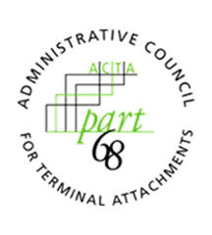
ADMINISTRATIVE COUNCIL FOR TERMINAL ATTACHMENTS (ACTA)
November 17, 2022, 3:00-4:00 PM ET
Meeting Agenda

ACTA Chair: Scott Lambert, Bureau Veritas (scott.lambert@bureauveritas.com)
ACTA Vice-Chair: Vacant

WELCOME & CALL TO ORDER

INTRODUCTIONS

REVIEW OF OPEN ACTION ITEMS

LIAISONS/CORRESPONDENCE

DISCUSSION

STATUS UPDATE ON ACTA ACTIVITY
- RPC Data Validation Discount Period

WORK/ASSIGNMENTS/MEETINGS
2023 Virtual Meetings:
- TBD

ANY OTHER BUSINESS
- Update from TCB Council

ADJOURNMENT

