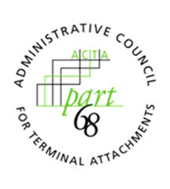
ADMINISTRATIVE COUNCIL FOR TERMINAL ATTACHMENTS (ACTA)
April 14, 2022, 3:00-4:00 PM ET
Meeting Agenda

ACTA Chair: Scott Lambert, Bureau Veritas (scott.lambert@bureauveritas.com)
ACTA Vice-Chair: Vacant

WELCOME & CALL TO ORDER

INTRODUCTIONS

REVIEW OF OPEN ACTION ITEMS

LIAISONS/CORRESPONDENCE
- Security Industry Standards Council (CISC) Liaison

DISCUSSION

STATUS UPDATE ON SUBMISSION GUIDELINES

WORK/ASSIGNMENTS/MEETINGS
2022 Virtual Meetings:
- Dates:
  - November 17, 2022, 3:00-4:00pm ET

ANY OTHER BUSINESS
- Update from TCB Council

ADJOURNMENT

