**ATIS-xxxxxxx**

ATIS Technical Report on

**VoIP Interconnection over the Public Internet**

**using UDP and IPSec**

**Alliance for Telecommunications Industry Solutions**

Approved xxxx xx, 2022

**Abstract**

This document describes an "OTT VoIP Interconnection" profile, where IP connectivity between VoIP Service Providers is established over the public internet using UDP and IPSec.

**Foreword**

The Alliance for Telecommunications Industry Solutions (ATIS) serves the public through improved understanding between carriers, customers, and manufacturers. The Packet Technologies and Systems Committee (PTSC) develops and recommends standards and technical reports related to services, architectures, and signaling, in addition to related subjects under consideration in other North American and international standards bodies. PTSC coordinates and develops standards and technical reports relevant to telecommunications networks in the U.S., reviews and prepares contributions on such matters for submission to U.S. International Telecommunication Union Telecommunication Sector (ITU-T) and U.S. ITU Radiocommunication Sector (ITU-R) Study Groups or other standards organizations, and reviews for acceptability or per contra the positions of other countries in related standards development and takes or recommends appropriate actions.

The SIP Forum is an IP communications industry association that engages in numerous activities that promote and advance SIP-based technology, such as the development of industry recommendations, the SIPit, SIPconnect-IT, and RTCWeb-it interoperability testing events, special workshops, educational seminars, and general promotion of SIP in the industry. The SIP Forum is also the producer of the annual SIP Network Operators Conference (SIPNOC), focused on the technical requirements of the service provider community. One of the Forum's notable technical activities is the development of the SIPconnect Technical Recommendation – a standards-based SIP trunking recommendation for direct IP peering and interoperability between IP Private Branch Exchanges (PBXs) and SIP-based service provider networks. Other important Forum initiatives include work in Video Relay Service (VRS) interoperability, security, Network-to-Network Interoperability (NNI), and SIP and IPv6.

The mandatory requirements are designated by the word *shall* and recommendations by the word *should*. Where both a mandatory requirement and a recommendation are specified for the same criterion, the recommendation represents a goal currently identifiable as having distinct compatibility or performance advantages. The word *may* denotes an optional capability that could augment the standard. The standard is fully functional without the incorporation of this optional capability.

Suggestions for improvement of this document are welcome. They should be sent to the Alliance for Telecommunications Industry Solutions, PTSC, 1200 G Street NW, Suite 500, Washington, DC 20005.

The **ATIS/SIP Forum IP-NNI Task Force** under the **ATIS** **Packet Technologies and Systems Committee (PTSC)** and the **SIP Forum** **Technical Working Group (TWG)** was responsible for the development of this document.

**Table of Contents**

ATIS-xxxxxxx i

ATIS Technical Report on i

VoIP Interconnection over the Public Internet i

Alliance for Telecommunications Industry Solutions i

Abstract i

1 Executive Summary 1

1.1 Scope 1

1.2 Purpose 1

2 References 1

3 Definitions, Acronyms, & Abbreviations 1

3.1 Definitions 1

3.2 Acronyms & Abbreviations 1

4 Overview 2

4.1 Reference Architecture 2

5 OTT VoIP Interconnection Procedures 3

5.1 Preconfigured Information to support OTT VoIP Interconnection 3

5.2 Procedures to Establish/Use the OTT VoIP Interconnection Interface 3

5.2.1 Location Discovery 4

5.2.2 Signaling Transport, Security and Authentication 4

5.2.3 Media and Session Interactions 4

**Table of Figures**

Figure 4.1 – OTT VoIP Interconnection Reference Architecture 2

Figure 5.1 – SIPconnect 2.0 Reference Architecture 3

**Table of Tables**

**No table of figures entries found.**

# Executive Summary

## Scope

This Technical Report describes an interconnect profile for VoIP Service Providers who choose to interconnect over the public internet. It recommends mechanisms for establishing IP connectivity using UDP transport, securing the signaling and media via IPSEC and sRTP respectively, and proposing bilateral agreements with respect to codec selection to address QoS impacts as well as costs for real-time media traversing the unmanaged public internet.

The report does not describe the SIP interworking procedures between interconnected VoIP Service Providers. Furthermore, automation regarding network discovery – including points of interconnection, encryption/authentication and telephone number ranges exchanged is out of scope of this document.

## Purpose

This report is to coexist with ATIS-1000063 as well as expand on options available for carriers to leverage the public internet for VoIP Interconnection described in IPNNI-2021-00059r000. The expansion of options that can be agreed to on a bilateral basis will accelerate adoption of VoIP interconnect as well as support for STIR-SHAKEN protocols to combat Robocalling.

# References

The following standards and documents contain provisions which, through reference in this text, constitute provisions of this Technical Report. At the time of publication, the editions indicated were valid. All standards are subject to revision, and parties to agreements based on this Technical Report are encouraged to investigate the possibility of applying the most recent editions of the standards indicated below.

ATIS-1000063, *Joint ATIS/SIP Forum Technical Report – IP NNI Profile*

ATIS-1000074-E, *Signature-based Handling of Asserted Information using Tokens (SHAKEN).*

# Definitions, Acronyms, & Abbreviations

For a list of common communications terms and definitions, please visit the *ATIS Telecom Glossary*, which is located at < <http://www.atis.org/glossary> >.

## Definitions

**<term>:** <meaning>.

## Acronyms & Abbreviations

|  |  |
| --- | --- |
| ATIS | Alliance for Telecommunications Industry Solutions |

# Overview

VoIP Service Providers (“SPs”) traditionally interconnect through a carrier hotel, where the managed IP networks of the two SPs are connected via private dedicated facilities. The carrier hotel model has good security and quality-of-service characteristics due to the physical security provided by the carrier hotel building and the direct non-shared facilities connecting the managed networks of the two SPs.

This document describes an "OTT VoIP Interconnection" model, where IP connectivity between SPs is established over the public internet. Since calls traverse the public internet in this case, special measures must be taken so that calls are delivered securely and with adequate quality. First, strong authentication mechanisms must be in place to ensure that Interconnected SPs can identify each other. Second, call signaling shall be encrypted and optionally media may be encrypted to protect from eavesdropping or manipulation via man-in-the-middle attacks while traversing the open internet. Finally, media encode/decode across the OTT VoIP Interconnection interface may utilize modern codec technology that incorporates the use of adaptive bit-rate support and forward error correction techniques to tolerate the potential of varying congestion levels encountered on the public internet. In order to avoid the latency inherent with transcoding as well as avoiding significant costs to perform such transcoding that will slow adaptation of VoIP Interconnection, bilateral agreement that transcodes to the SPs preferred codec should be used.

## Reference Architecture

Figure 4.1 shows the reference architecture for the OTT VoIP Interconnection model. SP-1 and SP-2 each deploy a Session Border Controller (SBC) at their interconnect point to support SIP signaling and media on the OTT VoIP Interconnect interface. SIP signaling across the interconnect interface is protected by IPSec with mutual authentication. Media may be protected by streaming within the same IPSec tunnel as signaling or using sRTP if outside the IPSec tunnel, or media may be transmitted without encryption. How media is handled is subject to bilateral communications and mutual agreement between the two SPs.

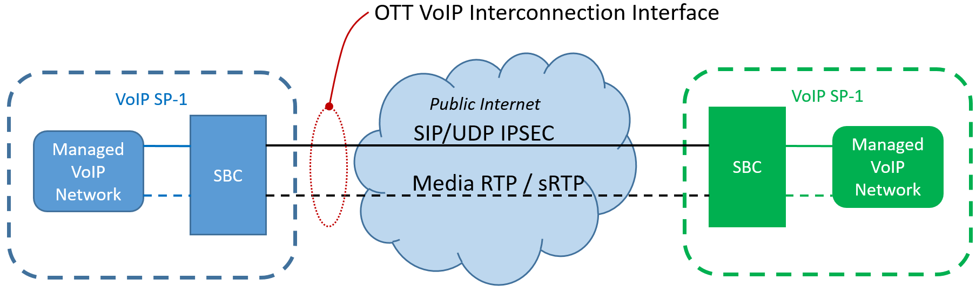

Figure 4.1 – OTT VoIP Interconnection Reference Architecture

# OTT VoIP Interconnection Procedures

## Information to support OTT VoIP Interconnection

Some level of information exchange must occur between two SPs who wish to establish a VoIP interconnection over the public internet. For example, each SP must provide to its interconnection partner the IP addresses of the SBCs that terminate the OTT VoIP interconnect interface to care for geo-redundancy as well as capacity distribution.

Furthermore, the traffic to be exchanged over the interconnection must be agreed upon. Identification of subject traffic should use existing numbering plan and portability correction databases. This information exchange should occur via bi-lateral communications and mutual agreement.

## Procedures to Establish/Use the OTT VoIP Interconnection Interface

### Locating SIP Servers

SPs shall exchange the public IP addresses of their SBCs that terminate the OTT VoIP Interconnection interface. This allows for geo-redundancy as well as capacity planning. VoIP SPs may choose to leverage public DNS to maintain active IPs that have been pre-established for interoperability.

### Signaling Transport, Security and Authentication

ATIS-1000063 section 6.0 Call Features describes general guidelines to be followed for SIP session interactions. Under this profile, a VoIP SP must support the SIP signaling transport, security and authentication using IPSec over UDP.

#### Minimum IPSEC Algorithms

The following table lists the minimum level of security for IPSEC that should be used for OTT VoIP Interconnection. Other algorithms may be implemented per bilateral agreement.



### Media Transport, Security and Audio Profile

ATIS-1000063 section 5**.**0General Procedures describes guidelines to be followed with regard to media and session interactions.

#### Media Transport

Under this profile, RTP or sRTP over UDP must be used for media transport. If supported by both SPs, RTP through the IPSec tunnel also used by signaling may be used.

#### Audio Profile

ATIS-1000063 section 5.5.1 shall be adhered to by the SPs. Codecs that are widely used in IP based voice networks shall be supported as described in the table below. Codecs in the Group 1 column MUST be supported for both transmission and reception across the NNI. Codecs in the Group 2 columns SHOULD be supported for both transmission and reception across the NNI. To tolerate the potential of varying congestion levels encountered on the public internet, SP may utilize modern codec technology that incorporates the use of adaptive bit-rate support and forward error correction techniques.

|  |  |
| --- | --- |
| **Group 1: Mandatory Codecs** | **Group 2: Optional** |
| G.711 μ-law 64 kbit/s | G.711 a-law 64 kbit/s |
|  | G.726, G.729, G.729a, G.729b, G.729ab 8kbit/s |
|  | Adaptive MultiRate (AMR) |
|  | G.722 (Wideband) |
|  | G.722.2 (AMR-Wideband) |

If incompatibility of codecs supported by the devices on each side exist, each party should transcode to the codec the destination requires. This improves voice quality by ensuring transcoding only occurs once (if needed), and places the transcoding requirement on the originating provider as the cost creator.

#### Media Security

sRTP may be implemented, and if so the following algorithms should be supported, with highest possible encryption supported by both sides preferred.

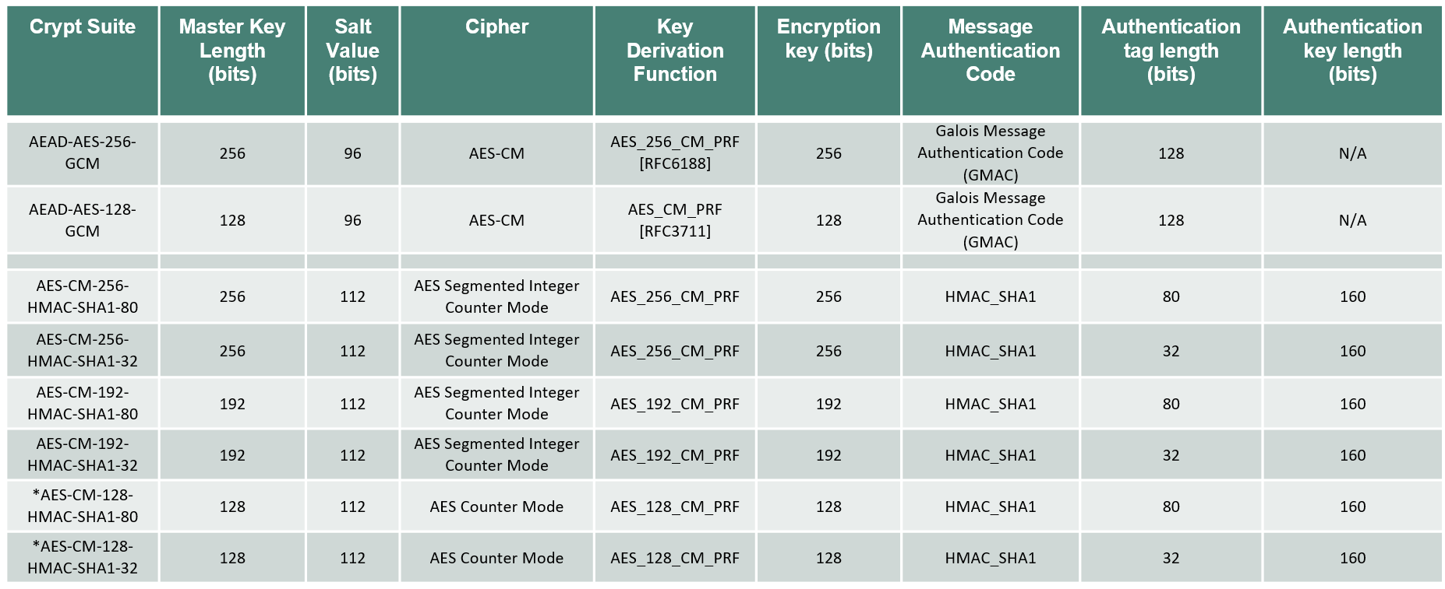

#### Transport of DTMF Tones

A VoIP SP should support the [RFC 4733] media transport of DTMF tones, however inband DTMF can be supported on bilateral basis via uncompressed codecs.

#### Fax Calls

A VoIP SP shall support the T.38 FAX transmission with G.711 fax fallback supported on bilateral basis.