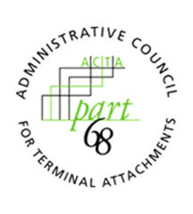
ADMINISTRATIVE COUNCIL FOR TERMINAL ATTACHMENTS (ACTA)
January 20, 2022, 3:00-4:00 PM ET
Meeting Agenda

ACTA Chair: Scott Lambert, Bureau Veritas (scott.lambert@bureauveritas.com)
ACTA Vice-Chair: Vacant

WELCOME & CALL TO ORDER

INTRODUCTIONS

REVIEW OF OPEN ACTION ITEMS
- Anna Karditzas (ATIS) will provide a redline copy of updates to the ACTA Submission Guidelines as a result of the new ACTA website and database. This is due by January 20, 2022.

DISCUSSION

EDITS TO SUBMISSION GUIDELINES

WORK/ASSIGNMENTS/MEETINGS
2022 Virtual Meetings:
- Dates:
  - April 14, 2022, 3:00-4:00pm ET
  - November 17, 2022, 3:00-4:00pm ET

ANY OTHER BUSINESS
- Update from TCB Council

ADJOURNMENT

