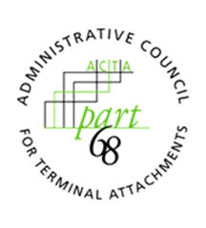
ADMINISTRATIVE COUNCIL FOR TERMINAL ATTACHMENTS (ACTA)
April 15, 2021, 3:00-4:00 PM ET
Meeting Agenda

ACTA Chair: Scott Lambert, Curtis-Straus, LLC (scott.lambert@bureauveritas.com)

WELCOME & CALL TO ORDER

INTRODUCTIONS

REVIEW OF OPEN ACTION ITEMS
- The ACTA will review the FAQ page on the Part68 website to ensure it is up to date. The ACTA will also add clarification regarding ACS definitions to the Part68 website.

DISCUSSION

PREVIEW OF NEW PART68 DATABASE/WEBSITE
- FAQs Page
- Website Location for Interconnected/Non-Interconnected VoIP - Definitions Presentation (ACTA-2021-00002R000.pptx)
- Updates to Submission Guidelines
- Updates to ACTA Presentations
  - Update - ACTA and Part 68 - Past, Present, and Future
  - Sunset - Update of Current Activities Relating to Part 68 Compliance by the Administrative Council for Terminal Attachments (ACTA)
  - ACTA Overview?

ATIS WORKSPACE FUNCTIONALITY

WORK/ASSIGNMENTS/MEETINGS
2021 GC Meetings:
- November 18, 2021, 3:00-4:00pm ET

ANY OTHER BUSINESS

ADJOURNMENT

