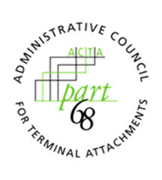
ADMINISTRATIVE COUNCIL FOR TERMINAL ATTACHMENTS (ACTA)
April 15, 2021, 3:00-4:00 PM ET
Meeting Agenda

ACTA Chair: Scott Lambert, Curtis-Straus, LLC (scott.lambert@bureauveritas.com)

WELCOME & CALL TO ORDER

INTRODUCTIONS

REVIEW OF OPEN ACTION ITEMS
- The ACTA will review the FAQ page on the Part68 website to ensure it is up to date. The ACTA will also add clarification regarding ACS definitions to the Part68 website.

DISCUSSION

REVIEW OF FAQS ON PART68 WEBSITE
- Clarification regarding ACS definitions

UPDATE ON NEW PART68 DATABASE/WEBSITE

FUTURE WORK/ASSIGNMENTS/MEETINGS
2021 GC Meetings:
- November 18, 2021, 3:00-4:00pm ET

ANY OTHER BUSINESS

ADJOURNMENT

