ATIS-0x0000x

ATIS Standard on

ATIS Standard on Toll-Free Numbers in the SHAKEN Framework

Alliance for Telecommunications Industry Solutions

Approved Month DD, YYYY

Abstract
This document is intended to cover calls using Toll-Free Numbers (TFNs) within the SHAKEN Framework. This addresses both calls where the calling party number displayed in the Caller ID is a TFN. This document considers some scenarios involving the calling party’s use of the TFN in order to enable them to attain full attestation for the TFN.
Foreword
The Alliance for Telecommunications Industry Solutions (ATIS) serves the public through improved understanding between carriers, customers, and manufacturers. The Packet Technologies and Systems Committee (PTSC) develops and recommends standards and technical reports related to services, architectures, and signaling, in addition to related subjects under consideration in other North American and international standards bodies. PTSC coordinates and develops standards and technical reports relevant to telecommunications networks in the U.S., reviews and prepares contributions on such matters for submission to U.S. International Telecommunication Union Telecommunication Sector (ITU-T) and U.S. ITU Radiocommunication Sector (ITU-R) Study Groups or other standards organizations, and reviews for acceptability or per contra the positions of other countries in related standards development and takes or recommends appropriate actions.
The SIP Forum is an IP communications industry association that engages in numerous activities that promote and advance SIP-based technology, such as the development of industry recommendations, the SIPit, SIPconnect-IT, and RTCWeb-it interoperability testing events, special workshops, educational seminars, and general promotion of SIP in the industry. The SIP Forum is also the producer of the annual SIP Network Operators Conference (SIPNOC), focused on the technical requirements of the service provider community. One of the Forum's notable technical activities is the development of the SIPconnect Technical Recommendation – a standards-based SIP trunking recommendation for direct IP peering and interoperability between IP Private Branch Exchanges (PBXs) and SIP-based service provider networks. Other important Forum initiatives include work in Video Relay Service (VRS) interoperability, security, Network-to-Network Interoperability (NNI), and SIP and IPv6. Suggestions for improvement of this document are welcome. They should be sent to the Alliance for Telecommunications Industry Solutions, PTSC, 1200 G Street NW, Suite 500, Washington, DC 20005, and/or to the SIP Forum, 733 Turnpike Street, Suite 192, North Andover, MA, 01845.
The mandatory requirements are designated by the word shall and recommendations by the word should. Where both a mandatory requirement and a recommendation are specified for the same criterion, the recommendation represents a goal currently identifiable as having distinct compatibility or performance advantages. The word may denotes an optional capability that could augment the standard. The standard is fully functional without the incorporation of this optional capability.
The ATIS/SIP Forum IP-NNI Task Force under the ATIS Packet Technologies and Systems Committee (PTSC) and the SIP Forum Technical Working Group (TWG) was responsible for the development of this document.

Table of Contents (Editor’s Note – Anna update)
1 Scope, Purpose, & Application 5
1.1 Scope 5
1.2 Purpose 5
2 References 5
3 Definitions, Acronyms, & Abbreviations 6
3.1 Definitions 6
3.2 Acronyms & Abbreviations 8
4 Principles 9
5 Overview 10
5.1 Problem Statement 10
5.2 Objective 10
5.3 Toll-Free Overview 11
5.3.1 Toll-Free Number Assignment 11
5.3.2 Toll-Free Call Origination 12
6 Scenarios 12
6.1 Toll-Free in SHAKEN 12
6.2 Delegate Certificate Management for Toll-Free Number 13
6.2.1 Issuing Delegate Certificate for Toll-Free Number 13
6.2.2 Utilizing Delegate Certificate to sign Originating Toll-Free Number 13
6.3 Toll-Free Call Flows 15
6.3.1 Toll-Free Translation Prior to Authentication Server Request 15
6.3.2 Toll-Free Translation After Authentication Request 16
6.4 Toll-Free Use Case – Toll-Free Originations (On Premise PBX, Hosted/Cloud Platform) in SHAKEN 17
7 The Right to Use the Toll-Free Number 17
8 Summary 18

Table of Figures (Editor’s Note – Anna update)
Figure 6.1 – Toll-Free Number Assignment Process 12
Figure 6.2 – Toll-Free Number Enterprise Originated Call 13
Figure 7.1 – RespOrg issues Delegate Certificate for Toll-Free Number 14
Figure 7.2 – STI Authentication/Verification during call setup 15
Figure 7.3 – SHAKEN Architecture with Toll-Free DIP (pre-Authentication Server) 16
Figure 7.4 – Toll-Free Translation Prior to Authentication Server Request 17
Figure 7.5 – SHAKEN Architecture with Toll-Free DIP (post-Authentication Server) 17
Figure 7.6 – Toll-Free Translation After Authentication Server Request 18
Figure 7.7 – Toll-Free Origination Use Case: Leveraging 3rd Party RespOrg and Different OSPs 19

Scope & Purpose

Scope
This document is limited to scenarios that use the currently defined STIR/SHAKEN framework to process calls where the calling party number is a TFN.

Purpose
The SHAKEN protocol specification [Ref 3] describes an authentication mechanism that can be invoked by the originating service provider (OSP) to "attest" to the legitimacy of the calling party telephone number associated with a call.
In this framework, the OSP’s Secure Telephone Identity Authentication Service (STI-AS) creates a Personal Assertion Token (PASSporT) and inserts this PASSporT in the SIP Identity header per ATIS-1000074 [Ref 3] and RFC 8224 [Ref 9]. The SIP INVITE is then routed over the network-to-network interface (NNI) through the standard inter-domain routing configuration.

References
The following standards contain provisions which, through reference in this text, constitute provisions of this document. At the time of publication, the editions indicated were valid. All standards are subject to revision, and parties to agreements based on this Standard are encouraged to investigate the possibility of applying the most recent editions of the standards indicated below.

Normative References
[Ref 1] ATIS-0300251, Codes for Identification of Service Providers for Information Exchange.
[Ref 2] ATIS-0417001-003, Industry Guidelines For Toll-Free Number Administration.¹
[Ref 3] ATIS-1000074, ATIS Standard on Signature-based Handling of Asserted Information using Tokens (SHAKEN).¹
[Ref 4] ATIS-1000080, SHAKEN: Governance Model and Certificate Management.¹
[Ref 5] ATIS-1000089, Study of Full Attestation Alternatives for Enterprises and Business Entities with Multi-Homing and Other Arrangements.¹
[Ref 6] ATIS-1000092, Signature-based Handling of Asserted information using toKENS (SHAKEN): Delegate Certificates.¹

[Ref 7] IETF RFC 3261, SIP: Session Initiation Protocol.²

[Ref 8] IETF RFC 4949, Internet Security Glossary, Version 2.²

[Ref 9] IETF RFC 8224, Authenticated Identity Management in the Session Initiation Protocol.²

Informative References

[Ref 101] ATIS-1000085, SHAKEN Support of “div” PASSporT. ¹

Definitions, Acronyms, & Abbreviations
For a list of common communications terms and definitions, please visit the ATIS Telecom Glossary, which is located at < http://www.atis.org/glossary >.

Definitions
Authoritative Directory: A data store of TNs and their verified association to the TN customer, which is populated by authorized parties.

Caller ID: The originating or calling party’s telephone number used to identify the caller carried either in the P-Asserted-Identity or From header fields in the Session Initiation Protocol (SIP) [Ref 7] messages.
(Digital) Certificate: Binds a public key to a Subject (e.g., the end-entity). A certificate document in the form of a digital data object (a data object used by a computer) to which is appended a computed digital signature value that depends on the data object [Ref 9]. See also STI Certificate.
Certification Authority (CA): An entity that issues digital certificates (especially X.509 certificates) and vouches for the binding between the data items in a certificate [Ref 9].

Company Code: A unique four-character alphanumeric code (NXXX) assigned to all Service Providers [Ref 1].
Customer: Typically, a service provider’s subscriber, which may or not be the ultimate end-user of the telecommunications service. In the context of the SHAKEN attestation model, the Customer is the entity with a direct business relationship and a direct user-to-network interface with the OSP. Enterprises, hosted/cloud service providers, OTT providers and other service resellers may be considered customers of an OSP depending on the use case.
End-Entity: An entity that participates in the Public Key Infrastructure (PKI). Usually a Server, Service, Router, or a Person. In the context of this document, an end-entity is a Service Provider, TN Service Provider, or VoIP Entity.

Originating Service Provider (OSP): The service provider that handles the outgoing calls from a customer at the point from which they are entering the public network. The OSP performs the SHAKEN Authentication function. OSP may also serve in the role as TNSP, RespOrg, TN reseller and other roles.
Private Key: In asymmetric cryptography, the private key is kept secret by the end-entity. The private key can be used for both encryption and decryption [Ref 9].

Public Key: The publicly disclosable component of a pair of cryptographic keys used for asymmetric cryptography [Ref 9].
Public Key Infrastructure (PKI): The set of hardware, software, personnel, policy, and procedures used by a CA to issue and manage certificates [Ref 9].

Responsible Organization (RespOrg): Entity designated as the agent for the Toll-Free subscriber to obtain, manage and administer Toll-Free Numbers and provide routing reference information in the Toll-Free Number Registry. RespOrgs are the only parties who assign, manage and administer Toll-Free numbers in the Toll-Free Number Registry.
RespOrg Identification (RespOrg ID): A 5-character code that designates or points to the Responsible Organization (RespOrg) associated with a specific Toll-Free number [Ref 2].

Root CA: A CA that is directly trusted by an end-entity. See also Trust Anchor CA and Trusted CA [Ref 9].
Secure Telephone Identity (STI) Certificate: A public key certificate used by a service provider to sign and verify the PASSporT.
Secure Telephone Identity Subordinate CA (STI-SCA): An SCA that gets its certificate directly from an STI-CA
Service Provider Code: In the context of this document, this term refers to any unique identifier that is allocated by a Regulatory and/or administrative entity to a service provider. In the US and Canada this would be a Company Code as defined in [Ref 1], or a RespOrg ID assigned to a RespOrg as defined in [Ref 2].
Signature: Created by signing the message using the private key. It ensures the identity of the sender and the integrity of the data [Ref 9].

Subordinate CA (SCA): A CA whose public-key certificate is issued by another (superior) CA.
Telephone Number Assignee (TN Assignee): Entity (e.g., enterprise, service provider, VoIP Provider, Over the Top Provider, hosted/cloud communications provider, etc.) that has been given the authority to use TNs by virtue of having been directly assigned these TNs by an authorized Telephone Number Service Provider. In the context of Toll-Free numbering resources, a TN Assignee is an entity that has been assigned the use of the TN by a RespOrg.
Telephone Number Service Provider (TNSP): An entity that is authoritative over a set of telephone numbers, and that can delegate a subset of those telephone numbers to another entity to attest for signing. In the context of this document a TNSP is a SHAKEN entity that is authorized by the STI-PA to obtain STI certificates from an STI-CA. Ultimately the entities entitled to obtain STI Certificates will be defined by the STI-GA.
Terminating Service Provider (TSP): The SP whose network terminates the call (i.e., serving the called party). The TSP performs the SHAKEN Verification function.
Toll-Free Application Server (TFAS): The real-time database systems (e.g. Service Control Point, routing engine, etc.) that contain routing instructions downloaded via the Toll-Free Number Registry.
Toll-Free Number Administrator (TFNA): An entity that is authoritative over the assigning, reserving and releasing of TFNs for public use.
Toll-Free Number Registry (TFNR): The main administrative support system of Toll-Free service. It is used to create and update subscriber Toll-Free records that are then downloaded to Service Control Points (SCPs) for handling subscriber’s Toll-Free calls. The system is also used by RespOrgs to reserve and assign TFNs.
Toll-Free Routing Database (TFR-DB): See also Toll-Free Number Registry.

VoIP Entity: A non-STI-authorized customer entity that purchases (or otherwise obtains) delegated telephone numbers from a TNSP.
VoIP Entity Authentication Service (VE-AS): The authentication service used by a VoIP Entity to create PASSporTs.

Acronyms & Abbreviations
ATIS | Alliance for Telecommunications Industry Solutions
BGCF | Breakout Gateway Control Function
CSCF | Call Session Control Function
CVT | Call Validation Treatment
HTTPS | Hypertext Transfer Protocol Secure
IBCF | Interconnection Border Control Function
IETF | Internet Engineering Task Force
IP | Internet Protocol
NNI | Network-to-Network Interface
OSP | Originating Service Provider
PASSporT | Personal Assertion Token
PBX | Private Branch Exchange
PKI | Public Key Infrastructure
SHAKEN | Signature-based Handling of Asserted information using toKENs
SIP | Session Initiation Protocol
SKS | Secure Key Store
SP | Service Provider
STI | Secure Telephone Identity
STI-AS | Secure Telephone Identity Authentication Service
STI-CA | Secure Telephone Identity Certification Authority
STI-CR | Secure Telephone Identity Certificate Repository
STI-VS | Secure Telephone Identity Verification Service
STIR | Secure Telephone Identity Revisited
TFAS | Toll-Free Application Server
TFN | Toll-Free Number
TFNA | Toll-Free Number Administrator
TFNR | Toll-Free Number Registry
TFR-DB | Toll-Free Routing Database
TN | Telephone Number
TNSP | TN Service Provider
TSP | Terminating Service Provider
UA | User Agent
URI | Uniform Resource Identifier
UUID | Universally Unique Identifier
VE-AS | VoIP Entity Authentication Service
VoIP | Voice over Internet Protocol

Overview

The Right to Use the Toll-Free Number
To enable an OSP to determine the appropriate attestation level when a TFN is used in the Caller ID, the OSP may need to determine the calling entity’s right to use the TFN. One possible way to demonstrate a calling entity’s right to use a TFN as the Caller ID is to show that the TFN is one that is in use and assigned to that entity. The TFNA manages the authoritative source for TFN information, the TFNR [Ref 2]. If requested, the TFNA will review and confirm via the authoritative source for TFN information to determine the RespOrg in the TFNR. The RespOrg can determine that the party has the right to use that TFN and provide this information to the OSP in advance of the call.

Problem Statement
STIR/SHAKEN describes a framework for originating service providers to create a SHAKEN PASSporT that can be carried by the SIP signaling protocol to cryptographically attest the identity of callers. (ATIS-100074 [Ref 3] and ATIS-1000085 [Ref 101]).
Businesses rely on calls using TFNs as the calling party number and it is important to have their calls processed appropriately through the SHAKEN framework.
Users originating calls with TFNs in the Caller ID may only be able to get “B” level attestation because the OSP may not have a direct relationship with the use of the TFN. Providing the confirmation of the right to use the TFN can enable the user to get the best level of attestation.

Toll-Free Overview
The Toll-Free Number Registry (TFNR) is the database for the management and administration of Toll-Free Numbers (TFNs) in the North American Numbering Plan (NANP), and the authoritative directory for TFNs. The TFN database is accessed by Toll-Free Service Providers (also known as Responsible Organizations [RespOrgs]) for reserving and managing TFNs (see ATIS-0417001-003 [Ref 2]). The RespOrg has been designated by the FCC as the agent for the subscriber to obtain, manage and administer TFNs and provide routing reference information in the TFNR. Reservation, assignment, or activation of TFNs may only be made by a RespOrg based upon negotiations with a specific prospective Customer. TFNs are assigned by RespOrgs to their Customers from a common pool of available numbers.

Toll-Free Number Assignment
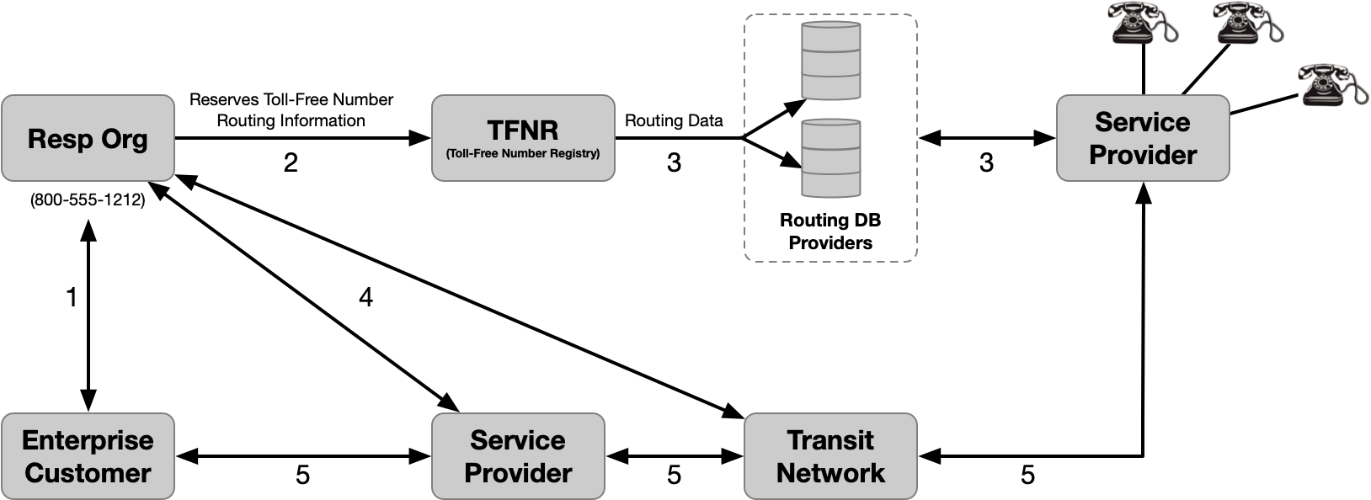
Figure 4.1 – Toll-Free Number Assignment Process

- Customer selects a RespOrg and requests a TFN.
- RespOrg reserves a TFN from the pool of available numbers within the TFNR. The TFN is marked as assigned to the RespOrg. The RespOrg also provisions the routing information.
- Routing data is delivered to Routing Database Providers and used by SPs to route calls.
- RespOrg works with the Transit Networks and SPs to establish the infrastructure to support the Toll-Free service.
- Enterprise is able to make calls using the TFN, as well as receive calls using the TFN as a call back number.

Scenarios

Principles
Where the originating entity utilizes the network connectivity of the OSP who is also the RespOrg or the reseller who assigned the TFN used as the Caller ID, the OSP is able to authenticate their customer's use of the TFN following the ATIS-1000074 [Ref 3] SHAKEN Principles.

The following core principles, as listed in items 1-4, are published in ATIS-1000089 [Ref 5] should be adhered to in order to attain full attestation in the event there is no naturally verified association available to the OSP regarding the customer and the use of a TN as the Caller ID (items 5-7 relate to this document):
- OSPs adhere to SHAKEN criteria for attestations “A”, “B” and “C”.
- Any enhancements required to SHAKEN PASSporT fields and certificates align with ATIS/SIP Forum IP-NNI Task Force standards and/or best practices.
- ATIS-1000074 [Ref 3] states that ultimately it is up to service provider local policy to decide which mechanisms are sufficient for an OSP to attest fully to a “legitimate right to assert a telephone number” for a given call.
- OSPs send a SHAKEN PASSporT, signed with their own credentials, attesting to the validity of the TN independent of other information such as an enterprise signed Identity header added to the call.
- Regardless of which enterprise mechanism is utilized, the OSPs should be able to audit the mechanism(s) used to establish authorization for a customer to use specific TFNs as the customer Caller ID.
- TNSPs and RespOrgs are authorized issuers of TFNs to business entities and can vouch for a customer’s right to use a given TFN as their Caller ID.
- The association between a Customer and a TFN may be determined by means other than direct assignment from the OSP.

The OSPs’ reputation and continued membership in the SHAKEN ecosystem may be directly dependent on how rigorously they have applied the above principles within their local policies regarding Caller ID attestation.

Toll-Free Number Origination in SHAKEN
RespOrgs performs an equivalent function as a TNSP in the SHAKEN framework for TFNs.
A RespOrg may be a Service Provider as that term is used in ATIS-1000074 [Ref 3] and ATIS-1000080 [Ref 4] or it may be a non-Service Provider entity that has the authority to obtain and assign TFNs to customers. A RespOrg is identified with a RespOrg ID assigned by the Toll-Free Number Administrator (TFNA).
There are various ways in which the attestation level of a TFN as the calling party number can be determined. Two methods are summarized in this document. Other implementations are possible.
- By using Delegate Certificates as specified in [Ref 6]. Refer to Clause 5.3.
- The OSP determines an appropriate attestation level, based on information it has on the caller’s right to use the signaled, Toll-Free calling number. The OSP may have direct knowledge of the relationship of the caller to the Toll-Free calling number (e.g., the OSP is the TNSP/RespOrg) or the OSP may obtain this relationship via a trusted 3rd party. Refer to Clause 4.1.

Delegate Certificate Management for Toll-Free Number

Issuing Delegate Certificate for Toll-Free Number
Figure 5.1 shows a high-level overview of the process for issuing delegate end-entity certificates to a VoIP Entity for a TFN. This does not assume that all SPs will use Delegated Certificates. Per ATIS-1000092 [Ref 6], a SHAKEN authorized SP that is or is not a RespOrg may issue Delegate Certificates that include TFNs to its customer, provided that the issuing SP complies with the ATIS-1000092 [Ref 6] or a TN Registry process.

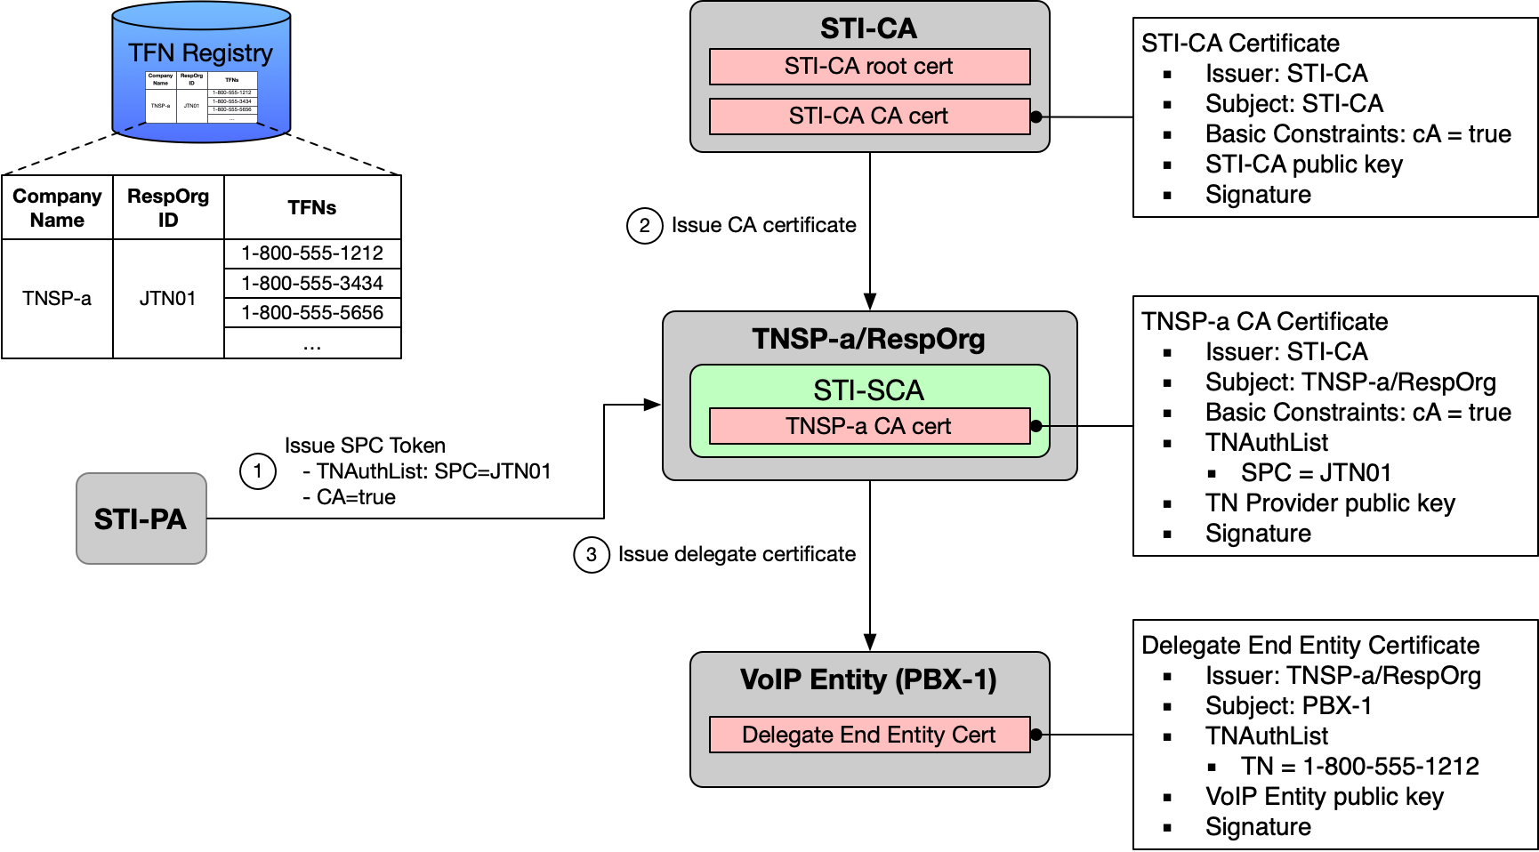
Figure 5.1 – RespOrg issues Delegate Certificate for Toll-Free Number

The procedure in Figure 5.1 is performed when TNSP-a as RespOrg (with RespOrg ID JTN01) issues a delegate end entity certificate for TFN 1-800-555-1212 to Enterprise PBX-1, as follows:

- STI-SCA (TNSP-a/RespOrg) obtains SPC Token (SPC-JTN01) from STI-PA.
- STI-SCA uses the SPC Token to obtain CA certificate from STI-CA.
- STI-SCA issues delegate end-entity certificate to PBX-1 (TN = 1-800-555-1212).

Utilizing Delegate Certificate to sign Originating Toll-Free Number
Figure 5.2 shows a high-level overview of a successful signing/verification of an originating TFN with credentials tied to a Delegate Certificate.

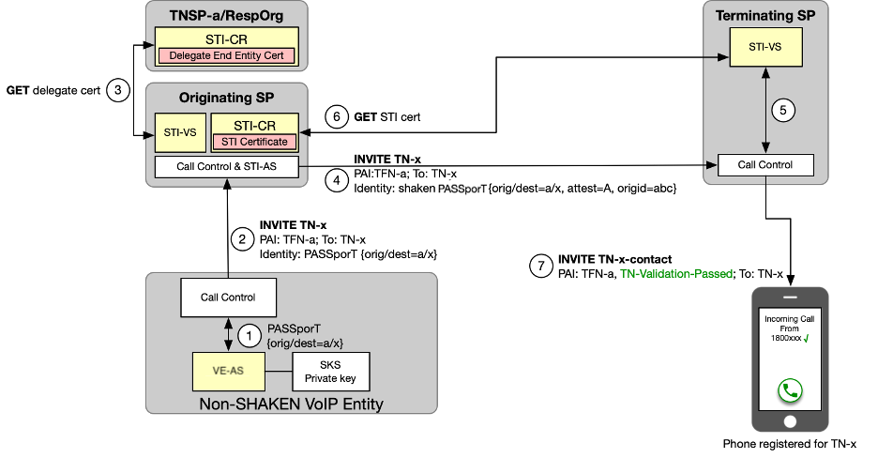
Figure 5.2 –Authentication/Verification during call setup

Figure 5.2 assumes that the TNSP has assigned a delegate certificate to the VoIP Entity as described in Clause 5.3.1. The call establishment procedure in Figure 5.2 is initiated when the VoIP Entity user initiates a call to called TN-x, and the VoIP Entity is configured to deliver a Toll-Free calling number (TFN-a in this example).
- The VoIP Entity Call Control function invokes the VoIP Entity-Authentication Service (VE-AS) to perform authentication for calling TFN-a, as specified in ATIS-1000092 [Ref 6]. The VE-AS constructs a PASSporT containing an "orig" claim of TFN-a and a "dest" claim of TN-x, and signs the PASSporT using the private key associated with the delegate certificate.
- The VoIP Entity Call Control includes an Identity header containing the newly created PASSporT in the originating INVITE request sent to the originating SP.
- The STI-VS fetches the referenced delegate certificate from the TNSP STI-CR and uses the certificate credentials to verify the PASSporT.
- The originating SP verifies that the PASSporT contained in the received INVITE request is valid. It then performs SHAKEN authentication, asserting an attestation level of "A" (based on the successful verification of a PASSporT received from the VoIP Entity). The originating SP includes an Identity header in the INVITE request to the TSP containing the newly created "shaken" PASSporT.
- On receiving the terminating INVITE request, the Terminating SP invokes the STI-VS to verify the received SHAKEN Identity header as specified in ATIS-1000074 [Ref 3].

- STI-VS fetches the referenced STI certificate from the OSP STI-CR and uses the certificate credentials to verify the "shaken" PASSporT.
- The TSP sets the INVITE Verstat parameter based on the verification results (in this case verification passed), and sends the INVITE to the phone registered for TN-x.

While the example figure and associated steps above reference using the base PASSporT, there are other PASSporTs that can also be used.

Annex A: Process of becoming a RespOrg (Informative)
To become a RespOrg, the Toll-Free Service Provider must complete the following process:
- Online application (including deposit): Any person, company, or organization that can demonstrate the required skills and financial responsibility for managing TFN can apply to become a Toll-Free Service Provider (RespOrg) in the TFNR.
- Training: Attend a TFNR class or self-train with materials about Toll-Free.
- Successful completion of an exam on Toll-Free Industry practices: The exam includes knowledge of customer records, number administration, and service provisioning. After the exam is passed, the applicant will be certified as a Toll-Free Service Provider (RespOrg). A RespOrg ID will be assigned.
- Each RespOrg is identified by a 5-character code (RespOrg ID) provided by the TFNA. Every TFN that resides in the TFNR must have an associated RespOrg ID. The TFNR Help Desk maintains and publishes the contact information associated with each operational RespOrg ID.

Available from the Alliance for Telecommunications Industry Solutions (ATIS) AT: < www.atis.org/ >. 2 Available from the Internet Engineering Task Force (IETF) AT: < https://www.ietf.org/ >.

