ATIS/SIP Forum NNI Task Force
March 31, 2014

Contribution
TITLE: The Current Routing Solution Description Using Public Routing Data
SOURCE*: Verizon, Mark Desterdick

_______________________________
ABSTRACT
This document illustrates some of the mechanisms currently in use and/or being deployed to facilitate the exchange of traffic associated with IP-based multimedia services (e.g., VoIP) between North American service providers. It provides a proposed solution for the ATIS/SIP Forum NNI Task Force to evaluate in the process of coming to a recommendation for an industry consensus approach that can be used immediately without any modifications to industry databases for all North American service providers.

NOTICE

This is a draft document and thus, is dynamic in nature. It does not reflect a consensus of the ATIS-SIP Forum IP-NNI Task Force and it may be changed or modified. Neither ATIS nor the SIP Forum makes any representation or warranty, express or implied, with respect to the sufficiency, accuracy or utility of the information or opinion contained or reflected in the material utilized. ATIS and the SIP Forum further expressly advise that any use of or reliance upon the material in question is at your risk and neither ATIS nor the SIP Forum shall be liable for any damage or injury, of whatever nature, incurred by any person arising out of any utilization of the material. It is possible that this material will at some future date be included in a copyrighted work by ATIS or the SIP Forum.

* CONTACT: Mark Desterdick; email: desterdick@verizon.com; Tel: +1212-681-5626

Introduction
This solution is in use today and is based on existing processes for the sharing of Public Routing Data provisioned in the NPAC and LERG. This solution has several strengths in that it is implementable now with relatively low cost, is flexible and has high availability in that all data required for real time call processing resides within the service provider network. This current solution can work in a hybrid TDM / IP environment, an all IP network, and co-exist with a global solution beyond North America.
The Local Exchange Routing Guide (LERG) produces output files used by SPs to identify the TDM switch serving the called party. In the LERG, each NPA-NXX is associated with a unique switch CLLI and during call processing the originating SP switch uses the NPA-NXX of the called party’s TN to determine the trunk group used to transport the call to that TDM switch.
With the introduction of Local Number Portability, for numbers shown in the NPAC the NPA-NXX of the called party’s TN is no longer valid since the number has been ported to another TDM switch. In this case, the NPA-NXX of the LRN shown in the NPAC must be used with LERG data to identify the destination TDM switch. During call processing, if the called party’s TN is associated with an LRN, then the LRN is used to identify the terminating TDM switch. If there is no LRN associated with the called party’s TN, the NPA-NXX of the called party’s TN is used to identify the terminating TDM switch.
Given at this time VoIP providers cannot be directly assigned numbering resources, many rely upon their CLEC partners to obtain TNs on their behalf in LATAs across the country. Given all TNs must be accessible by the TDM PSTN, these CLEC partners receive TDM calls destine to/from the VoIP provider’s customers, and as part of their CLEC service to the VoIP provider, also perform the TDM to IP conversion for these calls. In some instances, a CLEC will create “secondary LRNs” by utilizing the last four digits of their switch’s LRN to uniquely identify TNs served by the VoIP SP. These “secondary LRNs” are published by the CLEC in the NPAC so that they are sent during call processing to the terminating TDM CLEC switch, this way the CLEC knows which calls to route to the VoIP partner’s IP Switch. In some cases, CLECs create unique secondary LRNs for each of their VoIP provider partners so that calls may be routed by the CLEC to the correct VoIP provider.
Given the improved capabilities and quality achieved by keeping IP-to-IP calls IP all the way, SPs are entering into voluntary commercial agreements to interconnect via IP. These IP interconnection points are mostly located at “carrier hotels” in major cities. Therefore, the NPA-NXX (or LRN) is used to determine the destination ingress SBC(s) hosted in the carrier hotel(s) identified in the interconnection agreement, and not the TDM switch shown in the Local Exchange Routing Guide. So, during call processing, an SP goes through the ordinary steps to determine if the called party’s NPA-NNX or LRN should be used for call delivery, but takes an additional step to determine if the NPA-NXX or LRN is covered by an interconnection agreement and should be routed over an existing IP interconnection. If it is determined in this last step that no interconnection agreement covers such NPA-NXX or LRN, then the call is routed over the TDM network.
In summary, call processing still utilizes the NPA-NXX or LRN to identify the destination, but a second step is taken during call processing to determine if an interconnection agreement covering the NPA-NXX or LRN is in place, allowing the call to be routed over an IP interconnect.

Call Flow
The following is the inter-service provider call flow as shown in Figure Current-1:
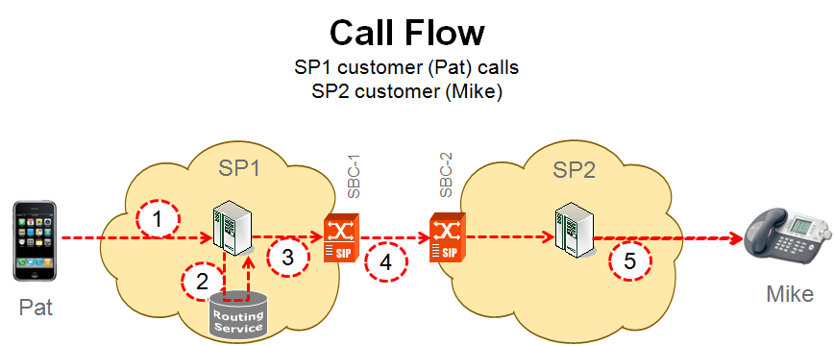
Figure Current-1
- Pat (subscriber of SP1) makes a session request (e.g., places a call) to Mike (subscriber of SP2).
- SP1’s network queries its routing service in real time using the called number to determine if Mike is part of a group (in this example, LRN) subject to a voluntary commercial IP interconnection. (Note, groupings may be based also on NPA-NXX, OCN and switch CLLI, but implementation is service provider specific and subject to commercial agreement). If not, the call is routed over the PSTN.
If it is, in this example the SP1 routing service returns a URI containing an SRV used to do a private DNS lookup-up to obtain the IP address of the SP1 egress SBC. (Note, the routing service may return an A record for use in a DNS look up, or an IP address (instead of an SRV used in this example) but implementation is service provider specific.
- Depending upon the service provider specific implementation, the application server sends the SRV, A record or IP Address to the egress SBC. In this example SBC-1 was selected out of a cluster of available SBCs into SP2’s network.
- SBC-1 indexes into its routing table, depending upon the service provider specific implementation (using the SRV, A record or IP Address) to determine the IP address of the ingress SBC of SP2. In this case that query returns the IP address of SBC-2 out of a cluster of available ingress SBCs into SP2’s network.
- SBC-2 admits the message to SP2’s network, forwarding it to an application server, and eventually to Mike, but how SP2 performs these functions is service provider specific.

Provisioning
Provisioning is shown in Figure Current-2:

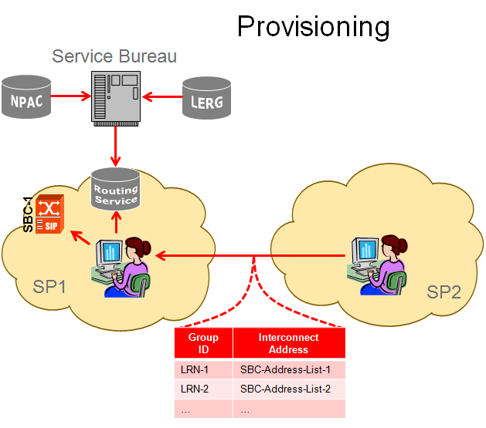
Figure Current-2

In this provisioning example, SP1 uses an SP2 Profile to populate its routing service and SBC routing tables based upon information provided in the interconnection agreement. In this example, LRNs are correlated to SBC interconnect address’ (points of ingress) into SP2’s network.

The information provided by SP2 used to create an “SP2 Profile” includes:
- Groupings of TNs at the NPA-NXX, LRN, OCN and/or switch CLLI level to identify if a called number is part of a group covered by an IP interconnection agreement. Numbers may be added or deleted from these groupings without the need to update SP1’s routing service or SP2’s Profile.
- SP2’s preferences for use in identifying destination ingress SBCs into SP2’s network based upon the state, LATA or geographic area (e.g., North East).
In summary, provisioning of the routing service and SBC routing tables involves the use of Public Routing Data and the SP2 Profile to determine if a called number is covered by an interconnection agreement, and which ingress SBCs are to be used based upon preferences provided with the information exchanged in the IP interconnection commercial agreement.
Evaluation Matrix

 | Criteria | Current Solution
1 | Specify interconnection information with finer granularity than the service provider level; specify different interconnection attributes for different groupings of a service providers numbers. For example, one per NPA/XXX or LRN, One per TN, alternative routes, etc. | The current solution can use groupings based on multiple group identifiers - OCN, LRN NPA-NXX and Switch CLLI. Other grouping can be accommodated as they are developed. Each grouping can be associated with multiple egress and ingress SBCs for reliability.
2 | Provide a mechanism for aggregation of routing information above the individual number level. For example, CO Code, NPA/NXX-X level | The current solution uses groupings based on multiple group identifiers - OCN, LRN NPA-NXX and Switch CLLI. Other grouping can be accommodated as they are developed
3 | Provide a mechanism to get some insight into the service capabilities of destinations in advance of routing a call. | Does not provide insight into service capabilities, however mutual service capabilities specified in the ICA between service providers can be accommodated in the routing logic.
4 | Support the ability to provide GETS. | Utilizing and enhancing existing database systems (LERG/NPAC) to support IP interconnection information exchange would not impact the ability of service providers to provide GETS
5 | A mechanism for terminating service providers to identify different interconnection points (for a given group of TNs) depending on the originating service provider. | Terminating service providers are able to specify different ingress points to be used by different originating providers for the same number
6 | The service provider connecting to the terminating provider selects the interconnect point, consistent with preferences identified by the terminating service provider. | Interconnect points determined by interconnect agreement are used, e.g.: state, region, lata or service capability
7 | The ability to exchange routing data between service providers in bulk. | Service providers use existing processes and industry databases to identify groupings of data. A small amount of information is exchanged between service providers to map groups to interconnection points.
8 | The ability to query a locally cached copy within each service provider, rather than always having to query the terminating service provider. | All data accessible in real time in each service provider’s network.
9 | Level of dependence on "CO codes", even during the transition. | CO Codes are used as a grouping mechanism  Other groupings can be accommodated
10 | What external bodies are required to modify existing arrangements, systems, etc.? | None as is.  Enhancements would be dependent on existing industry processes to modify NPAC and LERG
11 | Any solution must have a clear path to move to a global solution. | Can co-exist with a global solution.  Enhancements would need to be made
12 | The approach picked by this group must provide good solution for the end state all-IP network while maintaining backward compatibility (or interworking) during the transition. | Can co-exist with an all-IP network
13 | Compatibility for solutions for non-E.164 Public User Identities. | No – does not work for non E.164 identifiers
14 | What updates need to be done throughout the network for each option, and what is the estimated complexity of that? Impact on: | -
15 | • Time to implement - common infrastructure | In use today
16 | • Existing industry systems | In use today
17 | • Existing service provider systems | In use today
18 | • The need for additional industry systems and interfaces | None required
19 | • Call setup time | No Impact - local queries minimize call setup time
20 | • Signaling traffic | Minimized - no impact
21 | • Increase of vulnerability of security | Minimized - no impact
22 | • Network elements | No impact
23 | Reliability and scalability. | Experience to date indicates this is sufficiently scalable and highly reliable
24 | Support for secure tunnels and open Internet routing. | Yes / Yes
25 | Solution must be synchronized with number portability. | Solution uses the NPAC for to identify SP for ported numbers
26 | Solution cannot be tied to historical geography of numbering plan. | Accommodates geography but is not dependent on geography
27 | Registration in common industry databases should only be made by the current service provider of record or an authorized agent for the service provider of record | This is done today
28 | There is a need for service providers to exchange information for both primary and alternate routes. | Multiple ingress SBCs can be specified if required by ICA
29 | A solution cannot require additional significant investment to legacy systems. | Solution is in use today by multiple service providers

