CONTRIBUTION

TITLE: Industry Option Comparison of IPNNI-2014-022, utilizing LERG as a thin Tier 1 Registry, for the exchange of data to support Routing of E.164 Addressed Communications over IP Network-to-Network Interconnection (NNI).
SOURCE*: iconectiv

_______________________________
ABSTRACT
This contribution provides the comparison of IPNNI-2014-022, utilizing LERG as a thin Tier 1 Registry, as one of the industry options for the exchange of data for IP routing and interconnection for routing of E.164 Addressed Communications over IP Network-to-Network Interconnection (NNI). The work in this contribution is based on the original input contributions and addresses the issues and criteria that was developed by the IPNNI group at the February meeting and refined during the March conference call.
_______________________________

Introduction
There have been contributions that propose the implementation of an ENUM architecture to facilitate the exchange of data for IP routing and interconnection. This contribution supports that concept and proposes the LERG be utilized to function as the thin Tier 1 Registry. To accommodate this capability the existing LERG would need to be enhanced to include Tier 2 Name Server information.

The LERG was initially designed for routing of interLATA Time Division Multiplex (TDM) calls by interexchange carriers but has effectively evolved since its inception to support new networks and technologies. It continues to evolve with neutral governance processes that allow the industry to facilitate system process enhancements as required by service providers. For example, the LERG has also evolved to provide support for information exchange between all types of service providers including Incumbent Local Exchange Carriers, Competitive Local Exchange Carriers, Wireless Service Providers, Voice over IP (VoIP) Providers, etc. In addition, the LERG evolved to support the exchange of hybrid TDM/IP routing and interconnection architectures, Call Agent/Media Gateway homing arrangements and NPA/NXX assignments, to name a few.
Consequently, a solution to utilize LERG to provision Tier 2 Name Server information as well as any other IP data elements would allow the industry to continue to effectively manage process evolution as it pertains to IP routing and interconnection. This management would reside within interactive industry processes that have proven efficient, cost effective, and balanced in regards to all industry segments.
The LERG, functioning as a Tier 1 Registry, would also maintain consistency of data exchange across the multi-service provider ecosystem as opposed to a third party’s tiered solution that might be difficult to maintain a consistent quality of service benchmark across service providers.
Additionally, a LERG solution would avoid the need for IP enhancements to the SOAs or LSMSs which are used for Number Portability at every service provider. Number portability could function exactly as it does today by continuing to return an LRN where service providers then make use of the prior LERG data exchange to retrieve the associated data for call routing.

Routing Flow
A high level reference architecture is provided below that illustrates how the ENUM Domain Name System (DNS) query sequence would function during a session. In this example a Session Initiation Protocol (SIP) session is depicted.
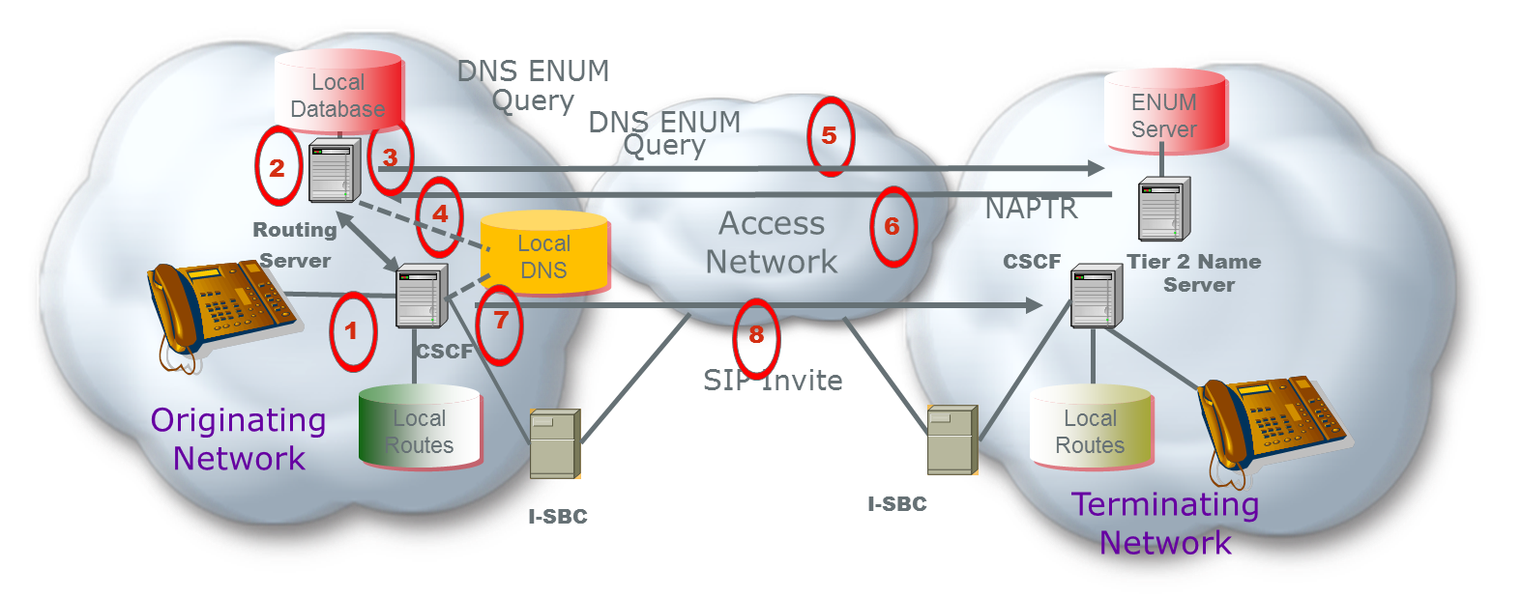
Figure 1 – Session Set-up
1 – A session is initiated
2 – The Call Session Control Function (CSCF) initiates a query to the Routing Server for a routing lookup (potentially using ENUM) in its local database
3 – The local database returns an NS record with the host name of a Delegated Tier 2 Name Server where specific VoIP routing information can be found. The number may need to be port corrected to get the authorized service provider of record. The NS record for that provider was pre-provisioned by the LERG download.
4- The originating Service Provider resolves the FQDN in the NS record to the IP address of the terminating service provider’s Tier 2 ENUM server
5 – The Routing Server sends an ENUM query to the terminating network’s Tier 2 Name Server
6 – The terminating network’s Tier 2 Name Servicer returns interconnect information in the form of one or more Naming Authority Pointer (NAPTR) records within the ENUM response.
7- The originating Service Provider resolves the hostname in the SIP URI to obtain the IP address of an agreed upon terminating Service Provider’s ingress SBC
8 – Based in the information received, the originating network initiates a SIP invite to the terminating network to initiate a SIP session
By implementing an ENUM approach, the network infrastructure needs to be enhanced to accommodate the additional queries as depicted in sequences 5-6.
Additionally, the network needs to standardize the information, content, and format in the Uniform Resource Identifier (URI). This includes standardizing the service parameters that are going to be supported for when the originating service provider receives the NAPTR records there is an agreed to and standardized process for how to use them for egress routing and session set up.
It should be pointed out that the initiation of a SIP session, sequence 8 above, has additional cross-network messages that are not depicted in this reference architecture but need to be supported by all service providers. From an originating service provider perspective, there are at least 1 additional ENUM query messages to accompany the 3 or 4 SIP set up messages, meaning the originating CSCF, and likely their I-SBC, must process 50% more messaging in an ENUM architecture.

Provisioning Flow
A high level reference architectures is proposed below that illustrates the provisioning sequence that could be implemented.
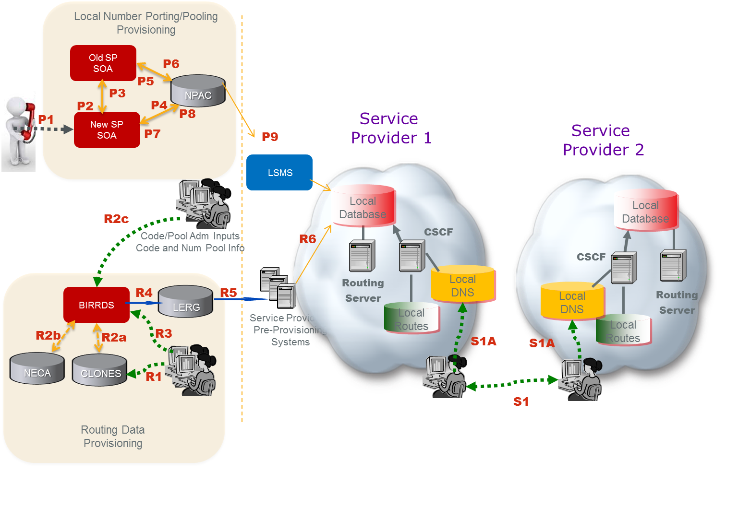
Figure 2 - High Level Provisioning Reference Architecture
As depicted in Figure 2, service providers would obtain the Tier 2 Name Server information from the LERG to enable a functional IP Network to Network Interconnection. This figure illustrates a logical view that may be realized by different operations systems.
Steps R1 and R2 provision Public Switched Telephone Network (PSTN) information while R3 through R6 includes both new IP information (i.e. the Name Server info) and existing PSTN data. Essentially, the current provisioning and routing data exchange systems and methodology for the PSTN can be applied directly to service provider Name Server data exchange. Also note that the number port provisioning flow is unchanged from today’s methodology.
Routing Data Provisioning:
(R1) Service provider develops a switch/point-of-interface (POI) CLLI Code and associated location attributes in the Common Language® CLONES database.
(R2a) The CLONES database provides newly developed CLLI Code and location reference data to the Business Integrated Routing and Rating Database System (BIRRDS). The location reference information is used by service providers in support of developing new BIRRDS switch/POI records.
(R2b) The National Exchange Carrier Association (NECA), provides new Company Codes (a subset of Operating Company Numbers (OCNs)), as they are assigned, to BIRRDS.
(R2c) National CO Code (NXX) Administrators and the Thousands-Block Pooling Administrator (US only) establish base CO Code and block assignment records in BIRRDS.
(R3) Service provider updates BIRRDS with Tier 2 Name Server information, switch/POI information (e.g. actual switch, points of interface, trunk gateways, call agents, signaling transfer points (STPs), etc.), homing arrangements, Location Routing Numbers (LRNs), and detailed information supporting the CO Code NPA/NXX and Thousands-Blocks that they have been assigned. This data is integrated with other BIRRDS data elements (e.g. Rate Centers) maintained by the BIRRDS administrator. At this time, BIRRDS can perform domain validations to validate Tier 2 Name Server accuracy. Name Server records can potentially be associated with OCN, at the highest order, or can be associated with other LERG data, e.g., CO level. That Name Server association would need to be agreed upon by the service providers.
(R4) The LERG is generated from current BIRRDS data and is provided to service providers monthly for their pre-provisioning systems. As an option, augmented daily activity may be provided nightly.
(R5) Based on service providers’ local methods and procedures, the LERG data is loaded into service providers’ pre-provisioning systems and is used for both PSTN and IP interconnection and routing covering switch translations, trunk engineering, numbering administration, legal and regulatory support, forecasting, intercompany billing support, and numerous other functions within the company.
(R6) Based on service providers’ local methods and procedures, the LERG data in service providers’ pre-provisioning systems is made accessible to switch translations engineers to configure the switch translation, routing tables and data elements used for both PSTN and IP interconnection and routing, e.g., Tier 2 Name Server information for IP.
Local Number Porting/Pooling Provisioning:
The following process involves a pre-port validation (PPV) process as well as a Number Pooling Administration Center (NPAC) Service Order Administration (SOA) process
(P1) A customer/subscriber requests to port his/her telephone number to the new/recipient service provider.
(P2) Pre-port validation - The new/recipient server provider requests validation of the port from the old/donor service provider.
(P3) Confirmation - verification of subscriber information is sent from the old/donor service provider to the new/recipient service provider.
(P4) The new/recipient service provider sends a creation of a pending port to NPAC.
(P5) NPAC sends a notification of port to the old/donor service provider.
(P6) An approval of the pending port is sent by the old/donor service provider to NPAC.
(P7) NPAC sends a notification of the old service provider’s port approval to the new/ recipient service provider.
(P8) Activation of the port is sent from the new/recipient service provider to the NPAC.
(P9) NPAC broadcasts the new routing information for the port to the Local Service Management Systems (LSMSs) for all service providers to update their local databases likely a Routing Server.
Service Provider Provisioning:
Service providers negotiate interconnection and exchange and provide Address records for their Tier 2 name servers (S1). In addition, address (A) records for the hostname FQDNs in URIs derived from the NAPTR records that will be provided in the responses from their Tier 2 name servers. These IP addresses correspond to the destination service provider’s I-SBCs that constitute the application layer POIs. Each service provider provisions the records received from the other service provider in its internal DNS (S1A).
In this reference architecture, BIRRDS/LERG would need to be modified/enhanced to allow the administrators to provide the registration of the Tier 2 name server information.

SUMMARY
A solution that utilizes the LERG as the thin Tier 1 Registry would allow the industry to continue to leverage existing processes for data exchange of the ENUM Name Server records with caching in local databases to avoid external NS queries. Furthermore, the industry could manage routing evolution for IP under the governance of a neutral body with existing linkages to other fora.
The existing industry framework supports the exchange of TDM and IP routing and interconnection, however, existing database systems would need to be enhanced according to the industry requirements in order to exchange Tier 2 NS records and other IP routing information. The following items are possible areas of enhancement to LERG functioning as the Tier 1 Registry for IP routing and interconnection:
- Adopt an ENUM architecture but avoid the overhead and complexity of external NS queries by supporting service provider exchange (i.e. local downloads) of Tier 2 Name Server information.
- Assign and exchange a single Name Server record for a given service provider (e.g. an OCN) or a set of Name Server Records depending on the NPA/NXX or other considerations (such as East vs. West). It is worth discussing what granularity a Name Server will need to support including what requirement would drive Name Servers at a full 10 digit TN level.
- Validate Domain Names and potentially full URIs associated with a Name Server address prior to accepting such routing information for exchange.
- Support more frequent routing data exchanges than daily.
- Global access to the NS information requires further evaluation.

 | Criteria | Response
1 | Specify interconnection information with finer granularity than the service provider level; specify different interconnection attributes for different groupings of a service providers numbers. For example, one per NPA/XXX or LRN, One per TN, alternative routes, etc. | The LERG can be enhanced to support IP interconnection information with finer granularity and to specify different groupings, for example, one per NPA/XXX or LRN, One per TN, alternative routes, etc.
2 | Provide a mechanism for aggregation of routing information above the individual number level. For example, CO Code, NPA/NXX-X level | In order to reduce the number of records an aggregation can be made to the NPA-NXX or NPA-NXX-X level if required.
3 | Provide a mechanism to get some insight into the service capabilities of destinations in advance of routing a call. | Enhanced LERG IP interconnection and routing data would be furnished to service providers pre-provisioning systems and can be used to provision ingress/egress route servers and will also provide a universal means for service providers to determine service capabilities associated with and interconnection points prior to call set up.
4 | Support the ability to provide GETS. | Utilizing and enhancing existing database systems (LERG/NPAC) to support IP interconnection information exchange would not impact the ability of service providers to provide GETS
5 | A mechanism for terminating service providers to identify different interconnection points (for a given group of TNs) depending on the originating service provider. | Based on interconnect negotiations and the URI/IP data records exchanged, different Partners can map the same TN to different sets of POIs. Also, SPs can respond with different NAPTRS to Tier 2 queries.
6 | The service provider connecting to the terminating provider selects the interconnect point, consistent with preferences identified by the terminating service provider. | Interconnect negotiations define the agreed-upon POIs and the rules for session deliver across those points. The URI/IP data record exchange and ENUM query response instantiate those agreements.
7 | The ability to exchange routing data between service providers in bulk. | IP interconnection data would be provided to originating and terminating service providers for their pre-provisioning systems, monthly and/or nightly with augmented daily updates. Additionally through the LERG service providers may share Tier 2 data.
8 | The ability to query a locally cached copy within each service provider, rather than always having to query the terminating service provider. | LERG data including enhanced IP interconnection data would be provided to originating and terminating service providers for their pre-provisioning systems, monthly and/or nightly with augmented daily updates. This shared data provides a local cached copy.
9 | Level of dependence on "CO codes", even during the transition. | The level of dependence on any level of codes is determined by the needs of service providers. If required, TN level could be defined for any and all numbers. However, it would not be practical to provision every number in that manner so some aggregation could be required.
10 | What external bodies are required to modify existing arrangements, systems, etc.? | Detailed requirements for BIRRDS/LERG enhancements would be governed via neutral CIGRR industry forum
11 | Any solution must have a clear path to move to a global solution. | Building a national ENUM Tier registry through the LERG supports multiple paths to globalization. Initially, DNAME records can be exchanged to link to foreign registries (and for foreign registries to link to the US)
12 | The approach picked by this group must provide good solution for the end state all-IP network while maintaining backward compatibility (or interworking) during the transition. | The ENUM approach provides a path to the end state solution since the records can easily be migrated to any consolidated registry target platform of the sort that has been proposed without changing the basics of network operation. By adding the IP routing information to the LERG backward compatibility is ensured during transition.
13 | Compatibility for solutions for non-E.164 Public User Identities. | The LERG can accommodate any data field whether it be a TN or any type of Public User Identify.
14 | What updates need to be done throughout the network for each option, and what is the estimated complexity of that? Impact on:
15 | • Time to implement - common infrastructure | A specific timeline would need to be defined by the industry; 12 months is a suggested reasonable timeframe.
16 | • Existing industry systems | Enhancements to the LERG
17 | • Existing service provider systems | Pre-provisioning systems need to be modified to accept new fields as well as other internal systems that require that data. In addition, each Service Provider would need to develop operational processes to receive the data and integrate that data into its routing fabric.
18 | • The need for additional industry systems and interfaces | Tier 2 name servers must be set-up either local or hosted as well as cross network queries would be required
19 | • Call setup time | Impacts to be accessed.
20 | • Signaling traffic | At least 1 additional external query is required and the message overhead associated with the query
21 | • Increase of vulnerability of security | Appropriate security measures for Tier 2 name servers must be put in place.
22 | • Network elements | With an ENUM implementation each of the Service Providers would need to add Tier 2 Name Servers to their infrastructure. In addition, the originating Service Provider would need to be able to accommodate the initiation of ENUM query to the Tier 2 Name Server.
23 | Reliability and scalability. | The impacts to reliability and security concerning the additional network elements; the Tier 2 Name Servers, with the additional queries and message overhead would need to be accessed.
24 | Support for secure tunnels and open Internet routing. | This is an implementation issue and Service Providers can choose to make use of it.
25 | Solution must be synchronized with number portability. | Would be synchronized with number portability; LERG data would include IP routable LRN indicators and would continue to work in conjunction with NPAC to provide number porting/pooling information
26 | Solution cannot be tied to historical geography of numbering plan. | The solution imposes no constraints on the geography of numbering.
27 | Registration in common industry databases should only be made by the current service provider of record or an authorized agent for the service provider of record | Mechanisms are in place to validate that the code holder or authorized agent is registering data.
28 | There is a need for service providers to exchange information for both primary and alternate routes. | LERG has the capability to provide both primary and alternate routes
29 | A solution cannot require additional significant investment to legacy systems. | Modifications and enhancements to the LERG would not be significant to provide this capability. However, investment in network infrastructure would need to be assessed since additional network queries and Tier 2 name servers would need to be added.

