ATIS-0x0000x

ATIS Standard on

ATIS Technical Report on a Framework for Display of Verified Caller ID

Alliance for Telecommunications Industry Solutions

Approved Month DD, YYYY

Foreword
The Alliance for Telecommunications Industry Solutions (ATIS) serves the public through improved understanding between carriers, customers, and manufacturers. The [COMMITTEE NAME] Committee [INSERT MISSION]. [INSERT SCOPE].
The mandatory requirements are designated by the word shall and recommendations by the word should. Where both a mandatory requirement and a recommendation are specified for the same criterion, the recommendation represents a goal currently identifiable as having distinct compatibility or performance advantages. The word may denotes a optional capability that could augment the standard. The standard is fully functional without the incorporation of this optional capability.
Suggestions for improvement of this document are welcome. They should be sent to the Alliance for Telecommunications Industry Solutions, [COMMITTEE NAME], 1200 G Street NW, Suite 500, Washington, DC 20005.
At the time of consensus on this document, [COMMITTEE NAME], which was responsible for its development, had the following leadership:

[LEADERSHIP LIST]

The [SUBCOMMITTEE NAME] Subcommittee was responsible for the development of this document.

Revision History
Date | Version | Description | Author

Table of Contents

[INSERT]

Table of Figures

[INSERT]

Table of Tables

[INSERT]

Scope, Purpose, & Application

Scope
This technical report provides a framework for signaling verified Caller ID information from the network to a User Equipment (UE), and displaying the information on the UE in a uniform manner, independent of technology. The main goal is to produce display guidelines that help empower consumers in managing their calls, as per the Robocalling Strike Force recommendations.
This report should be treated as a living document as the guidelines are expected to evolve. The deployment of verification methods, such as STIR/SHAKEN, and application of call analytics are expected to occur in stages over an extended period of time. Hence, the operations experience gained over time is expected to provide feedback and input to future issues of this report.
Results of applicable usability studies are expected to contribute to the evolution of the recommendations in this report, as they become available.
More research is needed to identify the types of displays that empower end users with messages that are easy to interpret. At this time, such research is outside the scope of this report.

Purpose
The guidelines presented in this document are best practices based on a review of industry standards and studies on the effectiveness of warning signs and human factors related to the reading and comprehension of variable messages (text and symbolic). These guidelines help meet the goals of regulators and consumer protection agencies for empowering consumers with simple and effective call information.
This report recommends that these guidelines be taken into consideration by all stakeholders (service providers, equipment manufacturers and analytics providers) in the deployment of verified Caller ID displays and the composition of its related messages.
Variations may exist, subject to local policy.

Normative References
The following standards contain provisions which, through reference in this text, constitute provisions of this Standard. At the time of publication, the editions indicated were valid. All standards are subject to revision, and parties to agreements based on this Standard are encouraged to investigate the possibility of applying the most recent editions of the standards indicated below.

ATIS-1000074: Signature-based Handling of Asserted Information using toKENs (SHAKEN).
3GPP TS 22.173: IP Multimedia Core Network Subsystem (IMS) Multimedia Telephony Service and supplementary services.
3GPP TS 24.196: Technical Specification Group Core Network and Terminals; Enhanced Calling Name.

Definitions, Acronyms, & Abbreviations
For a list of common communications terms and definitions, please visit the ATIS Telecom Glossary, which is located at < http://www.atis.org/glossary >.

Definitions
Caller identity: The originating phone number included in call signaling used to identify the caller for call screening purposes. In some cases, this may be the Calling Line Identification or Public User Identity. For the purposes of this study, the caller identity may be set to an identity other than the caller’s Calling Line Identification or Public User Identity.
End user/consumer: Used interchangeably to refer to a customer of telecommunications service that is not a carrier or a device, and for whom the service was ultimately created or intended.
Normal call profile: The display of all identity information/services the end user subscribes to, outside the mitigation services that include analytics.

Acronyms & Abbreviations

ATIS | Alliance for Telecommunications Industry Solutions

Signaling of Verified Caller ID using Conventional Caller Name (CNAM)
In its simplest form, a service provider performing STIR/SHAKEN verification, on behalf of one of their subscribers, will make a binary determination whether a call received is from a trusted source or not. Such a determination can be signaled from the network to a User Equipment (UE) via a single alphanumeric character. The 'verstat' tel URI parameter has been standardized to signal Verified Caller ID status. It is quite likely, however, that as STIR/SHAKEN caller authentication standards are implemented, there will be millions of UE that won’t initially be able to support 'verstat'. In particular, analog devices connected to IP networks are not expected to support 'verstat'.
Today, network switching support to query conventional Caller Name (CNAM) services across the United States is, for all practical purposes, ubiquitous. Conventional CNAM supports a 15-alphanumeric character field that is already signaled from IP/TDM networks and displayable on a broad range of existing consumer and business devices today. In IP networks, CNAM is signaled in the Display Name portion of either the SIP From or P-Asserted-Identity header.
Combatting illegal robocalls will require a range of mitigation techniques. The following two approaches incorporate the use of conventional CNAM today and more importantly when the STIR/SHAKEN caller authentication standards are implemented:
- A terminating IP/TDM switch, before completing a call to the associated UE, issues a conventional CNAM query to an authoritative 3rd party CNAM service. Prior to returning any CNAM of record, Call Validation Treatment (CVT) or “analytics” and policy are applied to determine if the CNAM of record should be overwritten with another name (e.g., “FRAUD CALL”). The policy-applied CNAM is then returned to the querying switch and transparently signaled to the UE.
- As STIR/SHAKEN is implemented, the result of verification can first be sent to the CVT service to determine if a CNAM of record should be returned or overwritten. The policy-applied CNAM can then be returned to the terminating IP switch through the STIR/SHAKEN verification process and be transparently signaled to the UE that does not yet support “verstat”.
Therefore, in an effort to accelerate the reach of Verified Caller ID across analog devices in IP networks, service providers can evaluate the use of conventional CNAM as a vehicle for signaling verification status. For service providers, this approach highly leverages an established ecosystem infrastructure. More importantly, it affords the opportunity to immediately begin signaling Verified Caller ID status to the broadest set of subscriber devices once STIR/SHAKEN implementations are established.
There is a range of implementation options that can be considered. Two simple examples are:
- The service provider performing the STIR/SHAKEN verification process appends a designated alphanumeric character to the end of the 15 character CNAM of record for a verified Caller ID (e.g., JOHN DOE*)
- The service provider appends a designated alphanumeric character to the beginning of the 15 character CNAM of record for a verified Caller ID (e.g., *JOHN DOE)
Note that the “*” in the simple examples above is meant to verify the Caller ID (telephone number identity) in the associated SIP URI and not the displayed CNAM. There are established commercial practices and policies around the subscriber information used in 3rd party CNAM services, how it is obtained and how quickly it is updated in authoritative databases.
As validated through actual testing, the examples above afford at least two, immediate to near term device implementation approaches:
- An existing analog device of a subscriber that supports conventional CNAM can just display what is signaled, e.g., “JOHN DOE*” (as discussed below, some agreement across service providers could simplify the subscriber education process)
- A device operating system or application vendor can interpret the “*” and enhance a screen-based display to the subscriber as illustrated below (i.e., the black padlock within the green circle):

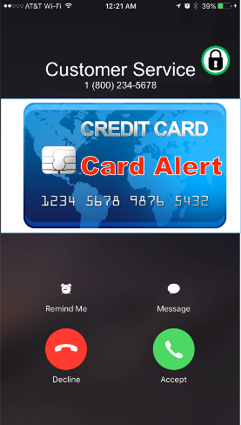

Given the above description and explanation, the following highlights items to consider when signaling Verified Caller ID status using conventional CNAM:
- As with any signaling approach, use of the conventional CNAM display field for relaying the Verified Caller ID status to the UE needs to be secure and not easily imitated by scammers. For example, a service provider should override any included CNAM from another network with this approach.
- If a single alphanumeric character is used from conventional CNAM instead of overwriting the CNAM of record with a different name like “FRAUD CALL”, existing 15-character CNAMs need to be addressed. Further, the selected character should not be used in existing CNAMs of record.
- This approach doesn’t assume that a 3rd party CNAM service is used. What is key is the ubiquitous network switching support for conventional CNAM queries and device support to display 15 character CNAMs.
- A draft IETF document, “PASSporT Extension for Rich Call Data”, proposes a way to broaden the identity claim to include CNAM that may be inserted at call origination. Thus, this approach is extensible in the future to not just signaling a verified Caller ID but also the associated, displayed CNAM.
- ATIS IP-NNI continues to discuss the desire to signal more information to the UE about the verification status. However, at this time, it seems like any such approach would require changes to the UEs to interpret and act on such information (e.g., any extensions to the “verstat” tel URI parameter). The near term approach to use conventional CNAM can be an option to accelerate implementations and signal the most critical piece of information to UEs. Note that another simple approach, for example, could be to use a single, numeric value between zero and nine, thus supporting up to ten possible statuses to be signaled.
- Any display approach to UEs will require subscriber education. For devices that simply display what is sent to them, subscribers will need to understand how their traditional display has changed. Such education can be greatly simplified if a uniform industry approach is agreed to.
- If conventional CNAM to signal Verified Caller ID status is considered for use as a near term approach, then a transition plan to any more standards-based approach needs to address implementation changes, subscriber education (re-education) and the results of their call experience with this approach.
- Accurate CNAM, along with Verified Caller ID, forms a foundation for building a much better subscriber call experience. Coupling these together is intuitive as many business-to-consumer calls are not identifiable enough today to be consistently answered. Further, analytics and policy rules, which are increasingly becoming more commercially supported, can be defined and used to modify the signaled CNAM based on the caller verification status. For example, a non-Verified Caller ID on an IP network could be signaled as “UNVERIFIABLE” to analog devices.
In summary, conventional CNAM affords service providers an opportunity to efficiently signal Verified Caller ID status to a broad set of existing subscriber devices as STIR/SHAKEN caller authentication standards are implemented in IP networks. Although positioned as a near term approach, CNAM is extensible in multiple ways enabling it to support a number of innovative ways to further enhance the subscriber call experience. Moreover, it allows companies to respond to accelerated timelines from regulators for addressing illegal robocalls and spoofing.

Considerations during Transition to STIR/SHAKEN Caller Authentication and Signaling

Using conventional CNAM to convey the Verified Caller ID status until STIR/SHAKEN caller authentication standards and “verstat”-capable UE become more widely deployed can benefit subscribers in the interim, especially those served on analog devices.
It is important to understand that during this transition, the use of any special character that may be appended/ prepended to the 15-character CNAM could be misused by bad actors. As the concept is implemented with some service providers, scammers could insert it on calls to other networks that do not offer this service securely. If the public, in general, is trained to trust that symbol, then some subscribers may be affected.

Display Guidelines of Verified Caller ID on All-IP Networks and Screen-based Devices
With the implementation of STIR/SHAKEN and certificate governance models on all-IP networks, specific data will be signaled between networks which could help assess the risk associated with each call.
It is important to realize that this information signaled between networks (such as attestation levels and certification information) is not meaningful or suitable to be displayed to the end user. However, when further analytics are applied to that information, a more useful "communication" can be formulated and presented to the end user.
The guidelines in this section are provided for screen-based devices, such as smartphones, operating on an all-IP network. Considerations for other scenarios of analog devices served by all-IP networks, or by circuit-switched networks will be discussed in Section 6.

Entities that shape the display
Multiple entities contribute to the ultimate message delivered to the user about the trust level of incoming calls.
Each entity may be responsible for specific data that is signaled, processed, or displayed at different points in the call setup.
Editor's Note: This section proposes the following entities as the key contributors to the ultimate display and the role each one plays. Other entities may be added in the future, if deemed necessary.
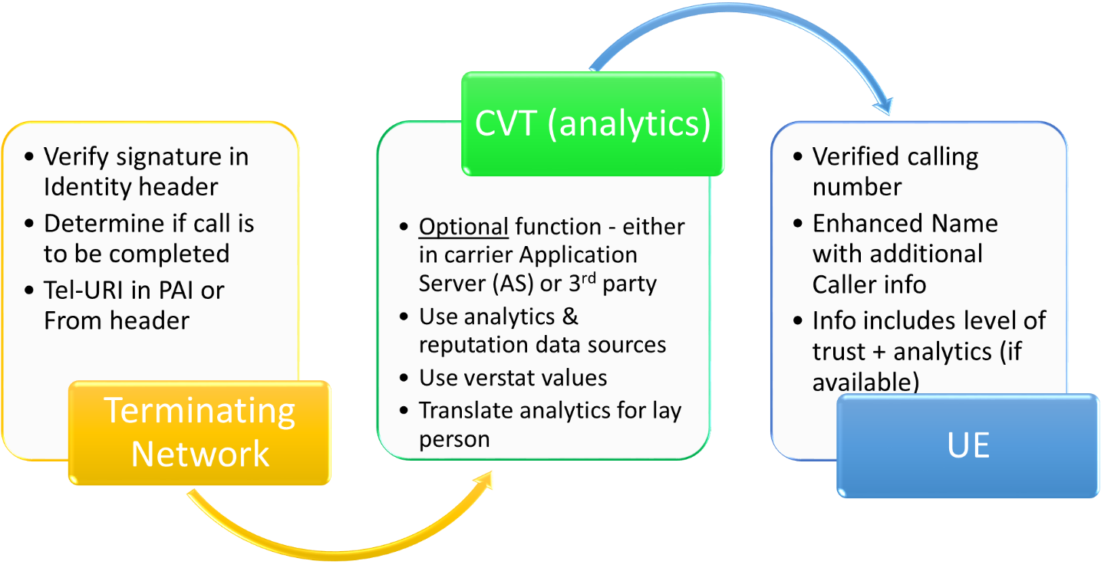
Figure 1. Entities Contributing to Ultimate Display

IP Network
The originating network is responsible for signaling the Identity header containing the pertinent claims and attestations about the calling number, per draft-ietf-stir-rfc4474bis and ATIS-1000074.

The terminating network is responsible for verifying the received claims. Results of the verification are inserted in the "verstat" tel URI parameter (defined in 3GPP TS 24.229) to provide the UE with the calling identity number verification status in an initial INVITE request.

Call Validation Treatment (CVT) or Analytics
CVT is a function that analyzes data to ascertain the level of risk associated with the incoming call. CVT may be implemented as part of the terminating network (e.g., in an application server) or by a third-party that partners with the service provider, or in association with a UE application. CVT applies different algorithms to data it obtains on the TN in question. CVTs typically access a multitude of data sources on each TN to improve the accuracy of its results.

User Equipment (UE)
This section assumes a wireless handset with a screen display that is compliant with “verstat” parameter requirements in 3GPP standards.

Assumptions
- The guidelines herein are limited in scope to empowering end users in managing their identity services, and not business verification services.
- Network data and/or analytics may not always be available/implemented in all networks.
- When an end user subscribes to or is provided an analytics service, the end user understands that the assessment is predicated on the statistical evaluation of data available on the current call along with data on other similar calls. Consequently, he/she may receive false positive and false negative messages on some of their incoming calls.
- It is expected that some service providers will delegate the delivery of the final call information display (including TN, calling name, and the results of verification) to an analytics provider. For those cases, the analytics provider is expected to adhere to the application of privacy rules for the calling number and name portions of the display; i.e., an "Anonymous" message would be displayed for name and TN.
  - The terms of agreement between the service provider and the analytics provider are expected to require preservation of the caller's privacy.
  - Further clarification and/or safe harbors are needed to determine whether the name and TN could be anonymized while additional call information, such as call category and potential fraud risk, could be delivered to help empower the end user.
- Where the delivery of the final call information display is not delegated to an analytics provider, the service provider is expected to adhere to the application of privacy rules for the calling number and name portions of the display; i.e., an "Anonymous" message would be displayed for name and TN.
- In the absence of clarification or any special allowances on handling private calls, the guidelines herein call for anonymizing ALL call information if the received calling number is anonymous. The determination of the authentication of the call is NOT "call information" in the traditional sense and should be presented to the user independent of legitimate privacy uses.
- The end user may subscribe to multiple mitigation services. Order and preference of display may be determined by the service provider. Variations in operating systems and the plethora of available applications make it impractical to set interoperability or prioritization guidelines. Therefore, it is the responsibility of end users to select the mitigation service that best meets their needs.

Available Call-related Information
The data outputs from the network and CVT will be at the center of the message delivered to the user (e.g., warning or other). Making more reliable information available to the CVT algorithms is likely to yield more accurate results for the user.

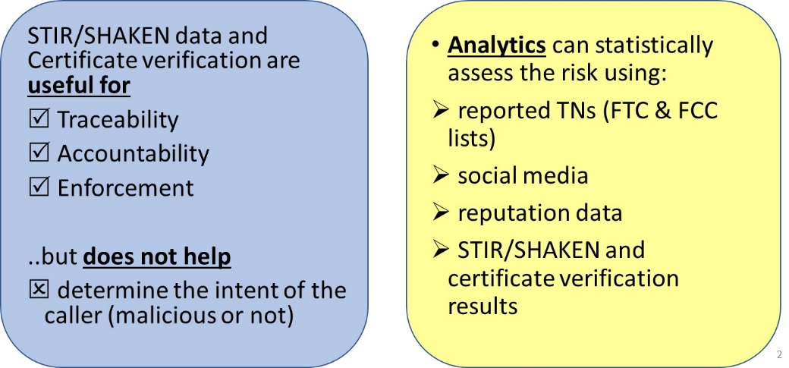
Therefore, it is recommended that attestation levels and identifiers from SHAKEN be made available to the CVT function, according to local policies.

Preliminary Display Usability and Comprehension Studies
Over the course of Q2 and Q3 2017, Hiya Inc. conducted several usability studies targeted at the display guidelines of the STIR/SHAKEN protocol. The goals of the study were twofold:
- To measure the potential impact of a positive assurance indication for verified calls (the “green checkmark”), and
- To assess various textual and iconographic display options for caution indicators on suspicious calls.

Hiya conducted three independent brief usability studies on different audiences:
- A user comprehension and influence study on robust caller profiles and certified call markers;
- A user impact analysis of various phrasings and iconography for suspicious call messaging; and
- A call pickup rate impact analysis of a “certified” checkmark icon against existing Hiya users.

Study #1: Comprehension and Impact of Certified Call Markers

Study Description
Hiya interviewed 11 randomly chosen individuals among a pool of volunteers to participate in a paper-based usability study.
Participants were offered no context or explanation of STIR/SHAKEN, or the purpose of the study.
Participants were presented with a sequence of incoming call UI mockups and asked a series of questions:
- What do you notice about this screen?
- What confidence or trust do you have in this caller information?
- What effect does this have on your opinion of previous screens (if any)?

The mockups were designed to enhance the incoming call experience with expanded caller profile information, with the final mockup showing a “certified call” confirmation reflective of STIR/SHAKEN validation.
Interviews lasted an average of 35 minutes per participant.

Results
In nearly all cases (10/11), participants showed a “strong” or “very strong” indication that additional caller profile information strengthened their confidence in the legitimacy of the theoretical phone call.
This applied across all mockups, prior to “certified call” marker.
For the “certified call” mark,
- A significant number of participants (8/11) identified the mark as reassurance to the legitimacy of the call, and all who identified this also expressed future doubts to the legitimacy of any future call lacking the indication.
- Some (6/11) expressly stated that they would become less likely to answer any unknown call lacking certification, once the certification marker was seen.

Conclusions
Hiya has concluded that the use of such a marker with clear context would negatively impact all calls lacking this marker.
It remained unclear from the study if the marker would have a positive impact on pickup rates for marked numbers. (Hiya has previously demonstrated that extended call profile information positively influences call pickup rates, without any “certified call” indication.)

Study #2: Call Pickup Rate Test

Study Description
Hiya selected 70 high-volume (in excess of 600 monthly observed calls) legitimate business phone numbers from Canada with varying pre-existing caller profile information. These numbers were chosen because of Hiya’s subscription rate of the Samsung “Smart Call” caller ID service in Canada.
Call creation rates and user pickup rates were monitored for these numbers over a two-week period, during which Hiya caused the display of a simple white checkmark to be shown for any Smart Call user.
After two weeks, the checkmark was removed, and call volume and pickup rates were measured for an additional two weeks.

Results
It is important to note that Hiya could not identify or control the individuals receiving phone calls from the selected businesses. Therefore, it is not possible to confirm the results of Study #1 (that individual pickup rates would drop as users become familiar with expecting a checkmark on legitimate calls).
On average, Hiya did observe a 4.89% increase in call pickup rates overall while the checkmark was present.

Conclusions
Further analysis is pending to determine if the number’s existing call profile (a “caller ID” name) or business industry was more effective than others.
However, overall, this is taken to reinforce the positive impact a certified marker can potentially have on pickup rates for verified calls.

Study #3: Warning Phrasing Test

Study Description
Hiya has crafted 7 near-identical mockups of an incoming call screen. The only delta between the screen mockups was the presence of a warning phrase, expressing reasonable doubt about the legitimacy of the caller. Study participants were shown this screen for 5 seconds, then asked a series of questions:
- Would you answer this call?
- Was this call from a trustworthy source?
- Would you block this number from calling in the future?
- Why do you think you’re receiving this call?
The following phrases were used, each shown to 400 unique participants (no overlap between phrases):
- Phone number only (baseline)
- “Fake Phone Number”, with phone number
- "Possible Fraud" with phone number
- "Private Number" with no phone number
- "Unknown Caller" with phone number
- "Caller Not Verified" with phone number
- "Spoofed Number" with phone number

Results
The results of the study are:
Display | Pickup Rate | Block Rate | User Trust
Phone number only | 30% | 29% | 46%
“Private Number”  (no phone number) | 28% | 43% | 38%
“Fake Phone Number” | 21% | 49% | 30%
“Possible Fraud” | 11% | 57% | 20%
“Unknown Caller” | 24% | 33% | 42%
“Caller Not Verified” | 24% | 39% | 40%
“Spoofed Number” | 19% | 51% | 29%

Conclusions
One main caveat is that these percentages should be validated against actual user behavior. A 29% block rate for unknown callers seems unexpectedly high. This should be verified via other means before concluding this reflects real-world behavior. However, while totals may not be actionable, the belief is the deltas between levels are valid.
“Private Number” was included in this study only as an anecdotal comparison and is not a recommended display string. From this we can see minimal change in pickup rates, but a large increase in block rates. It was otherwise excluded from analysis.
The main goal of the study is to find how different messaging affects users’ level of caution for an incoming call, while separately measuring their likelihood to block the number in the future. The ideal message would greatly increase caution level, with minimal impact on block rates (as spoofed calls may impersonate legitimate numbers).
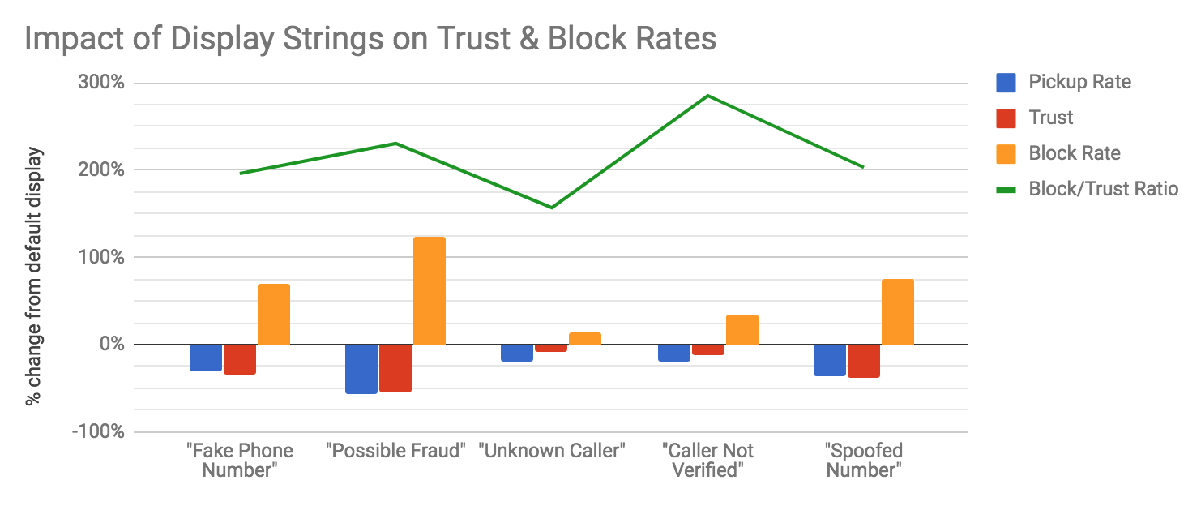Figure: Change in pickup rates, change in user trust, change in block percentages, and ratio between the two

Overall, we observed some variation in the delta of user trust as it relates to the delta in block rates. Less aggressive message “Unknown Caller” has a lower block/trust ratio, but overall has negligible impact on both. Overall, all strings tested had significant impact on the claimed block rate from users.
Similar results between “Fake Phone Number” and “Spoofed Number” indicates user general understanding of the term “spoof”.

Study #4: Iconography Impact Test

Study Description
Hiya selected two test strings “Possible Fraud” and “Fake Number”, and created 8 mockups of an incoming call screen, 4 with each string. Each string was paired with one of three possible flagged icons: a red stop sign, a yellow triangle, and an “unknown person” icon. These were to be compared against the results of these strings with no icon, tested in Study #2.

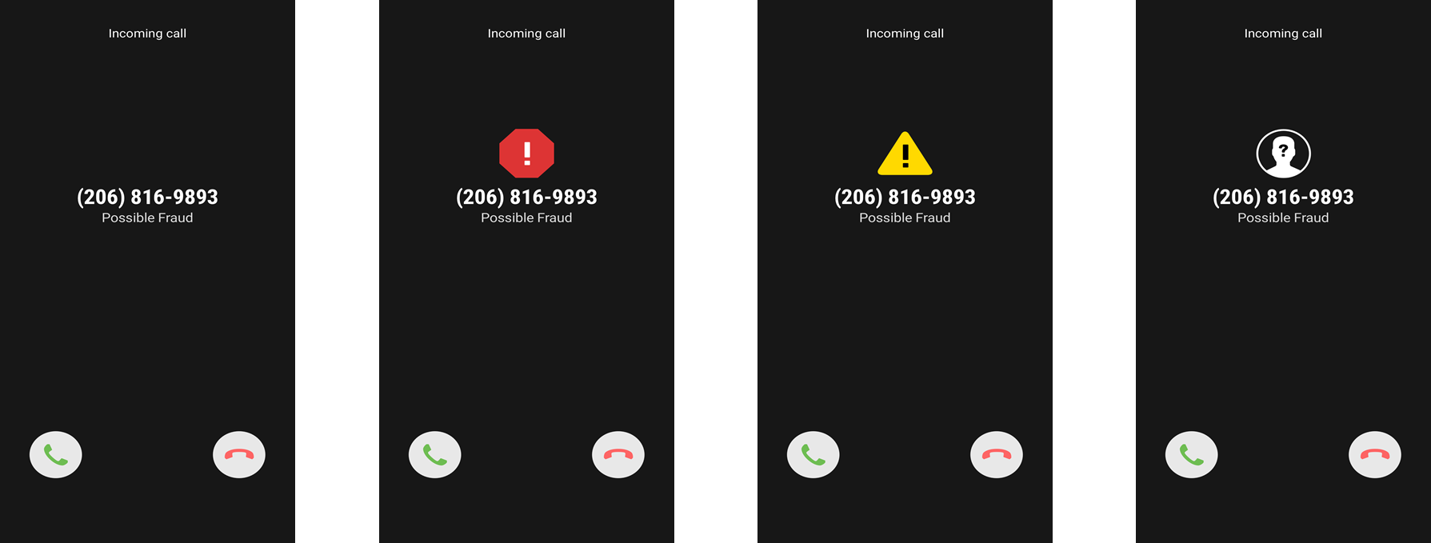

Figure: Test images for “Possible Fraud” string

Each participant (400 per mockup with no overlap) was asked the same questions as Study #2:
- Would you answer this call?
- Was this call from a trustworthy source?
- Would you block this number from calling in the future?
- Why do you think you’re receiving this call?

Results
The results of this analysis are:

Display | Pickup Rate | Block Rate | User Trust
“Possible Fraud” + no icon  “Fake Number” + no icon | 11%  21% | 57%  49% | 20%  30%
“Possible Fraud” + stop sign  “Fake Number” + stop sign | 9%  17% | 58%  51% | 18%  25%
“Possible Fraud” + warning sign  “Fake Number” + warning sign | 10%  17% | 60%  54% | 21%  25%
“Possible Fraud” + unknown sign  “Fake Number” + unknown sign | 13%  18% | 62%  50% | 20%  30%

Conclusions
Further analysis is recommended based on these results. Initial observations:
- The addition of icons has relatively minor impact on block rates, above that from text alone. In all cases though, block rates increased further.
- With the less severe “fake number” string, a supporting icon more strongly reduces pickup rates and overall perception of trustworthiness of the caller.
- With the more severe “possible fraud” string, the less-severe “unknown” icon actually improved pickup rates, tempering the impact of the warning message.
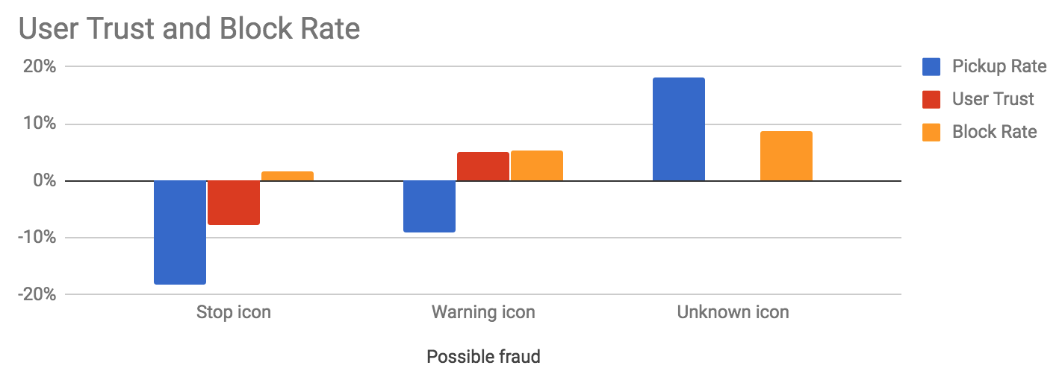
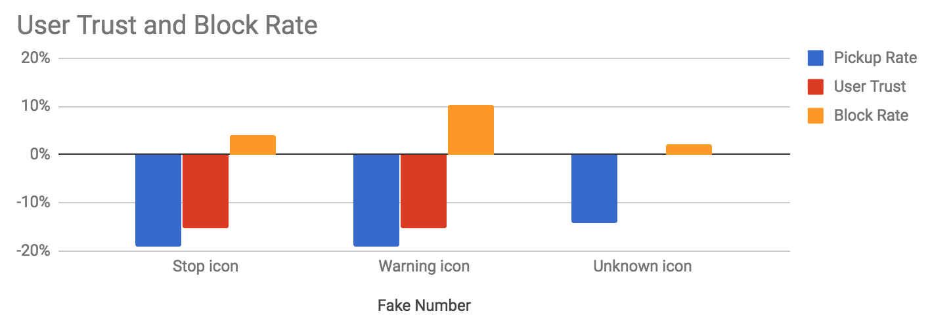
Figure: Impact on user trust and block rates, by icon.
Looking at all results together as deltas from the default unidentified call result, we arrive at this summary:
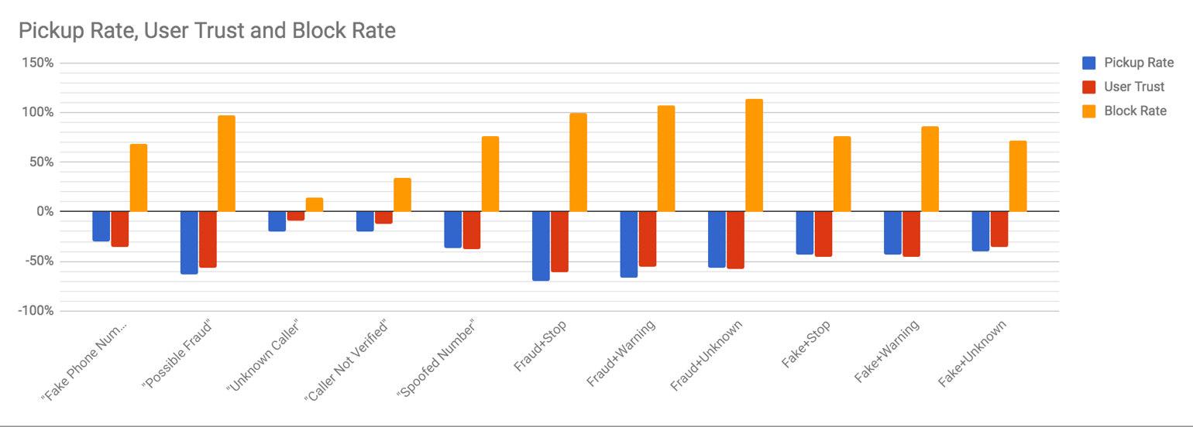
Figure: Pickup, trust, and block rates for all text-only and tested text+icon combinations

Recommended Data Treatment and Display Options

- In the absence of an analytics service, and subject to local policy, a warning (symbols and text) should be displayed to the user if verification fails, independent of the attestation level. Otherwise, for other values of verification, the user should receive a normal call profile based on the services they subscribe to.
- STIR/SHAKEN and verification information should be made available to the CVT (analytics) service, when available.
The following table summarizes the types of messages that should be displayed to the user based on the results of the STIR/SHAKEN identity verification methodology (ATIS-1000074). This table does not account for other factors, such as operational failures. It may be necessary to define more granular indicators reflecting different causes of failure (e.g., connectivity issues, certificate TTL expiration) in ATIS-1000074.

Table 1: Summary of Proposed Displays to the User
Attestation (by the originating end) | Verification (by the terminating network) of the originator's signature/cert | Availability of Analytics | Message presented to the User
A - Full | Passed | Not Available | Normal call profile
 |  | Available | Display analytics results*
 | Failed | Not Available | Warning**¹
 |  | Available | Display analytics results*
 | No Verification performed | Not Available | Normal call profile
 |  | Available | Display analytics results*
B - Partial | Passed | Not Available | Normal call profile
 |  | Available | Display analytics results*
 | Failed | Not Available | Warning**
 |  | Available | Display analytics results*
 | No Verification performed | Not Available | Normal call profile
 |  | Available | Display analytics results*
C - Gateway | Passed | Not Available | Normal call profile
 |  | Available | Neutral display with analytics results
 | Failed | Not Available | Warning**
 |  | Available | Display analytics results*
 | No Verification performed | Not Available | Normal call profile
 |  | Available | Display analytics results*
Not A, B or C. No Attestation performed (e.g., early stages when carrier hasn't implemented STIR/SHAKEN) | Nothing to sign | Not Available | Normal call profile
 |  | Available | Display analytics results*
¹ Delivery of a warning indicator upon verification failure is subject to local policy.
* This assumes the STIR/SHAKEN data was provided as input to the analytics service. Analytics results include additional information on the caller, and may include a warning.
** Some service providers may – based on consumer choice and consent - block these marked calls instead of completing them with a warning.

Example Displays
These examples are provided for the illustration and enhancement of the scenarios listed in the above table.

Full Attestation and Verification Passed (no analytics)
In this scenario, the user does not subscribe to a CVT service. The delivery of the “verstat” parameter (TN validation passed) delivers the call to the UE without warnings (or affirmations). The logo and location (city and state) of the caller is retrieved and delivered by enhanced CNAM (eCNAM).

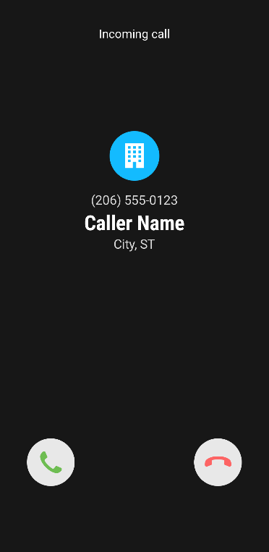

Gateway Attestation, Verification Passed, subscribes to analytics (analytics determine the call is suspicious)
In this scenario, the user subscribes to a CVT service that provides analytics. A gateway attestation is inconclusive to the caller, but an analytics service has flagged the caller as a known scammer. Therefore, a warning is provided to the user.
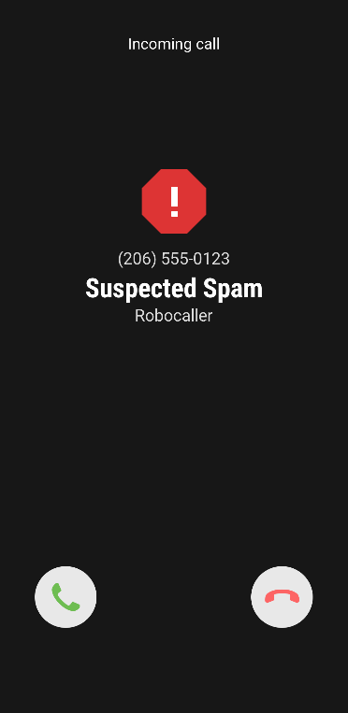

Verification Failed
If the verification failed, CVT may not be necessary or be used. There are two possible outcomes.
The service provider may simply block the call from terminating to the end user, per the end user's request.
Alternatively, a warning would be provided along with an explanation of the reason behind the warning. The end user is then forewarned and empowered to manage incoming calls based on all the information made available. A CVT service may be able to provide more useful reasoning, but is not expected to.

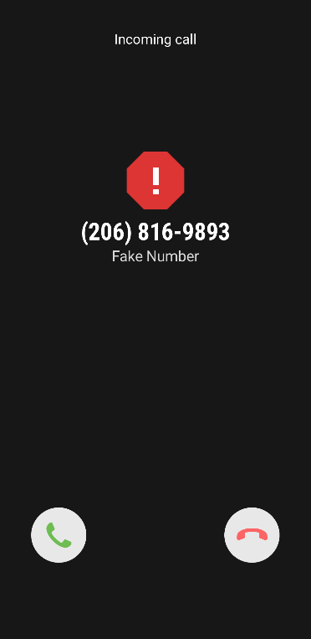

Basic recommendations on the Display or Message delivery to the UE
As a result of the above studies, it is recommended the following display/messaging behavior be adopted:
- On validation failure, recommend use of words “Fake Number” to inform the user not to trust the number being presented. If an icon can be presented, use of a “stop sign” or warning triangle further increases user caution with negligible impact on block rates. Such a string is short enough to fit in CNAM fields.
- eCNAM delivers the aggregate of all the information available about the TN (caller identity, results of CVT analytics, and information queried by the terminating provider).
- The use of multiple symbols in a given display is not recommended because the consumer's interpretation of different symbols may result in confusion and detract from the value the service is providing.
- Displaying status symbols, such as checkmarks, on calls with "full attestation – verification passed", is not recommended (studies show it leads to consumer confusion).
- It is recommended that only warning symbols be provided when warranted.
- Audible special ringing/tones may be applied on calls that fail verification as a consumer option.

ADA Considerations
- Eight percent of the male population are color-blind. Therefore, the display should not rely heavily on coloration to convey results.
- Ensure messages are clearly understood without industry knowledge (e.g. “spoof”) or strict dependence on sight and/or sound.
- Consider audio announcements for the visually impaired before the call is completed (within the limits of post-dial delays).

Display Guidelines for Analog Devices

Analog Devices connected to an IP Network
Analog Terminal Adapters (ATA) convert analog voice signals into digital IP packets. ATAs support many features including caller ID, Call Waiting and Call Forwarding. ATAs support multiple protocols, including SIP. They also support detection of call progress tones. However, there are no guidelines or standards requiring ATAs to support STIR/SHAKEN authentication and verification functions.
Given that the end user is served by an IP network, the available STIR/SHAKEN information may be relayed to an analytics service that could provide a useful text-based message reflecting the results of the analytics in the conventional CNAM or extended display of the analog device - to the extent allowed by the device display capabilities.
Icons may not be supported by analog devices.

Analog Devices connected to Circuit Switched (CS) Network
Efforts at reducing spoofing are likely to increase end user trust in the caller identity information (name and number) and to help empower them in managing their calls. However, end users served by the CS network are less likely to benefit from verification. Effective solutions for this segment of users may be better delivered in consumer devices.
It is recommended that devices allow one or more of the following:
- Storage and management of high volume black and white lists (10,000+ entries)
- End users to manage the lists via simple "button" presses to add/delete numbers from the list
- A mechanism that screens and reduces robocalls by requiring callers to proactively press a digit through an interactive request to prove the caller is not a robot, and
- Optional updates from more diverse reputation sources (e.g., FTC and FCC lists). This could be downloaded periodically to the device based on end user's subscription.

For this population of users, the available conventional CNAM display – albeit limited - should be used to maximize the caller information delivered/displayed. In addition to the calling number, the end users are encouraged to subscribe to a Name Delivery service. This will help improve their chances of receiving some benefits of analytics about the caller.

Related SDOs and Fora

3GPP
TS 24.229 and TS 29.165 have been modified to support and include syntax for the verstat URI parameter and the SIP Identity header defined in IETF RFC 4474bis (STIR).
Enhanced CNAM (eCNAM) is described in TS 24.196.

