ATIS-0x0000x

ATIS Standard on

Technical Report on Operational and Management Considerations for SHAKEN STI Certification Authorities

Alliance for Telecommunications Industry Solutions

Approved Month DD, YYYY

Abstract
This document provides operational and management considerations for the Certification Authorities with the SHAKEN Governance Model and Certificate Management framework. It introduces considerations for the STI Policy Administrator in managing the list of valid STI CAs and authorized Service Providers, as well as general operational and policy considerations for PKI. This document introduces those aspects which are unique to the SHAKEN use of PKI.

Foreword
The Alliance for Telecommunication Industry Solutions (ATIS) serves the public through improved understanding between providers, customers, and manufacturers. The Packet Technologies and Systems Committee (PTSC) develops and recommends standards and technical reports related to services, architectures, and signaling, in addition to related subjects under consideration in other North American and international standards bodies. PTSC coordinates and develops standards and technical reports relevant to telecommunications networks in the U.S., reviews and prepares contributions on such matters for submission to U.S. International Telecommunication Union Telecommunication Sector (ITU-T) and U.S. ITU Radiocommunication Sector (ITU-R) Study Groups or other standards organizations, and reviews for acceptability or per contra the positions of other countries in related standards development and takes or recommends appropriate actions.
The SIP Forum is an IP communications industry association that engages in numerous activities that promote and advance SIP-based technology, such as the development of industry recommendations, the SIPit, SIPconnect-IT, and RTCWeb-it interoperability testing events, special workshops, educational seminars, and general promotion of SIP in the industry. The SIP Forum is also the producer of the annual SIP Network Operators Conference (SIPNOC), focused on the technical requirements of the service provider community. One of the Forum's notable technical activities is the development of the SIPconnect Technical Recommendation – a standards-based SIP trunking recommendation for direct IP peering and interoperability between IP Private Branch Exchanges (PBXs) and SIP-based service provider networks. Other important Forum initiatives include work in Video Relay Service (VRS) interoperability, security, Network-to-Network Interoperability (NNI), and SIP and IPv6.
Suggestions for improvement of this document are welcome. They should be sent to the Alliance for Telecommunications Industry Solutions, PTSC, 1200 G Street NW, Suite 500, Washington, DC 20005, and/or to the SIP Forum, 733 Turnpike Street, Suite 192, North Andover, MA, 01845.
The mandatory requirements are designated by the word shall and recommendations by the word should. Where both a mandatory requirement and a recommendation are specified for the same criterion, the recommendation represents a goal currently identifiable as having distinct compatibility or performance advantages. The word may denotes an optional capability that could augment the standard. The standard is fully functional without the incorporation of this optional capability.
The ATIS/SIP Forum IP-NNI Task Force under the ATIS Packet Technologies and Systems Committee (PTSC) and the SIP Forum Technical Working Group (TWG) was responsible for the development of this document.

Revision History
Date | Version | Description | Author
May 10, 2017 | Initial | Baseline | Mary Barnes

Table of Contents
Table of Contents
1 Scope & Purpose 1
1.1 Scope 1
1.2 Purpose 1
1 Normative References 1
2 Definitions, Acronyms, & Abbreviations 2
2.1 Definitions 2
2.2 Acronyms & Abbreviations 4
3 Overview 5
4 Certificate Policy 6
5 Trust Authority Policy 7
6 Managing List of STI-CAs 7
6.1 Format of STI-CA List 8
6.2 Distributing Trusted STI-CA List 8
6.3 Lifecycle of Trusted STI-CA List 9
7 STI-PA administration of Service Providers 9

Table of Figures

[INSERT]

Table of Tables

[INSERT]

Scope & Purpose

Scope
This technical report introduces operational and management considerations for STI-CAs within the context of the SHAKEN framework [ATIS-1000074] and the SHAKEN: Governance Model and Certificate Management framework [ATIS-0x0000x]. This document focuses on the operational and management aspects that impact the authentication and verification services, as well as general CA practices and policies. The document addresses the STI-PA operational aspects of managing the list of STI-CAs and authorization of Service Providers to obtain STI certificates. This document does not address the policy aspects defined by the STI-GA and applied by the STI-PA in determining whether a CA is qualified to serve as an STI-CA nor whether a service provider is a valid service provider. The guidelines and recommendations provided in this document are based on an STI-PA starting with a list of valid STI-CAs and a list of valid Service Providers.

Purpose
The SHAKEN: Governance Model and Certificate Management framework uses standard PKI for creating and distributing STI certificates. As such PKI Certification Practice Statement (CPS) and Certificate Policy (CP), documents per [RFC3647], are an operational requirement for the STI-CAs. This document outlines the role of the STI-PA in defining and administering required certificate policies to support SHAKEN.
The SHAKEN Governance Model and Certificate Management framework introduces a model whereby the STI-PA maintains a list of valid STI-CAs. This list is distributed to Service Providers so that they can select a valid STI-CA when requesting issuance of certificates. The list is also used by the Service Provider during the verification process to ensure that the public key certificate associated with a specific SIP Identity header field has been issued by a valid STI-CA. This document specifies the form of the information stored in the list and the mechanism for distributing that list to the Service Providers.
The Service Provider obtains STI certificates from the STI-CA to create signatures authenticating the identity of originators of Session Initiation Protocol (SIP) requests. The SP can obtain STI certificates from any approved STI-CA in the list of approved CAs, which is received from the STI-PA. During account registration with the STI-PA, as detailed in the SHAKEN: Governance Model and Certificate Management framework, the SP selects the preferred STI-CA(s).
The SHAKEN certificate management framework is based on using a signed Service Provider Code token for validation when requesting an STI certificate. Prior to requesting a certificate, the Service Provider requests a Service Provider Code token from the STI-PA as described in [ATIS-1000080]. When a Service Provider initiates a Certificate Signing Request (CSR), the Service Provider proves to the STI-CA that it has been validated and is eligible to receive an STI certificate via the use of the Service Provider Code token. This document describes the STI-PA management of the Service Provider Code tokens.

Normative References
The following standards contain provisions which, through reference in this text, constitute provisions of this Standard. At the time of publication, the editions indicated were valid. All standards are subject to revision, and parties to agreements based on this Standard are encouraged to investigate the possibility of applying the most recent editions of the standards indicated below.
ATIS-1000074 Signature-based Handling of Asserted Information using Tokens (SHAKEN)
ATIS-0300251.2007 (R2012) Codes for Identification of Service Providers for Information Exchange
ATIS-1000080 Signature-based Handling of Asserted information using toKENs (SHAKEN): Governance Model and Certificate Management
draft-ietf-stir-passport
draft-ietf-stir-rfc4474bis
draft-ietf-stir-certificates
IETF RFC 5280 Internet X.509 Public Key Infrastructure Certificate and Certificate Revocation List (CRL) Profile
IETF RFC 5217 Memorandum for Multi-Domain Public Key Infrastructure Interoperability
draft-ietf-acme-acme Automatic Certificate Management Environment (ACME)
RFC 5652 PKCS #7: Cryptographic Message Syntax Version 1.5
RFC 2986 PKCS #10: Certification Request Syntax Specification Version 1.7
RFC 3261 SIP: Session Initiation Protocol
RFC 3647 Internet X.509 Public Key Infrastructure Certificate Policy and Certification Practices Framework
RFC 3966 The tel URI for Telephone Numbers
RFC 4949 Internet Security Glossary, Version 2
RFC 5217 Memorandum for Multi-Domain Public Key Infrastructure Interoperability
RFC 5246 The Transport Layer Security (TLS) Protocol Version 1.2
RFC 5958 Asymmetric Key Package
RFC 6960 Online Certificate Status Protocol (OSCP)
RFC 7159 The JavaScript Object Notation (JSON)
RFC 7231 Hypertext Transfer Protocol (HTTP/1.1): Semantics and Content”
RFC 7375 Secure Telephone Identity Threat Model
RFC 7515 JSON Web Signatures (JWS)
RFC 7516 JSON Web Algorithms (JWA)
RFC 7517 JSON Web Key (JWK)
RFC 7519 JSON Web Token (JWT)

Definitions, Acronyms, & Abbreviations
For a list of common communications terms and definitions, please visit the ATIS Telecom Glossary, which is located at < http://www.atis.org/glossary >.

Definitions

The following provides some key definitions used in this document. Refer to IETF RFC 4949 for a complete Internet Security Glossary, as well as tutorial material for many of these terms.
(Digital) Certificate: Binds a public key to a Subject (e.g., the end-entity). A certificate document in the form of a digital data object (a data object used by a computer) to which is appended a computed digital signature value that depends on the data object. [RFC 4949].
Certification Authority (CA): An entity that issues digital certificates (especially X.509 certificates) and vouches for the binding between the data items in a certificate. [RFC 4949]
Certificate Validation: An act or process by which a certificate user established that the assertions made by a certificate can be trusted. [RFC 4949]
Certificate Revocation List (CRL): A data structure that enumerates digital certificates that have been invalidated by their issuer prior to when they were scheduled to expire. [RFC 4949]
Chain of Trust: Deprecated term referring to the chain of certificates to a Trust Anchor. Synonym for Certification Path or Certificate Chain. [RFC 4949]
Certificate Chain: See Certification Path.
Certification Path: A linked sequence of one or more public-key certificates, or one or more public-key certificates and one attribute certificate, that enables a certificate user to verify the signature on the last certificate in the path, and thus enables the user to obtain (from that last certificate) a certified public key, or certified attributes, of the system entity that is the subject of that last certificate. Synonym for Certificate Chain. [RFC 4949].
Certificate Policy (CP): A named set of rules that indicates the applicability of a certificate to a particular community and/or class of application with common security requirements. [RFC 3647]
Certification Practice Statement (CPS): A statement of the practices that a certification authority employs in issuing, managing, revoking, and renewing or re-keying certificates. [RFC 3647]
CPS Summary (or CPS Abstract) - A subset of the provisions of a complete CPS that is made public by a CA. [RFC 3647]
Certificate Signing Request (CSR): A CSR is sent to a CA to get enrolled. A CSR contains a Public Key of the end-entity that is requesting the certificate.
Company Code: A unique four-character alphanumeric code (NXXX) assigned to all Service Providers. [ATIS-0300251.2007].
End-Entity: An entity that participates in the PKI. Usually a Server, Service, Router, or a Person. In the context of SHAKEN, it is the Service Provider on behalf of the originating endpoint.
Identity: Either a canonical address-of-record (AoR) SIP Uniform Resource Identifier (URI) employed to reach a user (such as ’sip:alice@atlanta.example.com’), or a telephone number, which commonly appears in either a TEL URI [RFC3966] or as the user portion of a SIP URI. See also Caller ID. [draft-ietf-stir-4474bis]
National/Regional Regulatory Authority (NRAA): A governmental entity responsible for the oversight/regulation of the telecommunication networks within a specific country or region.
NOTE: Region is not intended to be a region within a country (e.g., a region is not a state within the US).
Online Certificate Status Protocol (OCSP): An Internet protocol used by a client to obtain the revocation status of a certificate from a server.
Private Key: In asymmetric cryptography, the private key is kept secret by the end-entity. The private key can be used for both encryption and decryption. [RFC 4949]
Public Key: The publicly disclosable component of a pair of cryptographic keys used for asymmetric cryptography. [RFC 4949]
Public Key Infrastructure (PKI): The set of hardware, software, personnel, policy, and procedures used by a CA to issue and manage certificates. [RFC 4949]
Relying party: A system entity that depends on the validity of information (such as another entity's public key value) provided by a certificate. [RFC 5217]
Root CA: A CA that is directly trusted by an end-entity. See also Trust Anchor CA and Trusted CA. [RFC 4949]
Service Provider Code: In the context of this document, this term refers to any unique identifier that is allocated by a Regulatory and/or administrative entity to a service provider. In the US and Canada this would be a Company Code as defined in [ATIS-0300251.2007].
Signature: Created by signing the message using the private key. It ensures the identity of the sender and the integrity of the data. [RFC 4949]
Telephone Identity: An identifier associated with an originator of a telephone call. In the context of the SHAKEN framework, this is a SIP identity (e.g., a SIP URI or a TEL URI) from which a telephone number can be derived.
Trust Anchor: An established point of trust (usually based on the authority of some person, office, or organization) from which a certificate user begins the validation of a certification path. The combination of a trusted public key and the name of the entity to which the corresponding private key belongs. [RFC 4949]
Trust Anchor CA: A CA that is the subject of a trust anchor certificate or otherwise establishes a trust anchor key. See also Root CA and Trusted CA. [RFC 4949]
Trust Authority: An entity that manages a Trust List for use by one or more relying parties. [RFC 5217]
Trusted CA: A CA upon which a certificate user relies on for issuing valid certificates; especially a CA that is used as a trust anchor CA. [RFC 4949]
Trust List: A set of one or more trust anchors used by a relying party to explicitly trust one or more PKIs. [RFC 5217]
Trust Model: Describes how trust is distributed from Trust Anchors.

Acronyms & Abbreviations
ACME | Automated Certificate Management Environment (Protocol)
ATIS | Alliance for Telecommunications Industry Solutions
CA | Certification Authority
CORS | Cross-Origin Resource Sharing
CRL | Certificate Revocation List
CP | Certificate Policy
CPS | Certification Practice Statement
CSR | Certificate Signing Request
DN | Distinguished Name
DNS | Domain Name System
HTTPS | Hypertext Transfer Protocol Secure
IETF | Internet Engineering Task Force
JSON | JavaScript Object Notation
JWA | JSON Web Algorithms
JWK | JSON Web Key
JWS | JSON Web Signature
JWT | JSON Web Token
NECA | National Exchange Carrier Association
NNI | Network-to-Network Interface
NRAA | National/Regional Regulatory Authority
OAuth | Open Authentication (Protocol)
OCN | Operating Company Number
OCSP | Online Certificate Status Protocol
PASSporT | Personal Assertion Token
PKI | Public Key Infrastructure
PKIX | Public Key Infrastructure for X.509 Certificates
PSTN | Public Switched Telephone Network
SHAKEN | Signature-based Handling of Asserted information using toKENs
SIP  REST | Session Initiation Protocol  Representational state transfer (REST)
SKS | Secure Key Store
SMI | Structure of Management Information
SP | Service Provider
SP-KMS | SP Key Management Server
STI | Secure Telephone Identity
STI-AS | Secure Telephone Identity Authentication Service
STI-CA | Secure Telephone Identity Certification Authority
STI-CR | Secure Telephone Identity Certificate Repository
STI-GA | Secure Telephone Identity Governance Authority
STI-PA | Secure Telephone Identity Policy Administrator
STI-VS | Secure Telephone Identity Verification Service
STIR | Secure Telephone Identity Revisited
TLS | Transport Layer Security
TN | Telephone Number
URI | Uniform Resource Identifier
VoIP | Voice over Internet Protocol

Overview
The governance model in [ATIS-1000080] introduces an STI-Policy Administrator that bridges the governance aspects of STI with the protocol requirements to support digital certificates [RFC 5280] which are used by the SHAKEN framework [ATIS-1000074] to authenticate and verify telephone identities. Per the governance model and certificate management framework, the STI-PA maintains a list of valid STI-CAs to be provided to the Authentication and Verification services. The STI-PA also provides for management of the Service Providers authorized to obtain certificates and provide STI functionality within the VoIP network. Note that the criteria by which an entity can serve as an STI-CA or a Service Provider are established by the STI-GA, the details of which are outside the scope of this document.

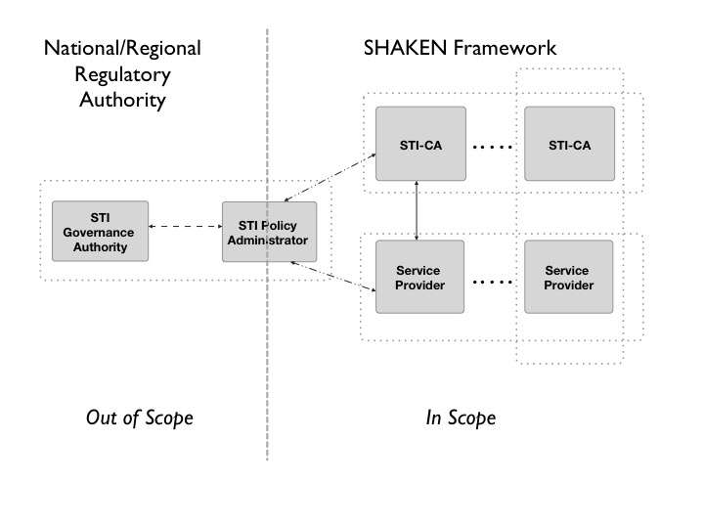
Figure 1: Governance Model for Certificate Management

Within the trust model of the SHAKEN Framework, the STI-PA is a Trust Authority external to the PKI; it does not issue certificates. However, the STI-PA maintains the Trust List of authorized STI-CAs which each establish their own PKI, per the following diagram:
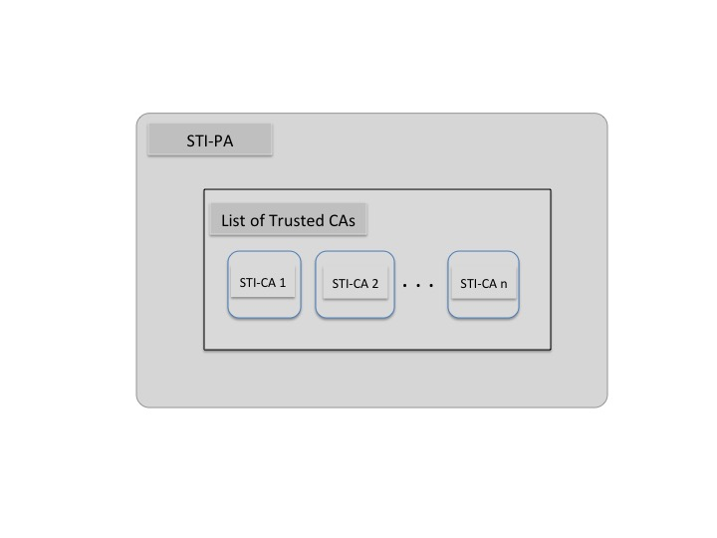

In the SHAKEN model, the STI-PA in its role as Trust Authority defines a Trust Authority Policy as outlined in section 4. The considerations for each of the STI-CAs in terms of Certificate Policy documents established by the STI-PA in its role as Trust Anchor is provided in section 5. Details on the management of the list of STI-CAs are provided in section 6 and the management of the authorized Service providers in section 7.

Trust Authority Policy
In a typical PKI model, the entity deploying a specific STI-CA/PKI would issue Certification Practice Statements (CPS). The STI-PA in its role as policy administrator and the entity that authorizes STI-CAs shall define a Trust Authority Policy, which imposes a Certificate Policy (CP) that shall be supported by the approved STI-CAs.
- Trust shall not be inherited from other STI-CAs in the deployment of the SHAKEN framework (i.e., the STI-PA is the only trust authority). To preclude this, policy mapping shall be inhibited.
- An STI-CA shall notify the STI-PA should it choose to no longer provide STI certificates.
- An STI-CA shall notify the STI-PA if certificates are revoked.
- An STI-CA shall follow recommended procedures to perform CA key rollover.
- An STI-PA may remove an STI-CA from the list of trusted STI-CAs based on specific criteria such as a failure to comply with the CP established by the STI-PA. Typically, compliance is audited and thus guidelines must be established for the timeframe in which an identified problem must be resolved.
[Editor’s note: So, here a question is who establishes that criteria? Is that done by the STI-PA in its role as Trust Authority OR is the role of the STI-GA to establish that criteria?
- Typically a Policy Management Authority (PMA) comprises the set of people to make these decisions. The set is typically comprised of the stakeholders (e.g., service providers in the case of SHAKEN)]

Certificate Policy & Certification Practice Statements
The STI-PAs shall define a Certificate Policy (CP) that defines the policies to be followed by an STI-CA within the SHAKEN framework. Within the SHAKEN framework, the STI-PA imposes some of these policies based on its role as the Trust Authority. The STI-CAs shall produce Certification Practice Statements defining the manner in which they abide by the Certificate Policy, aligning with their role as a CA issuing STI certificates.

Certificate Policy
[Editor’s note: this is a placeholder for items that should be considered/documented]
- Standardize server naming and CA naming to avoid collisions.
- Recommendation to NOT use online Root CAs. Offline CAs should be placed in a secure vault until a new certificate or CRL needs to be issued and published.
- Provide a way to specify extensions to be supported:
  - The CP should include a profile to the extensions for each kind of certificate issued, allowing other extensions so that the CP does not have to be updated for each extension.
- Handling of revoked certificates (e.g., OCSP, CRLs, short lived certificates)
- Use a Key Recovery Agent and Data Recovery agent to recover important data balancing with the importance of keeping this secure.
- Make sure system time on CA is properly set (e.g., use a secure form of NTP)

Certification Practice Statement

Managing List of STI-CAs

Per the SHAKEN Governance and Certificate Management Framework, the STI-PA shall manage a list of valid CAs. This list shall be distributed to each of the Service Providers for use in verifying that the STI-CA that issued the certificate has been authorized by the STI-PA.

Managing the list of STI-CAs introduces an additional interface from the STI-PA to the STI-AS and STI-VS:
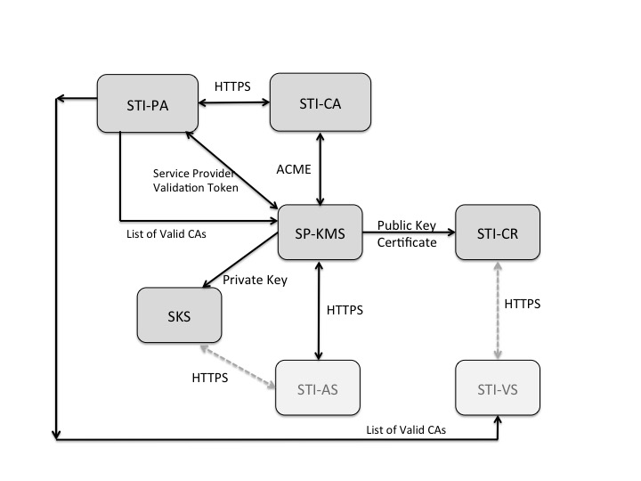
The STI-PA is responsible for the following prior to including an STI-CA in the Trust List. The STI-PA shall only add an STI-CA to the list of Trusted STI-CAs based upon the following:
- Reviewing the Certification Practice Statement of the STI-CA to determine that the PKI in which it resides is operated to an acceptable level of assurance
- Ensuring that the policies as identified in section 5 are supported
- Determining that the STI-CA/PKI provides a warranty with regards to the issued certificates.

Format of STI-CA List
[Editor’s note: Details of what is stored in the List of Valid CAs (e.g., Domain Name, etc.)]
Along with the individual entries, the list shall contain a counter that is incremented by one each time a new list is provided by the STI-PA. The list shall also contain a field indicating an expiry (e.g., notAfter field). If the list has expired, the Service provider shall request an updated list.

Distributing Trusted STI-CA List
One approach for distributing the trusted STI-CA list is using an API over HTTPS. In this case the STI-PA could sign the STI-CA list, also allowing it to be securely stored by the Service Provider.
Another approach is to use a signed PKCS#7/CMS [RFC 5652] container with the list of STI-CAs. Since this provides a signed data structure, the Service Provider can securely store it in their file system or database. The STI-VS shall verify the signature on the list each time the list is referenced.
In order to allow a Service Provider to determine the validity of an issued certificate, it is important that the list of valid STI-CAs is updated on a regular basis (e.g., daily). Details of the lifecycle management of the Trusted STI-CA list is provided in section 7.3.

Lifecycle of Trusted STI-CA List
This section discusses considerations and management of the lifecycle of the STI-CA list. Criteria by which a STI-CA would be removed from the Trust List are described in section 4 and are subject to policy considerations. In the case that an STI-CA is to be removed from the list, in order to minimize the timeframe during which certificates issued by that STI-CA are being used for active calls, the STI-PA shall send an updated list to the Service Providers. In addition, it is recommended that the expiry of certificates be a shorter interval than the frequency at which an updated Trust List is distributed in order to reduce the number of active calls that might be using a certificate issued by an STI-CA that has been removed from the list

STI-PA administration of Service Providers
The STI-PA shall maintain a list of valid Service Providers as represented by Service Provider Codes. The assignment of Service Provider Codes is outside the scope of this document. The assumption is that the STI-GA provides this list and a mechanism to periodically validate/renew the Service Provider Codes in this list.
The trust model for SHAKEN defines the STI-PA as the Trust Anchor for the token-based mechanism for validation of Service Providers within a national/regional administrative domain. Per the SHAKEN Governance model and certificate management framework, the STI-PA issues Service Provider Code tokens to Service Providers. The STI-PA shall also provide guidelines for the renewal and revocation of Service Provider Code tokens.

