ATIS/SIP Forum IP NNI Task Force
Virtual Meeting
July 11, 2017
Contribution

TITLE: Proposed Outline for the Display of Verified Caller ID
SOURCE*: Hala Mowafy (Ericsson) and Jonathan Nelson (Hiya)
ISSUE NUMBER:
_______________________________
Abstract
This contribution introduces a proposed outline for sections 6 and 7 of the “Technical Report on a Framework for Display of Verified Caller ID” [IPNNI-2017-00019R2]. The skeletal text provides a list of the different aspects of the display that assess the risk associated with incoming calls (e.g., scam robocalls). The contribution summarizes how the data available from the network (attestations and verification) and the data available from analytics influence the display.

_____________________________

ATIS-0x0000x

ATIS Standard on

ATIS Technical Report on a Framework for Display of Verified Caller ID

Alliance for Telecommunications Industry Solutions

Approved Month DD, YYYY

Abstract
This document provides a Technical Report on Originating Party Spoofing in IP Communication Networks. It describes problems associated with originating party spoofing in IP communication networks, identifies potential mitigation options, analyze pros and cons of mitigation options.

Foreword
The Alliance for Telecommunications Industry Solutions (ATIS) serves the public through improved understanding between carriers, customers, and manufacturers. The [COMMITTEE NAME] Committee [INSERT MISSION]. [INSERT SCOPE].
The mandatory requirements are designated by the word shall and recommendations by the word should. Where both a mandatory requirement and a recommendation are specified for the same criterion, the recommendation represents a goal currently identifiable as having distinct compatibility or performance advantages. The word may denotes a optional capability that could augment the standard. The standard is fully functional without the incorporation of this optional capability.
Suggestions for improvement of this document are welcome. They should be sent to the Alliance for Telecommunications Industry Solutions, [COMMITTEE NAME], 1200 G Street NW, Suite 500, Washington, DC 20005.
At the time of consensus on this document, [COMMITTEE NAME], which was responsible for its development, had the following leadership:

[LEADERSHIP LIST]

The [SUBCOMMITTEE NAME] Subcommittee was responsible for the development of this document.

Revision History
Date | Version | Description | Author

Table of Contents

[INSERT]

Table of Figures

[INSERT]

Table of Tables

[INSERT]

Scope, Purpose, & Application.

Normative References
The following standards contain provisions which, through reference in this text, constitute provisions of this Standard. At the time of publication, the editions indicated were valid. All standards are subject to revision, and parties to agreements based on this Standard are encouraged to investigate the possibility of applying the most recent editions of the standards indicated below.

Definitions, Acronyms, & Abbreviations
For a list of common communications terms and definitions, please visit the ATIS Telecom Glossary, which is located at < http://www.atis.org/glossary >.

Architecture
Editor’s note: add figure illustrating various access technologies and a variety of device types (UEs).

Signaling of Verified Caller ID

Display Guidelines for All IP Networks and Devices
The guidelines herein are provided for screen-based devices, such as smartphones, operating an all-IP network.
Considerations for other scenarios of analog devices served by IP networks, or by circuit-switched networks will be discussed in Section 7.

Entities that shape the display
There are multiple entities responsible for the ultimate message delivered to the user about the trust level of incoming calls.
Each entity may be responsible for data that is signaled, processed, or displayed at different points in the call setup.
Editor's Note: This section proposes the following entities as the key contributors to the ultimate display and the role each one plays. Other entities may be added in the future, if deemed necessary.

IP Network
The originating network is responsible for signaling the Identity header containing the pertinent claims and attestations about the calling number, per draft-ietf-stir-rfc4474bis and ATIS-1000074.

The terminating network is responsible for verifying the received claims. Results of the verification are inserted by the AS in the "verstat" tel URI parameter to provide the UE with the calling identity number verification status in an initial INVITE request.
The Verstat values are as follows:
Table X: Verstat values
Tel URI parameter value | Description
TN-Validation-Passed | The number passed the validation.
TN-Validation-Failed | The number failed the validation.
No-TN-Validation | No number validation was performed.

NOTE: The signaled information between networks is not meaningful to the end user. Further assessment and analysis need to be applied to the data so that a useful "communication" to the end user can be formulated.

Call Validation Treatment (CVT) or Analytics
CVT is a function that analyzes the level of risk associated with the incoming call. CVT may be implemented as part of the terminating network (e.g., in an AS) or in a third-party that partners with the service provider, or in association with a UE application. CVT applies different algorithms to data it obtains on the TN in question. CVTs typically access a multitude of data sources on each TN to improve the accuracy of its results.

User Equipment (UE)
The present document assumes a wireless handset with a screen display.

Interactions among Entities and Key Outputs
It is clear that the data outputs from the network and CVT will be at the center of the message delivered to the user. The CVT function (whether inside or outside the network) may be in a better position to process and assess the trust level of incoming calls.
Therefore, it is recommended that attestation levels and identifiers from SHAKEN be made available to the CVT function under the appropriate carrier and local policies.
Making more information available to the CVT algorithms is likely to yield more accurate results for the user.

Early Implementations
Early versions of anti-robocalling solutions are anticipated to be more conservative.
- Calls with any failed verification at the terminating end would be presented with a warning (independent of the attestation received).
As more experience is earned, and possibly more granularity is added to the signaling, the present guidelines are likely to be revised.

Refinement and Evolution
This section is expected to be a living section that provides input on the following scenarios as user needs evolve.
The table summarizes the available combinations of signaling information to date. The present document needs to assign a treatment for each combination.
The treatment may be carrier-specific or UE-specific.

Table X+1: Call Treatment
Attestation (by the originating end) | Verification (by the terminating network) of the originator's signature/cert | Analytics | Message presented to the UE
A - Full | Passed | Good/Absent | Neutral/normal call profile
 |  | Bad | Warning**
 | Failed | Good/Absent | Warning**
 |  | Bad
 | No Verification performed | Good/Absent | Neutral/normal call profile
 |  | Bad | Warning**
B - Partial | Passed | Good/Absent | Neutral/normal call profile
 |  | Bad | Warning**
 | Failed | Good/Absent | Warning**
 |  | Bad
 | No Verification performed | Good/Absent | Neutral/normal call profile
 |  | Bad | Warning**
C - Gateway | Passed | Good/Absent | Neutral/normal call profile
 |  | Bad | Warning**
 | Failed | Good/Absent | Warning**
 |  | Bad
 | No Verification performed | Good/Absent | Neutral/normal call profile
 |  | Bad | Warning**
** Some service providers may – based on consumer choice and consent - block these marked calls instead of completing them with a warning.

Potential Outcomes/Displays

Full Attestation and Verification Passed (no analytics)
In this scenario, the user does not subscribe to a CVT service. The delivery of the Verstat (TN validation passed) delivers the call to the UE without warnings (or affirmations). The logo and location (city and state) of the caller is retrieved and delivered by eCNAM.
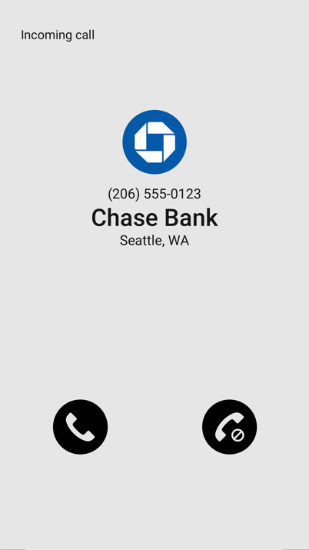

Gateway Attestation, Verification Passed, subscribes to analytics (analytics bad)
In this scenario, the user subscribes to a CVT service that provides analytics. A gateway attestation is inconclusive to the caller, but an analytics service has flagged the caller as a robocaller. Therefore, a warning is provided to the user.
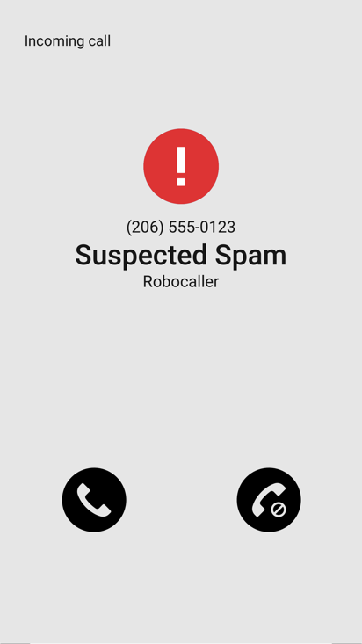

Verification Failed

If the verification failed, CVT may not be necessary or be used. There are several possible outcomes.
The service provider may simply block the call from terminating to the end user, per the subscriber's request.
Alternatively, a warning would be provided along with an explanation of the reason behind the warning. The subscriber is then forewarned and empowered to manage incoming calls based on all the information made available. A CVT service may be able to provide more useful reasoning, but is not expected to.
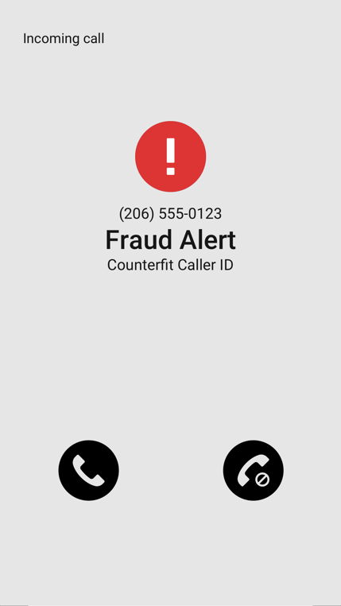

User Perspective

Usability Studies
Background and size of study groups
What did users prefer in terms of symbols and verbal messages, colors, order of display?
Other human factors [TBD].

Basic recommendations on the Display or Message delivery to the UE
As a result of the above studies, it is recommended that [ the following are examples of recommendations for further discussion]:
- The FTC is encouraged to sponsor usability studies with different focus groups (age, education, ethnic background, devices used, etc.) to increase the usefulness of the displays and hone the guidelines.
- eCNAM delivers the aggregate of all the information available about the TN (caller identity, results of CVT analytics, and information queried by the terminating provider)
- The use of CVT functions be extended to more end users.
- The use of multiple symbols in a given display is discouraged. If the display contains the results of signaling as well as analytics, and a conflict exists between the two, then assigning conflicting symbols will detract from the value the service is providing.,
- Audible special ringing/tone to be applied on calls that fail verification.
- Minimize length of verbal messages to a choice of tested, effective phrases (the following are examples for further discussion):
  - Warning
  - Fraud Alert
  - Possible Scam
  - More from human factors experts

ADA Considerations
- 8% of the male population are color-blind. Therefore, the display should not rely heavily on red and green to convey results.
- Ensure messages are clearly understood without relying on colors (e.g., via text or sound)
- Consider audio announcements for the visually impaired before the call is completed (within the limits of post-dial delays)

RECOMMENDATIONS
Capture from entire section

Display Guidelines for Analog Devices

Analog Devices connected to an IP Network
Limited Screen display
Are these devices capable of handling
a) PASSport's attestation levels
b) results of verification (Verstat), and
c) displaying analytics results?

Analog Devices connected to CS Network

Available Solutions
Devices that apply black and white lists with updates from FTC and FCC registries.
Devices that apply simultaneous ringing and block suspect calls, per the user's request.
More.

Related SDOs and Fora

Conclusions

Annex A
(normative/informative)

A Illustrative Examples
This annex will document supportive material

