ATIS-0x0000x

ATIS Standard on

Signature-based Handling of Asserted Information Using Tokens (SHAKEN): Governance Model and Certificate Management

Alliance for Telecommunications Industry Solutions

Approved Month DD, YYYY

Abstract
Signature-based Handling of Asserted information using Tokens (SHAKEN) is an industry framework for managing and deploying Secure Telephone Identity (STI) technologies with the purpose of providing end-to-end cryptographic authentication and verification of the telephone identity and other information in an IP-based service provider voice network. This specification expands the SHAKEN framework, introducing a governance model and defining the X.509 certificate management procedures. Certificate management provides mechanisms for validation of the certificate and verification of the signature, allowing for the identification of illegitimate use of national telecommunications infrastructure.

Foreword
The Alliance for Telecommunications Industry Solutions (ATIS) serves the public through improved understanding between carriers, customers, and manufacturers. The [COMMITTEE NAME] Committee [INSERT MISSION]. [INSERT SCOPE].
The mandatory requirements are designated by the word shall and recommendations by the word should. Where both a mandatory requirement and a recommendation are specified for the same criterion, the recommendation represents a goal currently identifiable as having distinct compatibility or performance advantages. The word may denotes an optional capability that could augment the standard. The standard is fully functional without the incorporation of this optional capability.
Suggestions for improvement of this document are welcome. They should be sent to the Alliance for Telecommunications Industry Solutions, [COMMITTEE NAME], 1200 G Street NW, Suite 500, Washington, DC 20005.
At the time of consensus on this document, [COMMITTEE NAME], which was responsible for its development, had the following leadership:

[LEADERSHIP LIST]

The [SUBCOMMITTEE NAME] Subcommittee was responsible for the development of this document.

Revision History
Date | Version | Description | Author
October 4, 2016 | 0.1 | Initial Draft | Mary Barnes
 | 0.2 | Baseline Draft

[Editorial – remove prior to letter ballot – idea is just to keep track of what changes have gone into what version :
Summary of changes for version -00067R009/00067R010 :
- Reorganization of document based on input from Chris Wendt and Ken Politz :
  - Removes section with background on protocols and adds a summary
  - Moves section on Governance (i.e., section 5.3 in baseline IPNNI-2016-00067R008) with regards to the process of establishing the CAs and the criteria to be a Service provider which are outside the scope of the protocol details in this document, to an Appendix.
- Editorial changes related to the reorganization (i.e., intro paragraphs, summaries, etc. to guide the reader through the material.
- Purely editorial changes from individual contributions that were not reviewed/agreed at virtual meeting on 11/21/2016 including IPNNI-2016-00081R000 and IPNNI-2016-00084R000 including editorial notes that indicate placeholders for content to fill out details in ACME section.

]
Table of Contents

[INSERT]

Table of Figures

[INSERT]

Table of Tables

[INSERT]

Scope & Purpose

Scope
This document expands the SHAKEN framework, defining a Governance model and certificate management procedures for Secure Telephone Identity (STI) technologies.

Purpose
This document introduces a Governance model and certificate management procedures to the SHAKEN framework [ATIS-1000074]. The Governance model defines recommended roles and relationships, such that the determination of who is authorized to administer certificates for VoIP networks can be established. This model allows for the application of specific regulatory requirements independent of the mechanisms for certificate management. The certificate management is based on the definition of roles similar to those defined in “Internet X.509 Public Key Infrastructure Certificate and Certificate Revocation List (CRL) Profile”, IETF RFC 5280. Per the SHAKEN framework, the certificates themselves are based on X.509 with specific policy extensions. The objective of this document is to provide recommendations and requirements for implementing the protocol specifications to support certificate management for the SHAKEN framework.

Normative References
The following standards contain provisions which, through reference in this text, constitute provisions of this Standard. At the time of publication, the editions indicated were valid. All standards are subject to revision, and parties to agreements based on this Standard are encouraged to investigate the possibility of applying the most recent editions of the standards indicated below.

ATIS-1000074 Signature-based Handling of Asserted Information using Tokens (SHAKEN)
draft-ietf-stir-passport
draft-ietf-stir-rfc4474bis
draft-ietf-stir-certificates
IETF RFC 5280 - Internet X.509 Public Key Infrastructure Certificate and Certificate Revocation List (CRL) Profile
draft-ietf-acme-acme Automatic Certificate Management Environment (ACME)
RFC 2986 PKCS #10: Certification Request Syntax Specification Version 1.7
RFC 5280 Internet X.509 Public Key Infrastructure (PKIX) Certificate and Certificate Revocation List (CRL) Profile
RFC 5958 Assymetric Key Package
RFC 6960 Online Certificate Status Protocol (OSCP)

Definitions, Acronyms, & Abbreviations
For a list of common communications terms and definitions, please visit the ATIS Telecom Glossary, which is located at < http://www.atis.org/glossary >.

Definitions
Caller ID: the originating or calling parties telephone number used to identify the caller carried either in the P-Asserted-Identity or From header fields.
Telephone Number Certificate Repository (TN-CR): This term is used in ATIS-1000074 and is synonymous with the term Secure Telephone Identity Certificate Repository (STI-CR) used in this document.

Acronyms & Abbreviations

ATIS | Alliance for Telecommunications Industry Solutions
NNI | Network-to-Network Interface
PSTN | Public Switched Telephone Network
STI | Secure Telephone Identity
VoIP | Voice over Internet Protocol

Overview

This document defines a Governance model and Certificate Management procedures for the SHAKEN framework [ATIS-1000074]. SHAKEN is defined as a framework that utilizes protocols defined in the IETF STIR working group (WG) that work together in an end-to-end architecture for the authentication and assertion of a telephone identity by an originating service provider and the verification of the telephone identity by the terminating service provider. This document provides recommendations and requirements for implementing the IETF STIR WG protocol specifications, draft-ietf-stir-passport, draft-ietf-stir-rfc4474bis, and draft-ietf-stir-certificates, to support certificate management for the SHAKEN framework.
The SHAKEN framework uses X.509 certificates, as defined in “Internet X.509 Public Key Infrastructure Certificate and Certificate Revocation List (CRL) Profile”, IETF RFC 5280, to verify the digital signatures associated with SIP Identifiers. Section 6 of this document defines how the certificates are managed and created using a governance model where there is a central policy administrator that authorizes telephone service providers (SPs) to acquire certificates from trusted Certification Authorities (CAs). The governance model is described in section 5 of this document.

SHAKEN Governance Model

This section defines a governance model to support STI by introducing two additional functional entities into the SHAKEN framework: a Governance Authority and an STI Policy Administrator. Section 5.1 defines some baseline requirements that lead to this model and section 5.2 defines the roles and responsibilities of these functional elements and the relationship to the STI Certification Authority and Service provider.

Requirements for Governance
[Editor’s Note: the first two paragraphs of this section were previously in section 4.3 “Requirements for Certificate Management”. These requirements were split between the Governance Model section and the Certificate Management section.]
The governance, creation and management of certificates to support STI introduce some requirements beyond typical web PKI. The original PKI model RFC 1422 defines a hierarchy including an Internet Policy Registration Authority (IPRA) at the top level, Policy Certification Authorities (PCAs) below the IPRA and then the CAs at the 3rd level.
The existing RFC 5280 model has no hierarchy and is a more distributed model. STI requires some hierarchy in terms of governance to ensure that those requesting certificates are valid Service Providers and that those issuing certificates are valid Certification Authorities.
In order to support these requirements, a process for establishing STI Certification Authorities and the criteria by which a Service Provider can obtain certificates is required. The details of this process, which is outside the scope of the protocols and recommendations described in this document are provided in section 7 (Appendix A).

Certificate Governance: Roles and Responsibilities
The SHAKEN model for Governance of Certificate Management for Service providers to support STI is illustrated in the following diagram.
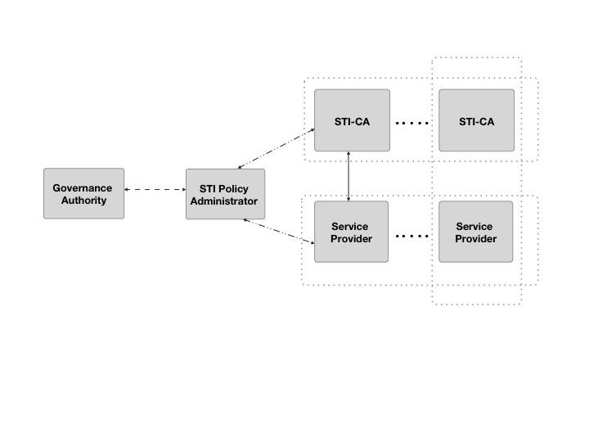
Figure 2: Governance Model
This diagram identifies the following roles associated with certificate management:
- Governance Authority (GA)
- Secure Telephone Identity Policy Administrator (STI-PA)
- Secure Telephone Identity Certification Authority (STI-CA)
- Service Provider (SP)

The Governance Authority (GA) and the STI Policy Administrator are distinct roles in this model, though in practice both roles could be performed by a single entity. The GA is the root of trust for all STI certificates within a given area. For example, all certificates in the United States would be associated with a single root of trust, while other countries could have a different root of trust. It is also worth noting that although the STI Certification Authority and Service Provider are distinct roles, it is also possible for a Service Provider to establish an internal STI Certification Authority for their own use.
The following sections describe these roles in more detail.

Governance Authority
The Governance Authority is responsible for defining and modifying the policies and rules that the STI Policy Administrator will use to authorize STI-CAs and to validate Service Providers. It is anticipated that the Governance Authority would be structured as a Committee or as a Board of Directors. The criteria for membership/ participation in the Governance Authority is out of scope for SHAKEN. Note, that the role of the Governance Authority is similar to the IPRA in the RFC 1422 model with the exception that it does not issue certificates for the Policy Certificate Authority.

Secure Telephone Identity Policy Administrator
The STI Policy Administrator will apply the rules and policies defined by the Governance Authority to confirm that service providers are authorized to request certificates and to authorize STI Certification Authorities to Issue the certificates.
The STI-PA functions very similar to a PCA in the RFC 1422 model as it effectively certifies the STI-CAs and validates the Service providers. In X.509, there are two types of CAs - a root CA and an intermediate CA. The root CA represents the Trust Anchor in a X.509 certificate. When constructing a public key certificate, a certificate chain is created that represents a chain from the domain owner to the trust anchor. The STI-PA serves in the role of a root CA and trust anchor.

Secure Telephone Identity Certification Authority
Analogous to the concept of Certification Authorities in X.509, SHAKEN defines the concept of a STI Certification Authority (STI-CA) In the X.509 model, the STI-CA serves as an intermediate CA. In the North American telephone network, it is anticipated that the number of entities that should act as STI-CAs is a relatively limited number. Certificate signing requests (CSRs) will be processed by STI-CAs and will be linked to STI-PA which is the trust anchor represented in the certificate chain.
[Editor’s note: Look at cross signature hash.]

Service Provider
The Service Provider obtains certificates from the STI Certification Authority. Before obtaining a certificate a service provider must be validated. The criteria by which a service provider is validated is outside the scope of the protocols associated with certificate management. When a service provider creates a certificate signing request, the service provider must prove that it has been validated and is eligible to be issued a certificate. In the context of SHAKEN, the recommendation is that once a service provider has been validated, it will be pre-configured with a token that is then used in the certificate signing request process to prove that it has been validated.
[Editor’s note: Details of the “token” should be included here and may be subject to change depending upon the requirements of the governance authority.]

SHAKEN Certificate Management

Management of certificates for TLS and HTTPS based transactions on the Internet is a fairly well defined and common practice for website and internet applications. Generally, there are recognized certification authorities that can "vouch" for the authenticity of a domain owner based on some out-of-band validation techniques like e-mail and unique codes in DNS.
The certificate management model for SHAKEN is based on Internet best practices for PKI to the extent possible. The model is modified where appropriate to reflect unique characteristics of the service provider based telephone network. Certificates are initially expected to take advantage of service providers’ recognized ability to legitimately assert telephone identities on a VoIP network. The fundamental requirements are identified in section 6.1. Section 6.2 describes new functional elements added to the SHAKEN framework architecture to support certificate management and section 6.3 details the steps and procedures for the issuance of certificates.

Requirements for Certificate Management

This section details the fundamental functionality required for certificate management. An automated mechanism for certificate management is preferred and includes the following fundamental functional requirements:
- A mechanism to determine the Certification Authority to be used to request certificates and the associated registration procedures.
- A process to request issuance of certificates
- A mechanism to validate the requesting Service Provider
- A process for adding certificates to a Certificate Repository
- A mechanism to renew/update certificates
- A mechanism to revoke certificates

In terms of certificate issuance, the primary difference between Web PKI and the requirements for STI is the procedure to validate that the entity requesting a certificate for a specific identifier is authorized to acquire certificates for the entity. Existing mechanisms for Web PKI, including the Automated Certificate Management (ACME) protocol rely on DNS or email. STI uses a token mechanism as described in section 6.3.3.

Certificate Management Architecture

The following figure represents the certificate management architecture for SHAKEN.
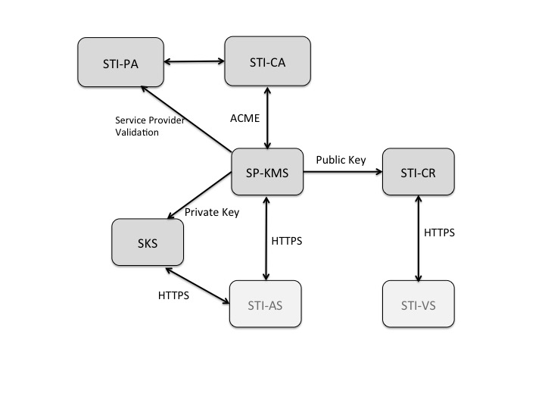
Figure 3: SHAKEN Certificate Management Architecture

The SHAKEN certificate management architecture defines the following elements:
- Secure Telephone Identity Certification Authority (STI-CA) - The STI-CA that processes the Certificate Signing Request (CSR) following a service provider validation process.
- Service Provider Key Management Server (SP-KMS) - The service provider server that generates private/public key pair for signing, requests a certificate from the STI-CA, and receives the STI-CA signed public key certificate.
- Secure Key Store (SKS) - The store for private keys used by the originating service provider Authentication Service.
- Secure Telephone Identity Certificate Repository (STI-CR) - The HTTPS server that hosts the public key certificates used by the destination service provider’s Verification Service to validate signatures.

Certificate Management Process
This section describes two approaches for the detailed process of acquiring a public key certificate – a manual flow and an automated approach using the ACME protocol. While an automated approach is recommended, a manual approach could be useful in the initial stages of testing the STI-AS and STI-VS components of the SHAKEN framework.

Manual CSR Flow
The flow for acquiring a signed public key certificate from a STI-CA would be as follows:
- Generate a PKCS#10 [RFC2314] Certificate Signing Request (CSR).
- Cut-and-paste the CSR into STI-CA web page.
- Prove ownership of the domain by one of the following methods:
  - Put an STI-CA-provided challenge at a specific place on the Authentication Service server.
  - Put an STI-CA-provided challenge at a DNS location corresponding to the target domain.
  - Receive STI-CA challenge at a (hopefully) administrator-controlled e-mail address corresponding to the domain and then respond to it on the STI-CA’s web page.
- Telephony Authority signs public key certificate as root
- Provider downloads the issued public key certificate and stores private key certificate in Secure Key Store associated with Authentication Service and the public key certificate is stored and made publicly available via HTTPS in their Certificate Repository.

ACME based Certificate Management Flow
ACME (draft-ietf-acme-acme) provides a more automated framework and set of protocols for acquiring a STI-CA signed public key certificate. ACME allows a client to request certificate management actions using a set of JSON messages carried over HTTPS, much like a traditional CA.
ACME enables the following certificate management functions:
- Account Key Registration
- Application for a Certificate
- Account Key Authorization (Service Provider Validation)
- Certificate Issuance
- Lifecycle Management of certificates (including Revocation)
[Editor’s note: add detailed sections for Account Key Registration, Application for a Certificate and Certificate issuance in the order above noting that there are already sections for Account Key authorization and Lifecycle management. ]

The ACME processing flow is as follows:
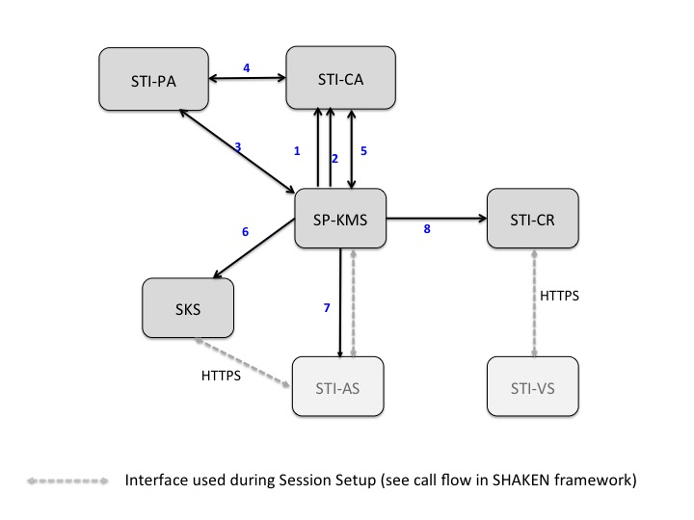
Figure 3 SHAKEN Certificate Management Call Flow

The ACME client on the Service Provider Key Management Server determines the service provider domain the Authentication Service is to represent and the ACME client presents the operator with a list of STI-CAs from which it could get a certificate. The operator selects a Secure Telephone Identity Certification Authority.
- If it has not already done so, the ACME client on the SP-KMS registers with the STI-CA prior to requesting a certificate per the procedures in draft-ietf-acme-acme
- Once the ACME client on the SP-KMS has registered with the STI-CA, the ACME client can send a request for a new certificate to the ACME server hosted on the STI-CA.
- In the context of the SHAKEN framework, the service provider that is requesting a signed certificate needs to be validated and prove ownership of the domain for which a certificate is being requested. In the SHAKEN framework, the STI-PA validates the service provider as described in section 5.4.3
- Once the STI-CA receives the indication that the service provider is authorized, the STI-CA can issue the certificate.
- In parallel with step 4, the ACME client starts polling for the status to determine if the service provider has been authorized to get a certificate and whether a certificate is available. Once the certificate has been issued, the ACME client downloads the certificate for use by the SP-KMS.
- The SP-KMS distributes the private key to the SKS.
- The STI-AS needs access to the URL for the public key when the Identity Header field and the “ppt” header field parameter (i.e., the PASSporT) are being added to an outgoing SIP INVITE request. Thus, the SP-KMS needs to notify the STI-AS that the public and private key pair is available. [The notification (via SIP MESSAGE, WEBPUSH, etc.) can include the URL for public key.]
- The SP-KMS puts the public key in the TN-CR.

After initially retrieving the certificate, the ACME client periodically contacts the STI-CA to get updated public key certificates, CRLs, or whatever else would be required to keep the server functional and its credentials up-to-date as described in section 5.4.4

Account Key Registration

[Editor’s note: add details from IPNNI-2016-00082R000.pdf discussed at 11/21/2016 virtual meeting.]

Application for a Certificate

[Editor’s note: add details from IPNNI-2016-00082R000.pdf discussed at 11/21/2016 virtual meeting.]

Service Provider validation

A process is required that allows the STI-CA to validate that the service provider has the authority to manage certificates for the domain for which a certificate is being requested. In the context of ACME, the ACME client fetches the challenges after the request for a new certificate and then answers the challenges.
ACME uses an extensible challenge/response framework for identifier validation. For this initial deployment of the SHAKEN framework, it is recommended to use HTTP validation per draft-ietf-acme-acme. The ACME client proves its control over the domain by proving that it can provision resources on the Authentication Service server. The STI-CA challenges the ACME client to provide the “token” that has been configured for the service provider as described in section 5.2.2

Certificate Issuance

[Editor’s note: add details from IPNNI-2016-00082R000.pdf discussed at 11/21/2016 virtual meeting.]

Certificate updates/rotation best practices
[Editor’s note: Per Sept. 28, 2016 virtual meeting, Stuart Wilson (Verizon) to submit a contribution proposing changes to this section.]
Consideration of impact of switching certificates and other certificate management impacts while there is in flight calls should be considered. Standard CRL techniques should be considered the initial preferred way of signaling the expiry of a certificate. OCSP techniques could be considered in the future.
[Editors’ note: Look at RFC 6489 (BCP 174) for how a CA performs a planned rollover.]

Evolution of STI certificates

SHAKEN proposes starting with service provider level certificates. There are important use cases that may require telephone number level certificates including School District, Police and government agencies, where calls should be validated in order to guarantee delivery through the potential use of anti-spoofing mitigation techniques.

Appendix A – Governance Process

This section describes the process for establishing Telephone Authorities and the criteria by which a Service Provider can obtain certificates.
Editor’s Note: the text from this section may be pulled out into a separate document in the future

Secure Telephone Identity Certification Authority Criteria
Ultimately this is the responsibility of the Governance Authority, however, the following criteria for becoming a Secure Telephone Identity Certification Authority (STI-CA) is proposed for initial implementation:
- An STI Certification Authority MUST have the necessary certificate management expertise
- An STI Certification Authority MUST have an in-market presence (e.g., be incorporated in the U.S.)

Security Telephone Identity Certification Authority Approval Process
[Editor’s Note: this section will outline the process used by an STI Certification Authority to obtain approval to operate as an STI Certification Authority. The details as to how an STI-CA obtains a certificate signed by the STI Policy Administrator are detailed in section 6.3.]

Service Provider Criteria
Ultimately this is the responsibility of the Governance Authority, but the initial criteria for obtaining Service Provider certificates will be having an OCN (Operating Company Number) as administered by the National Exchange Carrier Association. The OCN is proposed as an objective mechanism to determine that an entity is a service provider and entitled to sign calling party information. Initially there will not be a mechanism to revoke service provider certificates, although the Governance Authority will have the ability to define criteria for revoking certificates (e.g., signing invalid numbers) if it is determined to be appropriate. In addition, as a condition of being validated as a service provider for SHAKEN, service providers should commit to signing calling party information for all calls where it is technically and economically feasible.

