ATIS-0x0000x

ATIS Standard on

ATIS Technical Report on Originating Party Spoofing in IP Communication Networks

Alliance for Telecommunications Industry Solutions

Approved Month DD, YYYY

Abstract
This document provides a Technical Report on Originating Party Spoofing in IP Communication Networks. It describes problems associated with originating party spoofing in IP communication networks, identifies potential mitigation options, analyze pros and cons of mitigation options.

Foreword
The Alliance for Telecommunications Industry Solutions (ATIS) serves the public through improved understanding between carriers, customers, and manufacturers. The [COMMITTEE NAME] Committee [INSERT MISSION]. [INSERT SCOPE].
The mandatory requirements are designated by the word shall and recommendations by the word should. Where both a mandatory requirement and a recommendation are specified for the same criterion, the recommendation represents a goal currently identifiable as having distinct compatibility or performance advantages. The word may denotes a optional capability that could augment the standard. The standard is fully functional without the incorporation of this optional capability.
Suggestions for improvement of this document are welcome. They should be sent to the Alliance for Telecommunications Industry Solutions, [COMMITTEE NAME], 1200 G Street NW, Suite 500, Washington, DC 20005.
At the time of consensus on this document, [COMMITTEE NAME], which was responsible for its development, had the following leadership:

[LEADERSHIP LIST]

The [SUBCOMMITTEE NAME] Subcommittee was responsible for the development of this document.

Revision History
Date | Version | Description | Author

Table of Contents

[INSERT]

Table of Figures

[INSERT]

Table of Tables

[INSERT]

Scope, Purpose, & Application

Scope
This technical report provides analysis of originating party spoofing mitigation techniques in the converged IP communication network environment. The scope includes the following:
- Summary description of the problems associated with originating party spoofing in IP communication networks
- Provide an analysis of the following mitigation techniques:
  - 3GPP PAI trust model;
  - ATIS Verified Token;
  - STIR: signing parts of SIP messages based on RFC 4474bis ;
  - Blacklists (local and global);
  - Whitelists (local and global);
  - Honey Pots;
  - Post call notification (e.g., dial a “*” code after hanging up);
  - Network Verification of SIP PAI/FROM for IP PBX call originations
  - Do Not Originate

Purpose
The purpose of this document is to provide an analysis of the available and proposed mitigation techniques, and guidance on standard approaches for addressing originating party spoofing.

Application
ATIS member companies may rely on this paper to conduct meetings with policymakers at all levels of government who are dealing with constituents’ concerns about Caller ID Spoofing and Robocalling. Those meetings may educate government officials about these practices and may involve advocacy against premature regulation and legislation that could cement solutions or create regulatory barriers to the flexibility industry needs to mitigate Caller ID Spoofing and Robocalling.

Normative References
The following standards contain provisions which, through reference in this text, constitute provisions of this Standard. At the time of publication, the editions indicated were valid. All standards are subject to revision, and parties to agreements based on this Standard are encouraged to investigate the possibility of applying the most recent editions of the standards indicated below.
- ATIS-0300114 - ATIS Standard on Next Generation Interconnection Interoperability Forum (NGIIF) Next Generation Network (NGN) Reference Document Caller ID and Caller ID Spoofing
- Draft 3GPP TR 33.8de V0.4.0, Security study on spoofed call detection and prevention.

Definitions, Acronyms, & Abbreviations
For a list of common communications terms and definitions, please visit the ATIS Telecom Glossary, which is located at < http://www.atis.org/glossary >.

Definitions
Attestation: This is the declaration made by a network operator that the party placing a particular call is authorized to represent themselves by a particular caller identity. The party placing the call may not be the identity owner, rather is authorized by the identity owner to represent the identity owner.
Borrowed E.164 number: This is the E.164 number that a borrowing user has obtained permission from the identity owner to use as caller identity when making calls on behalf of the identity owner.
Borrowing operator: This is an operator who is not able to assign a specific E.164 number controlled since it is controlled by a different operator (see controlling operator). A borrowing user subscribed to a borrowing operator is authorized to use a borrowed E.164 number as caller identity in calls made on behalf of the identity owner.
Borrowing user: This is the user subscribed to a borrowing operator and is authorized by the identity owner to use the caller identity for calls made on behalf of the identity owner.
Caller identity: The originating phone number included in call signalling used to identify the caller for call screening purposes.In some cases this may be the Calling Line Identification or Public User Identity. For the purposes of this study, the caller identity may be set to an identity other than the caller’s Calling Line Identification or Public User Identity.
Controlling operator: This is the network operator who controls and the assignment of a specific E.164 phone number to a subscribed user for call routing and caller identity use.
Identity owner: This is the user, subscribed to the controlling operator, who is currently assigned a specifc E.164 phone number for call routing purposes. This E.164 number may be presented to a called party as the user;s calling party identity.The identity owner can authorize other users or subscribers of controlling or non-controlling operators to also use the E.164 number as caller identity in phone calls made on the identity owner's behalf.
Spoofed call: A call where caller identity creation, modification or removal in call signalling results in an unauthorized or illegal use of this identity in the call., This typically occurs where the caller intends to defraud the called party or otherwise illegally obscure the real caller identity.

Acronyms & Abbreviations

ANI | Automatic Number Information
ANSI | American National Standards Institution
ATIS | Alliance for Telecommunications Industry Solutions
Caller ID | Caller Identification Services
CLEC | Competitive Local Exchange Carrier
CLI | Calling Line Identity/ Identification
CLIP | Calling Line Identification Presentation
CNAM | Calling Name
CND | Calling Number Delivery
CPE | Customer Premise Equipment
CPN | Calling Party Number
CSR | Certificate Signing Request
CVT | Call Validation Treatment
DNSSEC | Domain Name System Security Extensions
eCNAM | Enhanced Calling Name
FCC | Federal Communications Commission
FTC | Federal Trade Commission
HTTP | Hypertext Transfer Protocol
HTTPS | HTTP Secure
IBCF | Interconnection Border Control Function
IETF | Internet Engineering Task Force
IETF STIR | Secure Telephone Identity Revisited, an IETF Working Group
IMS | IP Multimedia Subsystem
ISP | Internet Service Provider
IP | Internet Protocol
LEC | Local Exchange Carrier
M³AAWG | Messaging Malware Mobile Anti-Abuse Working Group
MIME | Multipurpose Internet Mail Extensions
NGN | Next Generation Network
POTS | Plain Old Telephone Service
PSAP | Public Safety Answering Point
PSTN | Public Switching Transition Network
PTSC | Packet Technologies and Systems Committee, an ATIS Committee
RFC | Request for Comments, an IETF publication
SIP | Session Initiation Protocol
SP | Service Provider
TCPA | Telephone Consumer Protection Act of 1991
TN | Telephone Number
TSR | Telemarketing Sales Rules
UE | User Equipment
VoIP | Voice Over Internet Protocol

Call Scenarios
The range of possible calling scenarios in the above sections can be illustrated with the following diagram. Reality is actually far more complex than this diagram suggests, with many suppliers providing the equipment within each category shown below, and different software releases, with different functionality, for each supplier’s equipment. In addition, in many cases the equipment has been manufacturer-discontinued, or the supplier is no longer in business.
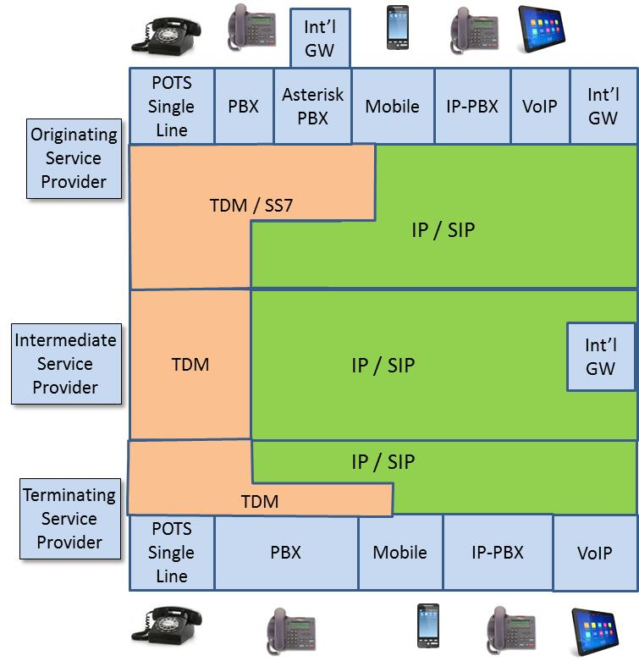

Although this diagram is a simplification of the range of calling scenarios found in today’s network, it is close enough to illustrate the limitations of simplistic approaches claiming to “solve” the problem of caller-id spoofing.
As terminating service providers consider mechanisms to stop unwanted calls, and in particular as they investigate “Caller-id spoofing” mitigation techniques, their options are limited by the fact that they do not have an end to end view of the full path of the incoming call. As a result, they do not have reliable information on where the call originated, and do not have any information that would allow meaningful estimates of the accuracy of the calling party information in the call signaling. This can be illustrated by the following diagram showing the terminating service provider’s view of an incoming call.
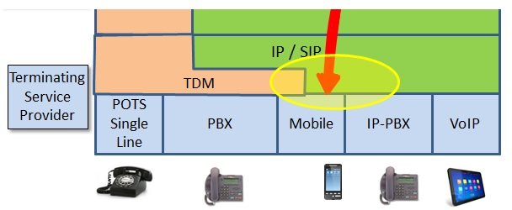

The terminating service provider knows that an incoming call is coming from an intermediate service provider, over an IP connection with SIP signaling, but that is all it can see. If the picture is expanded to show some of the possible sources of this incoming call, a far more complex picture emerges.
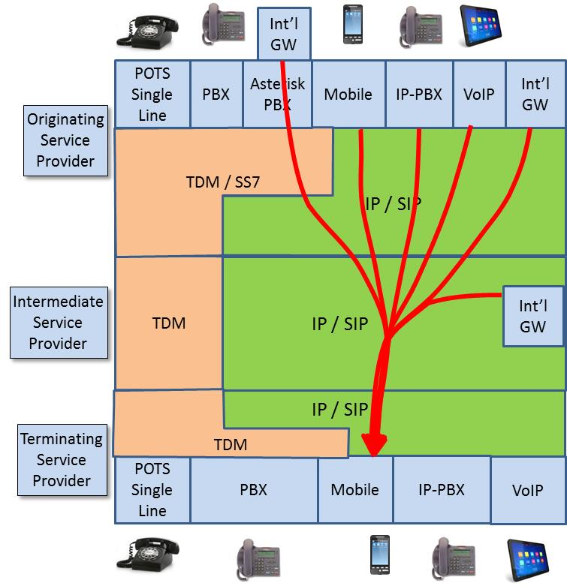

The inability of the terminating service provider to have any knowledge of the source of a call complicates attempts to mitigate caller-id spoofing and makes it impossible to rely on the accuracy of the incoming calling party information. This undermines the effectiveness of mechanisms intended to stop malicious calls.
Key insights emerge if one views this from the perspective of a con man, spoofing the caller-id to convince you a call is from the IRS. Today, an abundance of tools are available to spoof the caller-id. It has been suggested the best strategy is to identify today’s dominant weak spot, and develop a targeted “solution” – a “silver bullet”. The International Gateway is sometimes identified as the critical weak link in the existing system, and it has been suggested that addressing that weakness will “solve the problem”. The following diagram illustrates some of the limitations of a simplistic approach like this.
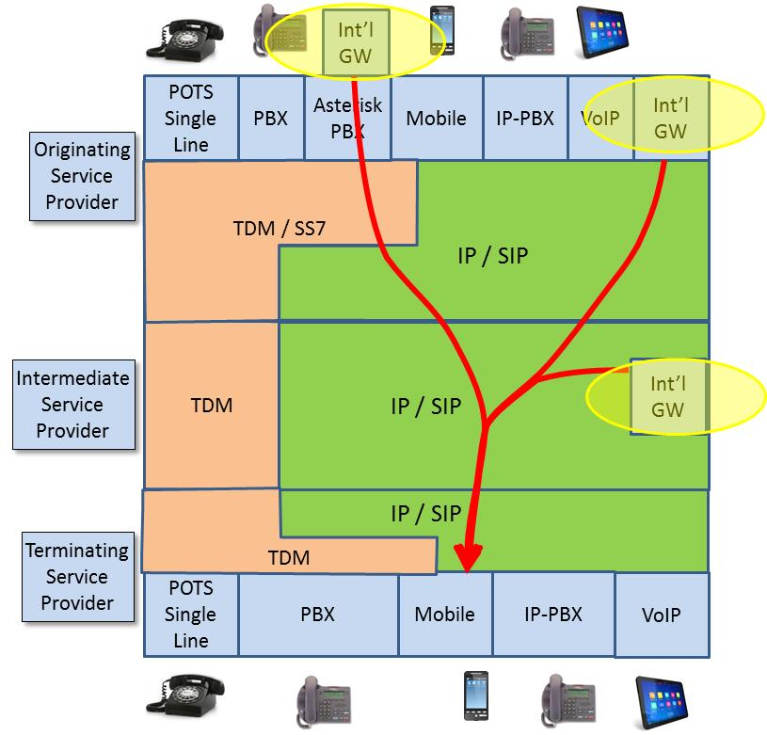
This illustrates that the “international gateway problem” is not in fact just one “problem”, since international gateway traffic can enter the network in many ways. Mandating a solution to block one of these routes, would simply shift traffic to other approaches, including new methods not shown here.
The challenges can also be illustrated by examining one of the more complex scenarios today, where an international gateway is “hidden” behind an enterprise Asterisk PBX, as shown below.
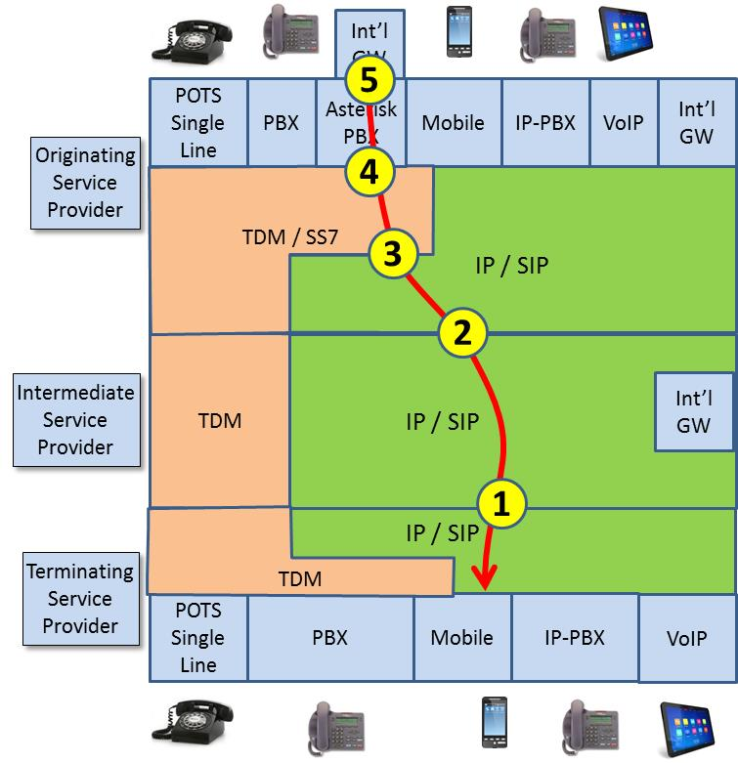
This diagram illustrates some of the points in this traffic flow where problems with calling party mitigation techniques occur today:
- When traffic is passed from the intermediate service provider to the terminating service provider, no mechanism is defined to identify if calling party information has been validated, or the source of the information. The only information available is whether or not the service provider is “trusted”. Potential solutions are being developed for SIP signaling, but nothing exists or could be developed for TDM traffic.
- When traffic is passed from the intermediate service provider to the terminating service provider, no mechanism is defined to identify if calling party information has been validated, or the source of the information. The only information available is whether or not the service provider is “trusted”. Potential solutions are being developed for SIP signaling, but nothing exists or could be developed for TDM traffic.
- In the future, mechanisms may be defined to indicate that the calling party information has been validated, but if that traffic originated in a TDM/SS7 network, it is impossible to obtain reliable information about the origination point. The end-to-end information is limited by the SS7 network, even though most of the signaling path is via SIP.
- Today, calling party information is inserted by the PBX and is not validated by the network. In the case of TDM equipment, it would be impossible to change this since the majority of the equipment is no longer supported by the manufacturer.
- The ultimate source of the traffic may be an “international gateway” that is “hidden” behind an enterprise PBX. The nature of equipment such as an Asterisk PBX makes it very inexpensive to integrate international gateway functionality into the PBX and create new entry points for malicious traffic. The service provider does not have any mechanism to stop, or even to detect, this situation.
As this example makes clear, addressing the challenges of calling party spoofing requires an end-to-end perspective that addresses a wide range of service providers, equipment, and functionality.

Calling party spoofing is not a single, well-defined problem that can be addressed with a single “silver-bullet solution”. It’s helpful to use the analogy of a flood to better understand the situation. If the problem is a single leak in the dyke, one small finger is enough to stem the flow. But if a sieve is the only thing holding back the flood, clearly a different approach is required. A realistic strategy must address specific threats where practical, but must also take a layered approach that adds secondary defenses to minimize the impact when even the best defense is inevitably bypassed. The strategy must also recognize that the threat is not static. As one threat vector is blocked, the attacks will shift to other weak points, and even discover new approaches that do not yet exist. Effective mechanisms to mitigate calling party spoofing must recognize this reality, and be structured accordingly.

Problem Descriptions

Valid caller identity scenarios

Introduction
This section describes representative call scenarios where the caller identity presented to the called user is allowed and valid. Some of the scenarios describe situations where the caller identity presented is different from the caller's identity. These scenarios assume the presence of a call spoofing detection capability in the terminating network.

Simple call scenario
A caller places a call and that caller's caller identity is presented to the called user. The terminating network is able to verify the attestation by the controlling operator's originating network of the caller's identity.

Privacy restriction call scenario
A caller places a call and as part of the call, the caller identity of the caller and a privacy indication is sent to the terminating network. The terminating network is able to verify the attestion by the controlling operator's originating network of the caller identity, but does not present the caller identity to the called user.

Roaming local breakout call scenario
A caller places a call while roaming and the caller's caller identity is presented to the called user. The terminating network is able to verify the attestation by the home PLMN of the caller identity.

Doctor call scenario
A doctor is subscribed to different operators for his mobile service and office phone service. The doctor is performing hospital rounds and calls a patient from his UE. The doctor does not want the patient to have his UE's E.164 number, and the patient would not recognize the number. Rather the doctor's UE replaces the caller identity in the call with the E.164 number of his office. This office number is presented to the patient (called user).

Contract call center attested to by controlling operator
A contract call center is engaged in an outbound advertising campaign for several months on behalf of ABC Company. The contract call center and ABC Company each subscribe to different network operators. ABC Company as the identity owner has given permission for the contract call center as the borrowing user to use ABC Company's E.164 number as the caller identity in calls placed as part of the campaign.
In this scenario, the operator that ABC Company has subscribed to as the controlling operator wants to provide the attestation that the contract call center is authorized by ABC Company to use the ABC Company E.164 number for caller identity in the outbound calls from the call center.
The terminating network uses the caller identity credentials provided by the controlling operator to verify that the caller identity is a valid use.

Contract call center attested to by the borrowing operator
A contract call center is engaged in a fundraising campaign for a non-profit organization XYZ. The contract call center and XYZ each subscribe to different network operators. XYZ as the identity owner has given permission for the contract call center as the borrowing user to use XYZ's E.164 number as the call identity in calls placed as part of the campaign.
In this scenario the operator that the contract call center has subscribed to as the borrowing operator wants to provide the attestation that the contract call center is authorized by XYZ to use the XYZ E.164 number for caller identity in the outbound fundraising calls from the call center.
The terminating network uses the caller identity credentials provided by the borrowing operator to verify that the caller identity is a valid use.

IP-PBX call scenario
An employee of a company using an IP-PBX places a call to another party outside of the IP-PBX. The controlling operator that the IP-PBX is connected to verifies that the caller identity provided is assigned to the IP-PBX and attests to the caller identity validity. It is assumed that any restriction by specific IP-PBX users to use specific assigned IP-PBX numbers for caller identity if present, is performed by the IP-PBX.
The terminating network uses the caller identity credentials provided by the controlling operator of the IP-PBX to verify that the caller identity is a valid use.

Call originating from a non-IMS SIP based network
A subscriber of a network which is SIP based but has not deployed IMS capabilities calls a user who is subscribed to a terminating network which is IMS based. The terminating network is able to verify the attestation by the controlling operator's originating network of the caller identity even though 3GPP defined IMS SIP extensions are not present in the call signaling.

Invalid caller identity scenarios (Spoofed Calls)

Introduction
This clause describes representative call scenarios where the caller identity presented to the called user is not allowed or invalid. These scenarios assume the presence of a call spoofing detection capability in the terminating network.
A caller intending to commit fraud places a call and sets the caller identity to an invalid or unauthorized number (it may or may not be a valid E.164 number) which is presented to the called user. The terminating network is able to verify that the caller is not authorized to use the provided caller identity.
Examples of spoofed caller identities include:
- Unassigned E.164 numbers
- Invalid E.164 numbers
- E.164 numbers local to the called user
- The called user's own E.164 number (called number)
- E.164 numbers billed at international rates

Spoofed calls
The Truth in Caller ID Act prohibits spoofing, or deliberately falsifying the telephone number (TN) and/or name relayed as the Caller ID information to disguise the identity of the caller for harmful or fraudulent purposes. However, the law only applies to callers within the United States.
- Reflection spoofing (i.e., spoofing the called TN in the Caller ID).
- Random number generators providing spoofed TN.
- Calling patterns:
  - Same phone number with many calls to different numbers within a short period of time.
  - Same phone number sequentially calling large blocks of phone numbers.
- Phantom traffic (i.e., calls terminating in which the Caller ID information has been stripped).
- Call back to the number (i.e., individual or business) that was spoofed.
- Local spoofed TNs resulting in call backs to the number.
- NGN number may be an exception being in the IP environment.
The following table X describes uses of Caller-ID and how the spoofing/fraud works.

Use Case | Scam uses of Caller-ID | How the spoofing/fraud works
1 | Robocaller hangs up before consumer answers, leaving behind a Caller-ID that the consumer calls back out of curiosity or concern. | Caller-ID is in another country and is expensive for the (unwitting) consumer to call. Robocaller gets a share of revenue from his telco.
2 | Robocaller leaves voice-mail telling consumer they need to call back this number regarding problems with their account at IRS or bank. | Consumer gets engaged in conversation that extracts personal details and results in identity theft or tax/credit fraud.
3 | Calling number shows a “name” (CNAM) such as “Card Services” or “FBI” selected by the caller to lend credibility to the call. | Robocaller just “rents” number for this purpose; not traceable. Robocaller may earn “dip” fees (fraction of a cent each time CNAM is displayed).
4 | Calling number really belongs to somebody else and is chosen for the CNAM it presents, or just to confuse. | Consumer answers call because the CNAM looks interesting; call traces to (annoyed) wrong party.
5 | Calling number is chosen arbitrarily or at random to obfuscate who is actually making the call. | Call origin cannot be traced or determined based on Caller-ID.

Comparative Call Types Where Spoofing May Occur
Table 4.1 below illustrates examples and potential impacts of Caller ID spoofing. This table is for illustrative purposes and should not be considered an all-inclusive list.

Table 4.1 - Types of Calls Where Caller ID Spoofing May Occur
Risk & Impacts | Legitimate Uses |  |  | Potentially Illegal Activities
 | Domestic Violence Shelters, Hospitals, Doctor’s Offices, Telemarketers, Answering Services, School Announcements, Newspaper Reporters, Certain Businesses and Government Announcements | Political Solicitation, Solicitation for Charities, Informational Surveys | Public Emergency Notifications (PSAPs) | Phishing for Active Subscribers, Changed/ Deleted/ Augmented Caller ID, Phantom Traffic (i.e., non-billable traffic), International Revenue Sharing Fraud, Focused Nuisance Attack, For Harmful or Fraudulent Purposes
Network Congestion | Low | Medium | High | High
Blocking E911 Calls | Low | Medium | High | High
Consumer Impact | Low | Medium | Medium | High
Table 7.1 Legend:
- High: Has high potential of experiencing the risk or impact
- Medium: Has medium potential of experiencing the risk or impact
- Low: Has low potential of experiencing the risk or impact

Mitigation Techniques
The following mitigation techniques are examined:
  - 3GPP PAI trust model;
  - ATIS Verified Token;
  - STIR: signing parts of SIP messages based on RFC 4474bis ;
  - Blacklists (local and global);
  - Whitelists (local and global);
  - Honey Pots;
  - Post call notification (e.g., dial a “*” code after hanging up);
  - Network Verification of SIP PAI/FROM for IP PBX call originations
  - Do Not Originate
The Pros and Cons analysis will address coverage (e.g., IP, Circuit Switched, Wireless), availability, and deployment complexity.

3GPP PAI trust model

Description
P-Asserted-Identity and Privacy headers are defined in RFC 3325. The P-Asserted-Identity contains the caller id information for the call on the INVITE SIP packet. The Privacy header contains information on which parts of the caller id are private. In “trusted” networks, the identity of the Calling Party number is validated and placed in the SIP PAI header.

Pros
- Useful in “trusted” network deployments for IP to IP calls, assuming a “trusted” chain of trust between all service providers in the call path;

Cons
- Does not address CS originated calls;
- Can be modified by MITM;
- IP PBX’s send PAI to the originating SP, who is likely not authenticating use of the number;
- Not all networks are trusted thereby PAI is now tainted.
- Operational impact determining/how to indicate trusted networks.
- Though the original intent of PAI was that only the contents of the PAI would be presented to the Called Party, carriers have been presenting the untrusted information contained in the SIP FROM header to the Called Party if there is no PAI present.

Number Signing and Validation Techniques

Description
STIR provides a protocol framework for the signing and validation of the telephone number or caller-id of the originating caller. It uses two specifications nearing completion draft-ietf-stir-rfc4474bis and draft-ietf-stir-passport. Persona Assertion Token, or PASSporT, defines a token framework for defining a method of signing the identity of a user and associated information with a call that can be passed over potentially untrusted networks. The signature at the terminating side of the call can validate this token and check the credentials to see if the caller identity has not been altered or spoofed. 4474bis defines the protocol framework to use PASSporT inside the SIP INVITE as part of a new header “identity”.
As defined in 4474bis, the “Authentication service” performs the role of authenticating the originator of the SIP request, and then signing the request with the private key of the credential corresponding to the domain or a telephone number used by the originator. Commonly, this role will be instantiated by a proxy server, since these entities are likely to have a static hostname, hold corresponding credentials, and have access to SIP registrar capabilities that allow them to authenticate users.
The “Verification service” or “verifier” performs the role of inspecting the signature and verifying the identity of the sender of the message. This role is typically instantiated by a proxy server at the target domain.
At a high level the proposed mechanism works as follows:
- The incoming SIP requests such as INVITE are processed at the originating end by the Authentication service.
- The service first authenticates the originator (sender) and validates that sender is authorized to assert the identity that it populated in the “From” header field.
- The service then computes a hash over some headers, including the “From” header field of the message.
- The hash is signed with the appropriate credential (for ex., private key) and inserted in the “Identity” header of the SIP message. The authentication service, as the holder of the private key, is asserting that the originator of the SIP message has been authenticated and that the originator is authorized to claim the identity that appears in the “From” header field.
- The service also inserts a companion header field “Identity-Info”, that tells the receiver how to acquire keying material necessary to validate its credentials.
- The modified request is forwarded to the target domain.
b) At the receiving domain, the “Verification service” receives the request
- Verifies the signature provided in the “Identity” header, and validates that the authority over the identity in the “From” header field has authenticated the originator, and permitted the originator to assert that “From” header field value.
- The message is then forwarded to the receiver.
In summary the mechanism:
- SIP header information
  - Canonical TN from FROM or P-A-I headers
  - Time Stamp + replay sequence or call id
    - Prevents cut/paste attack
  - Signed by a credential assigned to the number holder (device or service provider)
- Credential database
  - URI to cert in the SIP header. HTTP GET on the URI returns the cert from the database
  - Database that can be queried with TN and returns valid cert(s)
- Requires a certificate management infrastructure

The following items have been identified but have not been addressed to date:

- Certificate framework hierarchy is not yet defined
- Additional functional elements to provide an originating authentication service and terminating validation service are not yet defined
- Use of the knowledge at the terminating end that the information in the signaling is or is not valid is not yet defined
- There are policy issues surrounding actions that the terminating service provider may take in terms of call blocking based on potentially invalid information
- Mechanisms for presenting the validity of calling party information to the end user need to be developed

Caveats
- STIR has been designed in the context of VoIP services and therefore signed caller identity information cannot be conveyed in SS7 ISUP.
  - International VoIP calls can terminate on the backend of an
- There will be Operational impacts, to develop a database to manage either tokens or certificates, initiate/manage/maintain changes to routing with those, potential equipment augments, and ongoing management and maintenance. Systems will also be impacted, so there will be added Operational work for IT teams.
- Deployment Issues:
- What will be displayed to the user?
- What actions can be taken by the terminating service provider?

Certificate Granularity (Service Provider vs. TN)

Description
With the use of STIR defined protocols, digital signatures based on X.509 certificates are mandated with the purpose of using PKI and features like a certificate chain to a trust anchor that represents a common set of trusted authorities that validate that the authentication service created signature is associated with an authorized provider of telephone services.
Building and managing this certificate management infrastructure requires the cooperation and participation of telephone service providers that incorporate STIR authentication and verification services in their networks.
The ATIS/SIP Forum NNI Task Force and ATIS PTSC are in the process of defining an industry framework for a common approach to the deployment of STIR services and the requirements for interworking between providers. This framework is called SHAKEN, Secure Handling of Asserted Identities Using Tokens.
Certificate management between providers, we believe, needs to be an evolutionary process in order to facilitate early and quick adoption of STIR services.
Initial deployments should focus on getting the STIR protocol level functionality in place with a simple set of certificate granularity corresponding to service provider level certificates. From a telephone number allocation and number portability point of view the association of service provider level certificates to telephone numbers is straight forward.
Once there is wide industry adoption of STIR protocol, and there is a need and justification support of more granular TN level certificates, the ability to revoke certificates ownership for porting using OSCP, and other more advanced techniques can more easily adopted across VoIP networks.
Note: there are proposals to have TN range certificates and other granularity as well that could be considered.

Pros

Service Provider Level
- Easier industry adoption with straight forward certificate management techniques
- Service Provider Level certificates are highly cacheable, i.e. few certificates vs total number of calls
- Limited scale and functionality required to manage

TN Level
- Provides more advanced capability for providing validation of individual TNs and ownership

Cons

Service Provider Level
- None

TN Level
- Large scale certificate management required day one
- Requires network dip for almost every call to get TN certificate
- Requires additional functionality for revoking ownership

Blacklists (local and global)

Description
Blacklists place numbers in a table that are blocked at the terminating end, either in the terminating network or a CPE device in the home. Local blacklists are unique to a single subscriber, typically with input from the subscriber. The list of numbers provided by the subscriber can contain numbers that are unwanted versus robo/spoofed calls. Global blacklists are centralized administrated, and common to all or a portion of a service provider’s subscriber base.

Pros
- Subscribers can provide input to their local blacklists avoiding calls from numbers that they do not want to receive calls from.
- Applicable for circuit switch terminated calls.

Cons
- Global blacklists treat all subscribers the same, where a number in one geographic area is “good”, and not in a different geo-area.
- Numbers on blacklists can be reassigned, thereby good calls may be blocked.
- If the number used by a spoofer is blocked, it is too easy to move on to another number.
- Too easy for spoofer’s to utilize numbers from global white list pool.
- Administrative overhead
- Scalability
- There are Operational management needs for the white/black lists if they are carrier specific, and for customer specific there will be repair issues when customers have some problems or confusion.
- The lists will need to be maintained and referenced in the termination of each call so there are routing issues and potential equipment augmentation and ongoing maintenance (even if cloud based).
- To the extent these lists are scalable, more resources will need to be dedicated to maintain and manage the lists and ensure accuracy (e.g., a “good” number is not mistakenly included on a black list).

Whitelists (local and global)

Description
Whitelists place number in a table of number that would be accepted by the Called Party, with all other numbers being blocked. The whitelist table is either in the terminating network or a CPE device in the home.

Pros
- Local whitelists at on the subscribers UE or on a front end “adapter” in front of the subscribers UE can be controlled by the subscriber.
- Though whitelists will block legitimate calls, with the “consent of the subscriber” whitelists allowing only the following could be setup to protect the “vulnerable population:
  - address book entries
  - government agencies
  - medical providers
  - emergency alerts

Cons
- Global and Local whitelists will block legitimate calls. Global whitelists will block a larger amount of legitimate calls that will result in subscriber complaints.
- Too easy for spoofer’s to utilize numbers from global white list pool.
- Administrative overhead
- Scalability
- There are Operational management needs for the white/black lists if they are carrier specific, and for customer specific there will be repair issues when customers have some problems or confusion.
- The lists will need to be maintained and referenced in the termination of each call so there are routing issues and potential equipment augmentation and ongoing maintenance (even if cloud based).
- To the extent these lists are scalable, more resources will need to be dedicated to maintain and manage the lists and ensure accuracy (e.g., a “good” number is not mistakenly included on a black list)

Honey Pots

Description
Place attractive (dirty or selected isolated good) numbers in a “Honey Pot” to catch bad guys.

Pros
- Proactive approach for identifying the bad guys.

Cons
- Operational needs for building the honey pots, managing/maintaining them, and data review and handling.

Post call notification (e.g., dial a “*” code after hanging up)

Description
Called Party suspects a spoofed/fraud call. Upon off-hook the Called Party dials a new vertical service code that would result in the terminating SP to mark the CDR and report it to the FTC and/or centralized clearinghouse.

Pros
- Deployable in newer equipment, allowing the subscriber to identify unwanted calls in real time.

Cons
- There are codes like this today, such as *57, however, any new vertical service codes would require significant network upgrades that may not even be feasible due to some switch vendors no longer being in business.
- It will require the development of processes and procedures operationally, management/maintenance, and action taken on the data.
- Currently, reporting is performed manually which is time consuming and not scalable.

Network Verification of SIP PAI/FROM for IP PBX call originations

Description
The originating SP authenticates that the enterprise IP PBX can use the Calling Party number place by the IP PBX in the PAI or FROM, if the PAI is not present, header. The originating service provider’s network validates that the number in the PAI or FROM header can be used by the IP PBX. The service provider can then sign the PAI.

Pros
- Protects spoofing traffic from IP PBX origination.

Cons
- Does not protect from calls originating from PBXs with circuit switched access to the PSTN, as modifications cannot be made to circuit switched equipment.
- While these PBXs are CPE and customers have choice for the management and maintenance of the equipment, the demark at the originating network will have Operational needs, processes and procedures, should something new and different be set as the standard to accommodate the new standard from PTSC. In addition, anti-spoofing credentials carried in SIP FROM headers are likely to be discarded by Back2Back User Agent (B2BUA) software especially in older VoIP implementations.

Do Not Originate
Do Not Originate (DNO) servers would be deployed at IP gateways, where the gateway blocks numbers that “should not be there”. It predicates on the premise that almost all illegal robo-calls originate on VoIP. Example of numbers that should not be there include:
- 911 DNC list
- Financial institutions
- Government agencies
- NANPA: unassigned numbers
- TDM carrier numbers
- Facilities-based VoIP (with own gateways)
- OTT VoIP (except for contracted GWs)

Pros
- Deployment in a small number of large gateways can make a significant impact, at least initially.
- The number of numbers to be managed is manageable.

Cons
- Too easy for spoofers to gain access via smaller gateways.
- Does not protect against international VoIP originated calls to the back end of a PBX that accesses the PSTN via circuit switched trunks.
- Third party clearinghouse required once coverage expands beyond the large gateway providers.
- How high is the bar that defines a “large gateway” provider?
- A data base that customers enter TNs in and then carriers’ IP gateways need to block the origination of calls on this list. As thus described, it will require the selection of a national database vendor, and management of the vendor, a database build and data loads for TNs that “should not be there,”, and then links to each IP providers’ gateways, with management and maintenance of the links. All of which have Operational aspects.

Deployment Scenarios
This section describes the locations where mitigation techniques can be applied to mitigate nuisance calls.

End User Applied

Smartphone Apps
Many call blocking features exist that work across all smartphone operating systems (IOS, Android and QNX). Two categories of features exist: 1) those native to the smartphone dialer and 2) those available with downloadable VoIP apps. Each allow for setting up and maintaining black lists or white lists directly from call logs or contact lists. Do not disturb features also exist that disable all incoming calls. Blocked calls using these features can be optionally routed to voice mail, busy signal, recorded announcement, picked up and hung up automatically or mute the ringer. Pre-canned text messages can optionally be sent to the caller explaining why the call was not answered.

Consumer Equipment
Call blocking devices exist that can be installed by a user between their phone & phone line. Users can set white lists or black lists through the unit’s user interface and can also view call logs, including blocked calls. Similar call blocking functionality are also built into DECT cordless phones through a similar user interface.

Direct User Action

Network / Service Provider Applied
Mitigation techniques can be applied in the network by service providers. Calls pass through different categories or types of service providers, i.e., originating, terminating, and/or intermediate service providers, so there are several areas where mitigation techniques could be applied. The information available, as well as applicable regulation, varies significantly for each category of service provider, and this can limit the utilization of mitigation techniques. The role of each category of service provider is discussed in the remainder of this section.

Originating Service Provider
An originating service provider may be able to, authenticate a phone number assigned by the North American Numbering Plan (NANP). For groups of lines served by a private branch exchange (PBX), the originating network has to rely on the PBX to ensure the integrity of the calling line IDs being sent. (Additional detail is provided in section 8.1.) This may allow the originating service provider to authenticate the identity of the calling party, however, no mechanism is currently available that would allow the originating service provider to inform the terminating service provider, and intermediate service provider(s), as applicable, that specific phone numbers have been authenticated and others have not been authenticated.

Intermediate Service Provider
In the call path, the originating carrier provides the call signaling. The Intermediate service provider(s) then reliably passes the calling information in the signaling path to the downstream providers on the terminating side, unaltered.

Terminating Service provider
A terminating service provider can apply spoofing mitigation techniques at the request of the end user. This could be done using techniques, such as invoking a Calling Line ID check against a black list, and blocking certain calls prior to reaching the called party. The ability to reliably block unwanted calls, and to prevent legitimate calls from being blocked in error is contingent on the integrity of the black list and on the accuracy of the calling party information in the call signaling.

Analysis of Mitigation Techniques

Annex A
(normative/informative)

A XXXX
This annex will document supportive material

Table 7.1 is adapted from ATIS-0300105, Autodialer Reference Document, Table 8.1, Robocall Matrix.

