ATIS/SIP Forum NNI Task Force IPNNI-2014-00088R000
September 4, 2014
Contribution
TITLE: Per-TN Implementation – Query Using Independent Service Bureaus
SOURCE*: Verizon
_______________________________
ABSTRACT
This document describes three approaches SPs choosing to implement the per-TN method can use today that does not require changes to or the creation of a common shared industry infrastructure. With the use of independent Service Bureaus for Query (this contribution) and/or Zone Transfer (see IPNNI outline Section 5.5) of routing data, SPs may “opt-in” to the per-TN method as an initial routing solution, or to complement an existing routing method.
The ability for SPs to independently implement one or more routing methods without requiring the industry to implement a single solution allows continued innovation and the flexibility to evolve the features and capabilities of a SP/registry ecosystem as the industry’s needs evolve.
It is proposed that this text be added to the IPNNI baseline routing document in the Section describing Per-TN implementations.

NOTICE

This is a draft document and thus, is dynamic in nature. It does not reflect a consensus of the ATIS-SIP Forum IP-NNI Task Force and it may be changed or modified. Neither ATIS nor the SIP Forum makes any representation or warranty, express or implied, with respect to the sufficiency, accuracy or utility of the information or opinion contained or reflected in the material utilized. ATIS and the SIP Forum further expressly advise that any use of or reliance upon the material in question is at your risk and neither ATIS nor the SIP Forum shall be liable for any damage or injury, of whatever nature, incurred by any person arising out of any utilization of the material. It is possible that this material will at some future date be included in a copyrighted work by ATIS or the SIP Forum.

* CONTACT: Mark Desterdick; email: desterdick@verizon.com ; Tel: +1 212-681-5626
Jim Castagna; email: james.t.castagna@verizon.com; Tel: +1 845-620-6101
Section 5.6 – Per-TN Routing Implementation - Query Using Independent Service Bureaus
Some SPs have shown interest in the per-TN approach to exchanging routing data, whereas some others have plans to or have already implemented the Aggregation Method described in Section 4.1. Yet, there are many more SPs that have yet to determine what method best fits their operational capabilities and business needs. These varying needs among SPs are indicative of how the industry is still evolving a routing paradigm, and why a per-TN solution SPs can implement by “opting-in” without impacting other SPs is warranted.
Three approaches allowing SPs to implement a per-TN solution independently and in cooperation with like-minded SPs by “sharing copies of their per-TN database” is described in Section 5.5. This Section describes three additional per-TN approaches - with similar benefits - where SPs agreeing to employ the per-TN method do so by “querying an external database” hosted by a Service Bureau or directly with the interconnecting SP.
5.6.1 – Implementation
Some SPs subscribe to products offered by Service Bureaus to facilitate IP routing. For example, a Service Bureau subscribing to the LERG and NPAC feeds can manipulate and format data based upon the needs of an SP’s internal routing service. SPs choosing the per-TN method can “opt-in” by sharing routing data with a Service Bureau, so that interconnecting SPs choosing to employ the per-TN method can perform a real-time per-TN query to obtain routing information. Alternatively, SPs may agree to query each others’ per-TN database directly, but this is expected to be the exception. It is expected that Service Bureaus will synchronize the routing data of their subscribing SPs so that each will have authoritative routing information.
These three solutions do not require the development of existing or new shared industry infrastructure, but the database and query /response protocol should be uniform to facilitate interoperability. Also, uniformity as to how multiple registry providers may synchronize with each other so they can offer the same authoritative data to their respective SPs is also warranted.
Referring to Figure X, each set of arrows lettered A thru C (and color coded) represent three possible per-TN implementations. (The black arrows represent the manual exchange of URI and IP addresses to resolve SIP URIs obtained via query. Note that this manual exchange of a limited quantity of routing data is commonplace among per-TN and Aggregation methods describe elsewhere in this document.)
- The green arrows (lettered A) depict the case where SPs directly query each other’s per-TN database. This may be attractive to SPs having the operational capability that prefer not to outsource the query functionality to a Service Bureau.
- The blue arrows (lettered B) depict the case where SPs query a common Service Bureau, an example of where SPs have chosen the same Service Bureau to outsource query functionality.
- The red arrows (lettered C) depict the case where SPs do not use a common Service Bureaus, but allow their chosen Service Bureaus to exchange routing data on their behalf for query by SPs (subscribed to a different Service Bureau).
Note that each of the below three cases may be implemented simultaneously, allowing SPs to selected a Service Bureau that best meets their operational needs. It is expected that SPs would gain access to multiple Service Bureaus for interconnection purposes and that an ecosystem of Service Bureaus may evolve. The ability for Service Bureaus to provide both a query and zone transfer service – coupled with the synchronization of routing data among multiple registries – would provide SPs with a broad range of options.

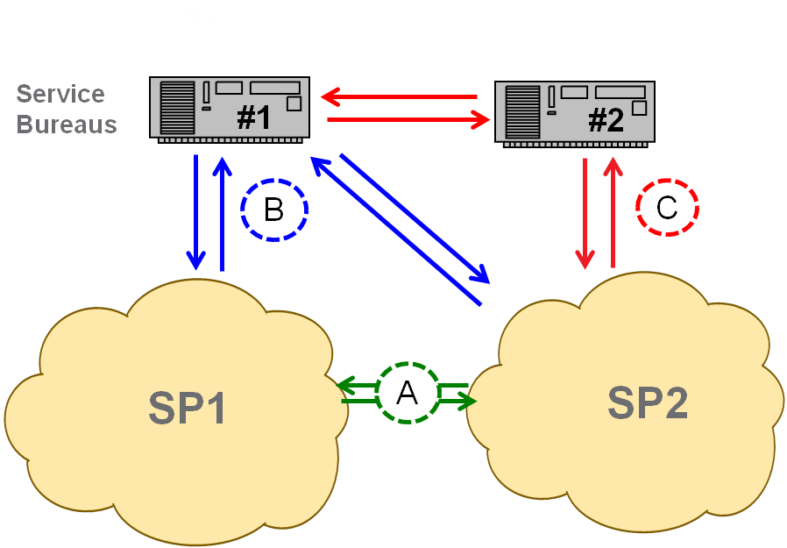
Figure X
5.6.2 - Provisioning
A Provisioning diagram is shown below in Figure Y. Note that only the case where both SPs employ a common Service Bureau is shown for simplicity:
In this provisioning example, SP1 provisions (black arrows) its Routing Service and DNS based upon information provided by SP2. SIP URIs are correlated with SBC interconnect IP addresses provided by SP2.
The SP1 and SP2 query each other’s database or employ a Service Bureau to offer its per-TN database for query. For example, TNs can be correlated with a URI that is a full SIP URI (e.g., sip:+13036614567@example.mso-a.com;user=phone ) but without the tel URI number portability parameters as defined in RFC 4694. How SP1 designs its routing service to use per-TN routing data is specific to SP1’s implementation.
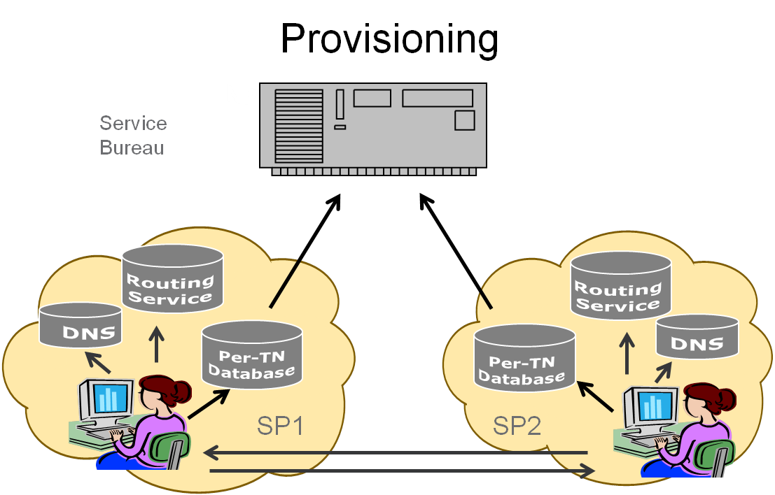
Figure Y

5.6.3 - Call Flow
An example of the Call Flow is shown below in Figure Z:
- Pat (non-roaming subscriber of SP1) makes a session request (e.g., places a call) to Mike (subscriber of SP2). SP1’s network provides originating services based on Pat’s subscription.
- SP1’s application server queries (2A) its routing service in real time using the called number to determine how to forward the request. The routing service first portability corrects the called number, and then determines that it is not subscribed to SP1. It then checks to see whether the code holder associated with the telephone number is covered by an IP interconnection agreement. If so, SP1 queries (2B) the Service Bureau specified by SP2, and the SP1 routing service (2A) supplies the application server with the ingress point through which SP2 has requested that session requests directed to this telephone number enter its network.
- The application server identifies SBC-2 and (if applicable) SBC-1 in SIP ROUTE headers, and forwards the resulting session request onward. SP1’s L3 processing resolves the host portion of the topmost ROUTE header (using DNS) to the IP address of SBC-1.
- SBC-1 removes the topmost ROUTE header (which identifies itself) and forwards the session request based on the next one (which identifies SBC-2). To do so it resolves (using DNS) the host portion of that header, yielding the IP address of SBC-2.
- SBC-2 removes the topmost ROUTE header (which identifies itself) and admits the message to SP2’s network, forwarding it to an application server, and eventually to Mike. How SP2 performs these functions is SP specific.

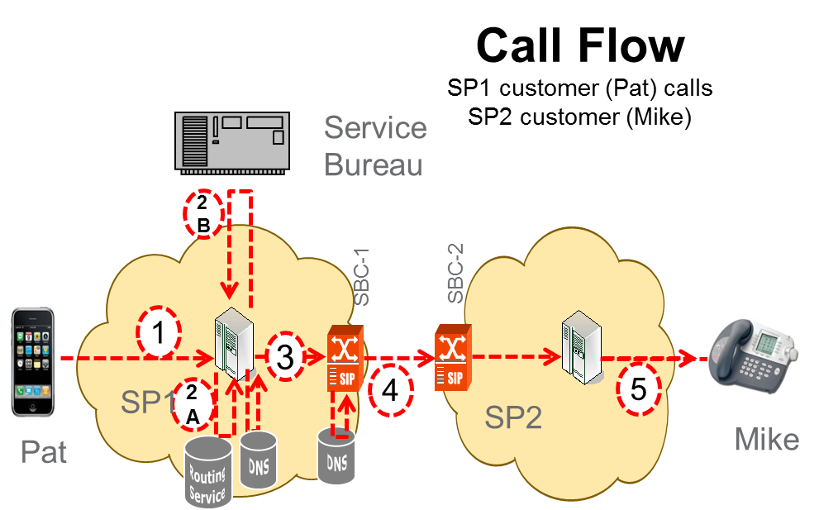
Figure Z

The “code holder” is a term used to refer to the SP serving the TN, which can be identified in LERG data using the LRN or the NPA-NXX of the telephone number (if not shown in the NPAC, e.g., ported or pooled).
How this is accomplished is implementation specific. Messages from an application server to a routing service is typically an ENUM query, but in some networks a SIP message is sent to a proxy collocated with the ENUM service, which sends back a 302 “redirect” response.

