Contribution
TITLE: Changes to Routing Report Section 5
SOURCE*: AT&T, Penn Pfautz

_______________________________
ABSTRACT
This document proposes revisions to sections 5.0, 5.1, and 5.2 of the routing report.

NOTICE

This is a draft document and thus, is dynamic in nature. It does not reflect a consensus of the ATIS-SIP Forum IP-NNI Task Force and it may be changed or modified. Neither ATIS nor the SIP Forum makes any representation or warranty, express or implied, with respect to the sufficiency, accuracy or utility of the information or opinion contained or reflected in the material utilized. ATIS and the SIP Forum further expressly advise that any use of or reliance upon the material in question is at your risk and neither ATIS nor the SIP Forum shall be liable for any damage or injury, of whatever nature, incurred by any person arising out of any utilization of the material. It is possible that this material will at some future date be included in a copyrighted work by ATIS or the SIP Forum.

* CONTACT: Penn Pfautz; email: pp3129@att.com; Tel: +1732-420-4962

Scope, Purpose, & Application

Informative References

Definitions, Acronyms, & Abbreviations

Aggregate Approaches Based on Existing NANP Data Structures

Per-TN Overview and Approaches

A number of service providers have identified that they have a need for more molecular routing than that based on NANP aggregation elements as discussed in the previous section.
In general these needs arise where TNs may share common point of interconnection (PoI) for TDM interconnection (and are thus associated with the same LRN or CLLLI) but need to be treated differently for IP interconnection.
For example, wireless SPs are migrating their existing 2G/3G subscribers to VoLTE – from TDM to IP based user equipment (UE). For VoLTE to VoLTE calls, IP interconnection makes sense for a number of reasons – support for high definition (HD) voice and other Rich Communication Services (RCS) features and elimination of needless IP-TDM and TDM-IP conversions as would be required for TDM interconnection. SPs must still offer TDM interconnection for VoLTE TNs since not all SPs are capable or willing to provide IP interconnection. And because the migration will be gated by customer adoption of VoLTE capable UE, SPs may want to maintain existing TDM PoIs for both 2G/3G and VoLTE TNs and maintain existing TDM routing to those PoIs. Moreover, it may be desirable not to use the IP interconnection serving VoLTE TNs for 2G/3G TNs. First, additional network equipment must be deployed sooner than if IP interconnection scales with VoLTE adoption and, second, 2G/3G calls will be forced to go through unnecessary TDM/IP and IP/TDM conversions. These issues can be avoided if an SP can specify IP interconnection routing for VoLTE TNs separately from the associated LRNs.
A related case cited during Task Force discussions occurs in the deployment of RCSe capabilities outside North America in situations where voice calls and sessions using other RCS features need to be routed differently. This may be particularly the case where number portability methods may not support aggregation via methods like porting to different LRNs.
There may be other use cases for TN routing as well. It has been suggested that per-TN routing could be used to either avoid routing calls to fax numbers over IP interconnections using incompatible compression or taking other measures to insure adequate transmission quality.
The reminder of this section discusses different approaches to providing per-TN routing information. The first four make use of an authoritative industry registry for the exchange of per-TN data while the fifth discusses the exchange of per-TN information on a bilateral basis or via ad hoc service bureaus that do not constitute an industry authoritative registry. Of the registry-based solutions, the first uses the registry to provide routing data (SIP URIs) directly while the other three are based on a tiered ENUM approach in which the registry provides name server (NS) records that direct the interconnect partner how to query the terminating service provider for specific routing data (NAPTR records resolving to SIP URIs). Two of the registry solutions use the NPAC to perform the registry function while one leverages the LERG and the other proposes an independent registry.

NPAC URI Registry
This approach makes use of the existing Voice URI field in the NPAC subscription version, essentially as originally contemplated. This field provides a SIP URI that, in conjunction with bilaterally exchanged IP connection information as in the aggregate approaches discussed in section 4, resolves to the traffic exchange route(s) agreed to between the interconnection partners.
Service providers wishing to provide per-TN routing perform the following provisioning activities:
- As part of bilateral traffic exchange negotiations provide mappings for SIP URI hostnames to SBC IP addresses.
- Populate the Voice URI field in the NPAC subscription version for TNs available for IP interconnection with the appropriate SIP URI. The URI will be a full SIP URI (e.g., sip:+13036614567@example.mso-a.com;user=phone ) but without the tel URI number portability parameters as defined in RFC 4694.
NPAC provisioning is carried out through Change Oder 400 compliant SOAs. If a TN is not pooled or ported, the pseudo LRN capability is used to create a subscription version.
Service providers electing to use the per-TN routing information provided by their interconnect partner will:
- Provision the hostname – IP address mappings into their internal DNS (A or AA records).
- Provision TN-URI mappings from the NPAC into their internal routing servers using a Change Order 400 compliant LSMS to obtain the NPAC data . If the routing server is accessed via a SIP query, the SIP URI may be directly populated. If the routing server is accessed via an ENUM query, the SIP URI is encapsulated into a NAPTR record.

Provisioning
This provisioning process is illustrated in Figure 5 below.
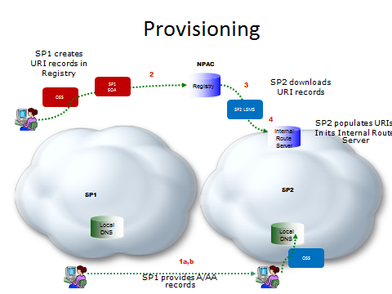

Figure 5 – Provisioning NPAC TN Registry

Call Flow
On call origination, the originating service provider will query their routing server and obtain the corresponding SIP URI for numbers available for IP interconnect. They will resolve the hostname from the URI in their internal DNS to obtain the IP address of the terminating provider’s ingress SBC. The call flow is shown in Figure 6 below:
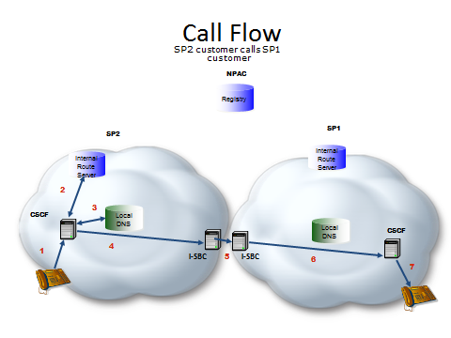
Figure 6 – Call Flow NPAC TN Registry

- SP2 Caller dials destination number
- SP2 S-CSCF queries internal route server and SP2 route server responds with a URI passed back to S-CSCF
- SP2 S-CSCF resolves the hostname in the SIP URI to obtain the IP address of an agreed upon SP1 ingress SBC
- A SIP INVITE is sent to egress SBC of SP2 that has layer 3 connectivity to the ingress SBC of SP1
- The SIP INVITE is forwarded to the SP1 ingress SBC.
- and 7. SP1 terminates the call to its end user.
Note that although the NPAC URI approach is proposed primarily in support of per-TN information exchange, the Voice URI can also be populated on thousands block level, thus providing some level of aggregation where appropriate.

The NPAC as a Tier 1 ENUM Registry
Consistent with 3GPP IMS recommendations for inter-carrier routing, an ENUM-based architecture is proposed for routing across the IP NNI. The essence of this architecture is a query using the protocol described in RFC 6116. 3GPP recommendations do not specify, however, the details of the ENUM data repository to be queried nor the source of the data in that repository. This proposal includes recommendations for these matters, the corresponding data formats, and the manner in which the results of ENUM queries are processed to resolve responses to the IP address(es) toward which a SIP INVITE to the destination network Session Border Controller are to be directed.
The classic ENUM “golden tree” architecture assumed a tiered structure in which a Tier 0 registry (such as the one currently managed by RIPE for the e164.arpa user ENUM domain) contains name server (NS) records pointing to the Tier 1 name servers authoritative for individual E.164 country codes. The Tier 1 registries in turn consist of NS records pointing to the authoritative Tier 2 server for a specific E.164 number. The Tier 2 servers, maintained by or for the assignee of the number, contained NAPTR records that resolved to the URIs needed to establish communication to the number in question.
As the industry has yet to establish a universally recognized Tier 0 for infrastructure ENUM (RFC 5067) as opposed to user ENUM, a combined Tier 0/1 registry is proposed for the US portion of Country Code 1. This Tier 0/1 registry is in principle extensible to other portions of Country Code 1 if desired by the competent authorities and may eventually be linked to registries for other country codes or to a global Tier 0 when and if consensus on such a Tier 0 emerges. In the interim the registry simply contains NS records for individual numbers in the US portion of CC1.
To speed deployment and leverage existing infrastructure it is proposed that the Number Portability Administration Center (NPAC), the local number portability database of record, serve as the Tier 0/1 registry. Unlike the Tier 0 and Tier 1 registries in the classic ENUM architecture, the NPAC is not a DNS name server and is not queried during call processing. It can however download data for NS records to service providers or service bureaus for them to provision in their name servers to be queried on call origination.
As in the classic ENUM model, the NS records will point to Tier 2 name servers that respond with NAPTR records containing the actual routing data. Service Providers will maintain themselves or have service bureaus provide for Tier 2 name servers for the numbers they serve. Based on the NS records obtained from the Tier 0/1 query, the originating service provider will query the Tier 2 name server to obtain the NAPTR record for call routing. Together the SIP URI obtained from the NAPTR record and the bilaterally exchanged URI hostname to IP address mapping instantiate the routing agreed to by the interconnect partners.

Call Flow
The following is the inter-service provider call flow as shown in the Figure below:
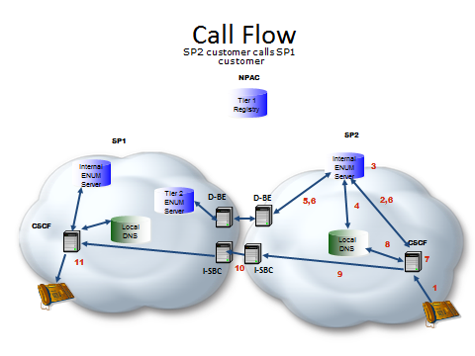
Figure 7 – Call Flow Tier 1 NS Records in NPAC
- SP2 Caller dials destination number
- SP2 S-CSCF queries internal ENUM server
- SP2 ENUM server finds an NS record
- SP2 internal ENUM server resolves the FQDN in the NS record to the IP address of SP1’s Tier 2 ENUM server.
- An ENUM query is forwarded to SP1’s Tier 2 ENUM server.
- SP1’s Tier 2 ENUM server responds with a NAPTR record(s) passed back to S-CSCF
- SP2 S-CSCF processes the NAPTR record set returned resulting in a SIP URI
- SP2 S-CSCF resolves the hostname in the SIP URI to obtain the IP address of an agreed upon SP1 ingress SBC
- A SIP INVITE is sent to egress SBC of SP2 that has layer 3 connectivity to the ingress SBC of SP1
- The SIP INVITE is forwarded to the SP1 ingress SBC.
- SP1 terminates the call to its end user.

Provisioning
Provisioning is shown in the Figure below:

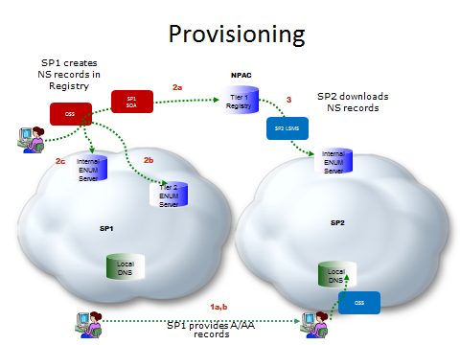
Figure 8 – Provisioning – Tier 1 NS Records in NPAC
- Service providers negotiate interconnection and exchange, as part of the interconnect technical negotiation process,
  - Address (A or AA) records for their Tier 2 name servers
  - Address (A or AA) records for the hostname FQDNs in URIs derived from the NAPTR records that will provided in the responses from their Tier 2 name servers. These IP addresses correspond to the destination service provider’s I-SBCs that constitute the application layer POIs.
Each service provider provisions the records received from the other carrier in its internal DNS.
- When new numbers are provisioned or existing numbers made available for IP interconnection by an SP, the SP
  - Provisions NS record information for the number into the NPAC Voice URI field of the subscription version (SV) of the number through its SOA. (If there is no existing subscription version one is added.)
  - Provisions NAPTR records for number in its Tier 2 name server.
  - Provisions internal NAPTR records in its internal ENUM server for use within network calls.
- Service providers download SVs from the NPAC, extract the NS information from the Voice URI field and provision it as NS records into their internal ENUM server. Note that a record is provisioned for each TN.

SUMMARY
A Tiered ENUM approach using the NPAC as the Tier 0/1 registry populates NS records into existing fields in the subscription version that already contains TDM routing elements. SVs are populated in the NPAC for each TN for which IP interconnection is offered. (If a TN is not otherwise ported or pooled an SV with a pseudo LRN is created). This approach simply enhances the existing interfaces (direct or via service bureaus) that all SPs have with the NPAC, requiring no new governance structures.

There may be alternate approaches to combining the bilaterally exchanged URI-IP address mappings and the TN-URI mappings obtained from the Registry and combining them in a routing server for session establishment.
In infrastructure ENUM, the Tier 1 servers point to Tier 2 servers maintained by or for the service provider of record for the number.
Resolution is shown in recursive mode. It could also take place in iterative mode with the NS record being returned to the S-CSCF for the S-CSCF to resolve the FQDN in the NS record and then issue a query to the SP1 Tier 2.
Use of separate Data Border Element is shown.
There are alternate approaches to the resolution of Tier 2 name servers and interconnection URI FQDNs. These include a) exchange of SRV instead of A/AA records, b) resolution in the internet DNS, c) sharing through some controlled access industry system including but not necessarily limited to a private DNS.
The VOICE URI field was originally defined to contain a URI that would be used to provide for IP routing of voice calls, but it is currently little used and has no explicit typing. It simply allows up to 255 characters. It is proposed that NS record information be populated in the VOICEURI field in the form tier2enum.serviceprovider.com (i.e., just the nameserver name as an FQDN) as opposed to the full NS form: 3.8.0.0.6.9.2.3.6.4.1.e164enum.net IN NS tier2enum.serviceprovider.net The full record form would be reconstituted by the service provider for provisioning in its ENUM server. Note that an NS record or records are generally provisioned for each individual number. Multiple NS records could be populated in the NPAC VOICEURI field through the use of some agreed upon separator character. This would allow for redundancy as it is expected that carriers would want to have multiple name server instances. Note that an apex domain, for example, e164enum.net, needs to be agreed upon.
The ENUM query may return multiple NAPTR records with different order, preference, and enumservice fields as defined in RFC 6116. Thus multiple options for interconnection can be provided including different gateways for different service types (e.g., voice versus video) where appropriate. A NAPTR for general SIP interconnection might look like NAPTR 10 100 "u" "E2U+sip" "!^.*$!sip:\1@gw02.serviceprovider.net; user=phone!" . its resolution would result in the URI sip:+14632963800@gw02. serviceprovider.net; user=phone The querying service provider would then resolve the hostname gw02.serviceprovider.net to obtain an IP address for the terminating provider’s ingress SBC.

