ATIS/SIP Forum NNI Task Force
August 7, 2014

Contribution
TITLE: Insert of iconectiv proposed routing solution text to IP Interconnection Routing Outline baseline document appendix

SOURCE*: iconectiv

_______________________________
ABSTRACT
This contribution proposes inserting text within the Appendix of the IP Interconnection Routing Outline baseline document (IPNNI-2014-064R2), where the “Other Solution Proposals” are defined. The proposed text describes three proposed iconectiv routing solutions – 1) Utilization of Existing BIRRDS/LERG Industry Database, 2) Utilizing LERG as an ENUM Registry, and 3) an Independent ENUM Registry.

NOTICE

This is a draft document and thus, is dynamic in nature. It does not reflect a consensus of the ATIS-SIP Forum IP-NNI Task Force and it may be changed or modified. Neither ATIS nor the SIP Forum makes any representation or warranty, express or implied, with respect to the sufficiency, accuracy or utility of the information or opinion contained or reflected in the material utilized. ATIS and the SIP Forum further expressly advise that any use of or reliance upon the material in question is at your risk and neither ATIS nor the SIP Forum shall be liable for any damage or injury, of whatever nature, incurred by any person arising out of any utilization of the material. It is possible that this material will at some future date be included in a copyrighted work by ATIS or the SIP Forum.

* CONTACT: Gary Richenaker;grichenaker@iconectiv.com Tel: +1732-699-4701
John Curreri; jcurreri@iconectiv.com Tel +1732-699-3247

ATIS-0x0000x.YYYY

American National Standard for Telecommunications

IP Interconnection Routing

Alliance for Telecommunications Industry Solutions

Approved Month DD, YYYY
American National Standards Institute, Inc.

Abstract
Abstract text here.

Foreword
The information contained in this Foreword is not part of this American National Standard (ANS) and has not been processed in accordance with ANSI’s requirements for an ANS. As such, this Foreword may contain material that has not been subjected to public review or a consensus process. In addition, it does not contain requirements necessary for conformance to the Standard.
The Alliance for Telecommunications Industry Solutions (ATIS) serves the public through improved understanding between carriers, customers, and manufacturers. The [COMMITTEE NAME] Committee [INSERT MISSION]. [INSERT SCOPE].
ANSI guidelines specify two categories of requirements: mandatory and recommendation. The mandatory requirements are designated by the word shall and recommendations by the word should. Where both a mandatory requirement and a recommendation are specified for the same criterion, the recommendation represents a goal currently identifiable as having distinct compatibility or performance advantages.
Suggestions for improvement of this document are welcome. They should be sent to the Alliance for Telecommunications Industry Solutions, [COMMITTEE NAME], 1200 G Street NW, Suite 500, Washington, DC 20005.
At the time of consensus on this document, [COMMITTEE NAME], which was responsible for its development, had the following leadership:

[LEADERSHIP LIST]

The [SUBCOMMITTEE NAME] Subcommittee was responsible for the development of this document.

Table of Contents

[INSERT]
Contents
ATIS-0x0000x.YYYY ii
American National Standard for Telecommunications ii
IP Interconnection Routing ii
Alliance for Telecommunications Industry Solutions ii
Abstract ii
1. Scope, Purpose, & Application v
1.1 Scope v
1.2 Purpose v
1.3 Application vi
2. Informative References vi
3. Definitions, Acronyms, & Abbreviations vi
3.1 Definitions vi
3.2 Acronyms & Abbreviations vi
4. Reference Model for IP NNI Routing vii
4.1 Network Connections viii
4.2 Routing ix
5. Aggregate Approach Based on Existing NANP Data Structures x
6. Telephone Number Registry (per-TN) Approach x
6.1 Per-TN Use Case x
6.2 Per-TN Routing Implementation xi
7. Interworking between Current and Registry based approaches xiii
7.1 Data from an Aggregate SP to a per-TN SP xiii
7.2 Data from an per-TN SP to an Aggregate SP xiv
7.3 A Registry could provide both aggregate and expanded per-TN data based on aggregate input xiv
7. Next Steps xiv
Appendix A – Other Solution Proposals xiv
1. Utilization of Existing BIRRDS/LERG Industry Database xiv
2. Utilizing the NPAC as an ENUM Registry xiv
1. Call Flow xv
2. Provisioning xvii
3. SUMMARY xviii
3. Utilizing LERG as an ENUM Registry xix
4. Independent ENUM Registry xix
Appendix B - Routing Criteria Tables xix
Appendix C – Data Exchange Worksheet Example xix

Table of Figures

[INSERT]

Table of Tables

[INSERT]

Scope, Purpose, & Application

Scope
This document was developed under a joint ATIS/SIP Forum collaboration. The document discusses the existing in-use and proposed routing solutions to facilitate the exchange of traffic associated with IP-based services between North American service providers.
Many options and issues were previously investigated by an ATIS Inter-Carrier VoIP Call Routing Focus Group (IVCR-FG), which issued its final report in February 2008. At that time, the IVCR-FG report noted that a number of vendor proposals have been made, but no initiative exists to develop the necessary standards needed to enable VoIP call interconnectivity [1].
Subsequent to the formation of the ATIS/SIP Forum collaboration, the Federal Communications Commission authorized the creation of a Numbering Testbed to “spur the research and development of the next generation standards and protocols for number allocation, verification, and call routing.” The Commission also held a workshop to initiate a Numbering Testbed on March 25, 2014. Discussion at the Workshop focused on ideas for a “future integrated registry” that would support number allocation, verification, and call routing across all types of NANP numbers in a post TDM environment.
It should be noted that this first report does not address the development of such an integrated registry, but instead focuses on the identification of existing in-use and proposed “interim” solutions to facilitate call routing across IP interconnections between now and the deployment of the future integrated registry envisioned at the Workshop.

Purpose
As Service Providers introduce and expand IP-based service offerings, there is increasing interest in identifying the opportunities for the industry to facilitate IP routing of VoIP traffic using E.164 addresses. The ATIS/SIP Forum Task Force has taken on the initiative to develop the necessary standards and is publishing this first report to describe the candidate proposals for circulation and comment. Recognizing that IP traffic exchange is developing as an overlay to existing TDM interconnection and will be implemented by different service providers with varying timelines,
The purpose of this first report is to:
- Document already in use routing methods based on existing industry data in the LERG and NPAC supplemented with the bilateral exchange of information to map LERG and/or NPAC identifiers to specific IP connection information.
- Detail a simple registry approach that provides the ability to exchange routing information on a per-TN basis without aggregation via NANP data structures. This approach also requires some bilateral exchange of specific IP connection information.
- Discuss methods for interworking between service providers that choose differing approaches.

An appendix also provides information on other proposals reviewed by the Task Force.

Application
This standard is defined for North America deployments, but may be applicable for deployments outside North America.

Informative References

[1] ATIS-I-0000017, ATIS Inter-Carrier VoIP Call Routing (IVCR) Assessment and Work Plan, February 2008
[2] ATIS-0x0000x, Technical Report.
[3] ATIS-0x0000x.201x, American National Standard.

Definitions, Acronyms, & Abbreviations
For a list of common communications terms and definitions, please visit the ATIS Telecom Glossary, which is located at < http://www.atis.org/glossary >.

Definitions
AAA: xxxx.
Bbbb: xxxx.

Acronyms & Abbreviations
[this list was copied from Protocol document]
3GPP 3rd Generation Partnership Project
ALG Application Level Gateway
ATCF Access Transfer Control Function
B2BUA Back to Back user agent
BGCF Border Gateway Control Function
CSCF Call Session Control Function
IBCF Interconnection Border Control Function
I-BGF Interconnection Border Gateway Function
I-CSCF Interrogating-Call Session Control Function
ICSS IMS Centralized Services
II-NNI Inter-IMS Network to Network Interface
IM-CN IP Multimedia Core Networks
IMS IP Multimedia Subsystem
IMS-ALG Multimedia Subsystem Application Level Gateway
IP Internet Protocol
IPSec IP Security
IPv4 Internet Protocol Version 4
IPv6 Internet Protocol Version 6
MGCF Media Gateway Control Function
MGF Media Gateway Function
MIME Multipurpose Internet Mail Extensions
MSC Mobile Switching Center
NAT Network Address Translation
NAT-PT Network Address Translation—Protocol Translation
NNI Network to Network Interface
P-CSCF Proxy Call Session Control Function
RTP Real-Time Protocol
SBC Session Border Controller
S-CSCF Serving-Call Session Control Function
SCTP Stream Control Transmission Protocol
SDP Session Description Protocol
SGF Signalling Gateway Function
SIP Session Initiation Protocol
SIP URI SIP protocol Uniform Resource Identifier
SIP-I SIP with encapsulated ISUP
SIP-T SIP for Telephones
SLA Service Level Agreement
SRVCC Single Radio Voice Call Continuity
TCP Transmission Control Protocol
tel-URI Telephone Uniform Resource Identifier
TRF Transit and Roaming Function
TrGw Transition Gateway
TLS Transport Layer Security
UA User Agent
UDP User Datagram Protocol
URI Uniform Resource Identifier
VoIP Voice over IP

Reference Model for IP NNI Routing
There are two broad steps to establishing IP interconnection between service providers:
• Establishing the network connections between the service providers
• Setting up service provider specific routing to use those connections

Network Connections
In order to examine what is needed for routing SIP sessions across the IP NNI, it is helpful to consider first the implementation of network interconnections in more detail. What follows expands on the model presented in, for example, ATIS-1000039.
Figure 1 below shows three types of transport arrangements: through the public Internet on the top, via direct physical connection of the partner service providers in the middle, and using an intermediary service provider (e.g., as an IPX) on the bottom.
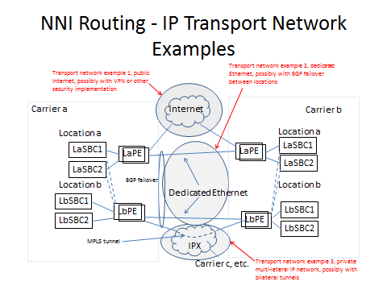
Note that interconnection may involve multiple egress and ingress Session Border Controllers (SBCs) each connected through multiple Provider Edge (PE) Routers in turn linked by multiple physical facilities. The SBCs may in turn host multiple signaling and media IP addresses and associated port numbers. For a given telephone number in the terminating SP network the set of PE Routers, ingress SBCs, IP addresses may not be the same for different interconnecting SPs.

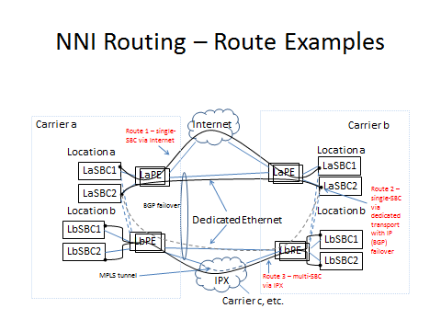

Routing
A route from Service Provider A to Service Provider B will ultimate involve a path from an SP A egress SBC through SP A PE Router over an interconnection facility to an SP B PE Router and thence SP B ingress SBC as shown in Figure 2. There will generally be multiple routes for exchange of traffic between two service providers to ensure reliability and to optimize network resources.
Routing across the NNI will involve selecting on the available paths based on the destination number and the routing discipline agreed to by the service providers in their traffic exchange agreement.
Setting up routing involves associating route identifiers provided by the terminating network with the appropriate route. There are many choices for what routing identifiers can be used including; AOCN/OCN, NPAC SPID, CO code, 10-digit telephone number, domain name and SIP URI. Current methods generally employ route identifiers that aggregate a set of telephone numbers, usually based on some LERG or NPAC construct.
To begin with, the terminating carrier provides a list of route identifiers to the originating carrier and the network entry-point(s) to be used for routing calls to each identifier. The entry points will be defined by the corresponding Session Border Controller IP addresses.
As part of its internal routing process the originating SP may create and name the SIP trunk groups (see RFC 4904) between the various SBC pairs that identify each connection, (The SIP TG is sometimes referred to as a session agent)
Following this approach, the originating carrier establishes a process during call setup (such as a dip to a route server) to create a URI that often includes destination trunk group parameters as per RFC 4904 and portability parameters as per RFC 4694. To do this, the originating carrier will (1) portability-correct the dialed digits, (2) associate the portability corrected digits with a route identifier and (3) identify the SIP TG based on the route identifier. The original dialed-digits, portability-data, outbound SBC and trunk-group are typically identified in the URI that is used to route the call/session. For example:
  - sip:+12125551234;npdi;tgrp=1234;trunk-context=origin.tld@outbound_sbc.origin.tld;user=phone
The originating carrier then routes the call/session to the interconnected carrier based on the SIP TG identified in the URI.

Aggregate Approach Based on Existing NANP Data Structures

Introduction
Some service providers are already exchanging voice traffic over IP facilities. This section details how routing for such exchanges has been implemented based on existing industry data in the LERG and NPAC supplemented with the bilateral exchange of information to map LERG and/or NPAC identifiers to IP addresses.
Existing approaches to IP interconnection routing rely on NANP constructs for aggregating telephone numbers into groups and then associating a route (SBC URI or IP address) with the TN group. Common methods of aggregation are Location Routing Number (LRN) in the NPAC, OCNs, CLLIs, and central office codes (NPA-NXXs).

Placeholder:
This section illustrates some of the mechanisms currently in use and/or being deployed to facilitate the exchange of traffic associated with IP-based multimedia services (e.g., VoIP) between North American service providers.
See IPNNI-2014-045R1.

Telephone Number Registry (per-TN) Approach

Per-TN Use Case
A number of service providers have identified a need to move beyond routing based on NANP aggregation elements as discussed in the previous section.
In general these needs arise where TNs may share common point of interconnection (PoI) for TDM interconnection (and are thus associated with the same LRN or CLLI) but need to be treated differently for IP interconnection.
For example, wireless SPs are migrating their existing 2G/3G subscribers to VoLTE – from TDM to IP based user equipment (UE). For VoLTE to VoLTE calls, IP interconnection makes sense for a number of reasons – support for high definition (HD) voice and other Rich Communication Services (RCS) features and elimination of needless IP-TDM and TDM-IP conversions as would be required for TDM interconnection. SPs must still offer TDM interconnection for VoLTE TNs since not all SPs are capable or willing to provide IP interconnection. And because the migration will be gated by customer adoption of VoLTE capable UE, SPs may want to maintain existing TDM PoIs for both 2G/3G and VoLTE TNs and maintain existing TDM routing to those PoIs. Moreover, it may be desirable not to use the IP interconnection serving VoLTE TNs for 2G/3G TNs. First, additional network equipment must be deployed sooner than if IP interconnection scales with VoLTE adoption and, second, 2G/3G calls will be forced to go through unnecessary TDM/IP and IP/TDM conversions. These issues can be avoided if an SP can specify IP interconnection routing for VoLTE TNs separately from the associated LRNs.
A related case cited during Task Force discussions occurs in the deployment of RCSe capabilities outside North America in situations where voice calls and sessions using other RCS features need to be routed differently. This may be particularly the case where number portability methods may not support aggregation via methods like porting to different LRNs.
There may be other use cases for TN routing as well. It has been suggested that per-TN routing could be used to either avoid routing calls to fax numbers over IP interconnections using incompatible compression or taking other measures to insure adequate transmission quality.

Per-TN Routing Implementation
Service providers wishing to provide per-TN routing perform the following provisioning activities:
- As part of bilateral interconnect negotiations provide mappings for SIP URI hostnames to SBC IP addresses.
- Populate registry records for TNs available for IP interconnection with the appropriate SIP URI. The URI will be a full SIP URI (e.g., sip:+13036614567@example.mso-a.com;user=phone ) but without number portability information.
The registry must insure that only the provider of record for the number as defined by LERG/NPAC can populate a corresponding record.
Service providers electing to use the per-TN routing information will:
- Provision the hostname – IP address mappings into their internal DNS (A or AA records).
- Provision TN-URI mappings from the Registry into their internal routing servers. If the routing server is accessed via a SIP query, the SIP URI may be directly populated. If the routing server is accessed via an ENUM query, the SIP URI is encapsulated into a NAPTR record.
This provisioning process is illustrated in Figure 1 below. The Figure shows the registry instantiated in the NPAC but alternate registry implementations (using different provisioning mechanisms than the SOA/LSMS) are possible.

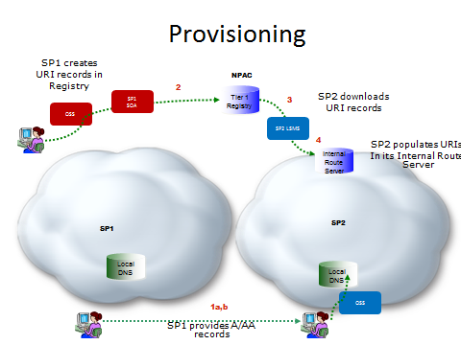

Figure 1

On call origination, the originating service provider will query their routing server and obtain the corresponding SIP URI for numbers available for IP interconnect. They will resolve the hostname from the URI in their internal DNS to obtain the IP address of the terminating provider’s ingress SBC.

The call flow is shown in Figure 2 below:

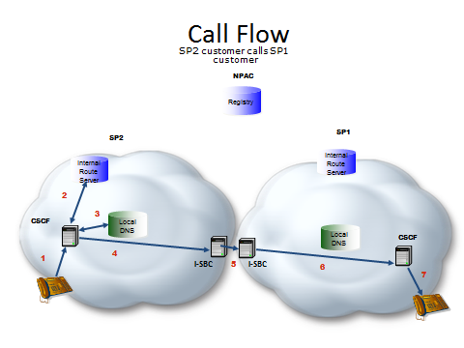
- SP2 Caller dials destination number
- SP2 S-CSCF queries internal route server and SP2 route server responds with a URI passed back to S-CSCF
- SP2 S-CSCF resolves the hostname in the SIP URI to obtain the IP address of an agreed upon SP1 ingress SBC
- A SIP INVITE is sent to egress SBC of SP2 that has layer 3 connectivity to the ingress SBC of SP1
- The SIP INVITE is forwarded to the SP1 ingress SBC.
- SBC sends an appropriate SIP invite to the CSCF
- SP1 terminates the call to its end user.

Interworking between Current and Registry based approaches
This section discusses how interworking may take place between service providers using different routing approaches.
When considering interworking between carriers it is important to recognize that the interconnection process has a number of steps that are common to all the approaches.
- Interconnection agreements are formally negotiated between carriers on a bilateral basis. This negotiation process will lead to a formal agreement between the carriers on a number of key points related to the interconnection, including an agreed mechanism for exchanging routing data. As a result, there isn’t a need to define an approach where two carriers with arbitrary preferences interconnect and exchange data without first agreeing on the approach they will use.
- Under all scenarios being considered, carriers will use data from a variety of sources (LERG, NPAC, etc.) as input into their internal OSS/BSS to build and maintain an internal database for routing calls. Each carrier uses their own system, with their own algorithm, for this, and it is therefore out of scope for the NNI. The routing data defined in this document is an important enabler for interconnection, but it is just one of the sources of data used by the carrier to construct their routing tables.

One thing that differs between the solutions is what data is being uploaded to a registry, or exchanged between carriers as part of interconnection negotiation. This is an important aspect that is specified in this document.
Previous sections of this document cover the cases where carriers agree on the use of aggregate or per-TN routing data. This section covers the case where they prefer different approaches, and outlines a series of intermediate options that would allow them to meet somewhere in the middle.

Data from an Aggregate SP to a per-TN SP
There are several possibilities for how the per-TN SP may arrange to route to the Aggregate SP”
First, the Per-TN provider may simply agree to implement aggregate-based routing as described in Section 4.
The second alternative is to transform the aggregate data into a per-TN representation. In the basic case, the per-TN SP receives the aggregate data and then creates individual TN records in its routing server based on that data. For example, if an AOCN to SBC IP address mapping is provided, the per-TN SP uses LERG and NPAC data to map the AOCN into the set of TNs the aggregate SP is offering for IP traffic exchange. This involces determining from the LERG the set of NPA-NXXs and/or thousands blocks under the AOCN, creating a record for each TN, then removing records for numbers that have ported or pooled away from the aggregate SP and adding records for numbers ported or pooled into an LRN that is associated (has an NPA-NXX with the code holder AOCN of the aggregate SP). It is the responsibility of the Per-TN SP to update the record set based on changes in the LERG or NPAC. Not that the expanded data set may include records for unallocated numbers. Except for misdials, these records would not be accessed.
The expansion described above could also be performed by a third party, either on behalf of the per-TN SP or the aggregate SP depending on business arrangements.
In a special case the third party could be the registry operator and the aggregate data could be delivered to the registry by the aggregate provider. Because the registry could distribute date to multiple per-TN providers records would not include IP addresses, which would be target provider specific, but would map TNs to a SIP URI with a generic host name keyed to the aggregation element provided in the bilateral exchange. For example, a SIP URI containing the hostname aocn<aocn>.<spname>.net might be used in the registry records. The recipient provider could then populate the TN records in its routing server as described in Section 5 and resolve the host name in its internal DNS, having built address records that matched the host name to the IP address associated with the corresponding AOCN in the bilateral data exchange.

Data from an per-TN SP to an Aggregate SP
There are likewise several possibilities for how an aggregate SP may route to a per-TN SP.
First, the per-TN provider may agree to provide aggregate data. Aggregate data may include TNs beyond those for which the per-TN provider prefers to prefer IP interconnection. For example, a wireless SP that has both VoLTE (IP served) and GSM/UMTS (non-IP) subscribers that are not distinguished from a NANP data point of view may simply provide mappings from, for example, its AOCNs to it SBC IP addresses. This will result in some VoLTE originated calls transiting the IP interconnection even though destined for GSM/UMTS users.
A second possibility is that the aggregate SP will accept per-TN information to populate its routing server even though it prefers to provide routing information for its own TNs on an aggregate basis The per-TN data could be provided via the registry.

A Registry could provide both aggregate and expanded per-TN data based on aggregate input
In this hybrid case, as discussed as part of Section 6.1 above, the aggregate input would map a NANP construct to a SIP URI rather than a set of IP addresses. Bilateral negotiation would then provide URI to IP address mapping. The Registry would retain the aggregate input, however, and make it available to SPs that prefer aggregate input via an interface to be defined.

Next Steps

Appendix A – Other Solution Proposals

Utilization of Existing BIRRDS/LERG Industry Database
.

This section describes the exchange of data for IP routing and interconnection using existing industry database systems, architectures and processes for routing of E.164 Addressed Communications over IP Network-to-Network Interconnection (NNI). See IPNNI-2014-044R1.
This approach would allow existing downstream systems and processes to be utilized and enhanced, as may be needed, with minimal impact to service providers. The LERG and NPAC have evolved since their inception to support new technologies and industry processes. These neutral database systems have embedded governance processes that allow the industry to facilitate system process enhancements as required by service providers. Consequently, a solution to utilize existing database systems would allow the industry to continue to manage process evolution as it pertains to IP routing and interconnection within established industry forums that are proven, efficient, cost effective, and are balanced across industry segments.
The Business Integrated Routing and Rating Database System (BIRRDS) is a collection of input databases from which the LERG is generated. BIRRDS is a neutrally administered database for the exchange of service provider call routing/rating and interconnection information for all telephone numbers within the North American numbering plan. BIRRDS is a dynamic database with an established history of changes to data elements and data values, edits, and functionalities, which occur in response to technology and numbering changes where such changes are addressed via established industry governance processes.
BIRRDS includes data driven by industry standards including: Common Language® CLONES location reference data for the identification of switch and interface locations per ANSI T1.253, Identification of Location Entities for the North American Telecommunications System, and NECA assigned Company Codes per ATIS-0300251.2007(R2012), Codes for Identification of Service Providers for Information Exchange used to identify service providers, (used as OCNs in BIRRDS) to identify service providers that are associated with switch records, NPA/NXX records, etc.
The LERG is the North American telecom industry's common, authoritative database used for routing calls based on telephone numbers within the North American numbering plan. The LERG was initially designed for interexchange carriers to manage their TDM network routing based on call origination and call termination points as provided by Regional Bell Operating Companies (RBOCs) and Incumbent Local Exchange Carriers (ILECs). However, via industry governance, it has, and continues to evolve to support routing related changes in the industry. The LERG has also evolved to support information exchange between additional types of service providers, including Competitive Local Exchange Carriers (CLECs), Wireless Service Providers (WSPs), Voice over IP (VoIP) providers, etc.
The LERG is issued monthly but also provides for daily BIRRDS activity updates so that service providers may obtain the most current network interconnection and routing information exchange across the industry.
Utilizing LERG as a neutral database for support of IP interconnection would maintain consistency of data exchange across the multi-carrier ecosystem. Additionally, utilization of the LERG routing data allows the originating provider to retain control of egress route selection through management of its own translations and routing tables.
Service providers can continue to leverage NPAC and existing Local Number Portability (LNP) system processes, such as Service Order Administration (SOA) and the LSMS framework, with minimal impact to their business processes for ported and pooled numbers that are serviced by IP technology.
The existing industry framework supports the evolution of TDM to IP routing and interconnection, however, existing database systems would need to be enhanced according to the industry requirements. The following items require further study and are possible areas of enhancement to these industry databases in support of IP routing for both PSTN transition and all IP networks. Upon industry consensus, BIRRDS/LERG can be enhanced to support:
- service provider exchange of Uniform Resource Identifier (URI) to identify I-SBCs (session border controllers) or other IP interconnect equipment.
- service provider exchange of location data for I-SBCs or other IP interconnect equipment. For example, Session Border Controller Location Entities could still be specified per ANSI T1.253, Identification of Location Entities for the North American Telecommunications and exchanged between service providers.
- a process for service providers to exchange service types and attribute parameters (e.g. Classes of Service, CODEC capabilities, Transcode Free Operation (TrFO), facsimile support, etc.) that are associated with a specific Session Border Controller (SBC)/IP interconnection point. This can be similar to the current process in BIRRDS/LERG to identify TDM switch attributes known as Switch Office Functionality indicators (SOFs).
- a process for flagging specific LRNs, as defined by the service provider, to be “related to” IP interconnection.
- a process to support service provider exchange of per service type (e.g. SIP, PSTN, mailto, etc.) Uniform Resource Identifier (URI) and parameter exchange.
- a process to exchange potential PSTN and IP routes simultaneously.
- a process to retain policy control for selection of primary and alternate egress routes and all the associated business processes.
- a process to validate Domain Names and potentially full URIs associated with an IP interconnection point prior to accepting such routing information for exchange.
- a process to have routing/interconnection database systems support alternative number conservation methods (e.g. use of 100 or other number block sizes); BIRRDS/LERG can be enhanced to meet this need, all while maintaining compatibility with routing on existing NPA/NXX and thousands blocks assignments. Support for a “Just In Time” number allocation model at a single TN level warrants further evaluation; however, in that case an industry requirement for coexistence with block level assignments should also be evaluated.
- more frequent routing data exchanges than daily, then BIRRDS/LERG can be enhanced to meet this need.
In addition, NPAC can continue to serve as the authoritative database system for porting/pooling information exchange.

Routing Flow

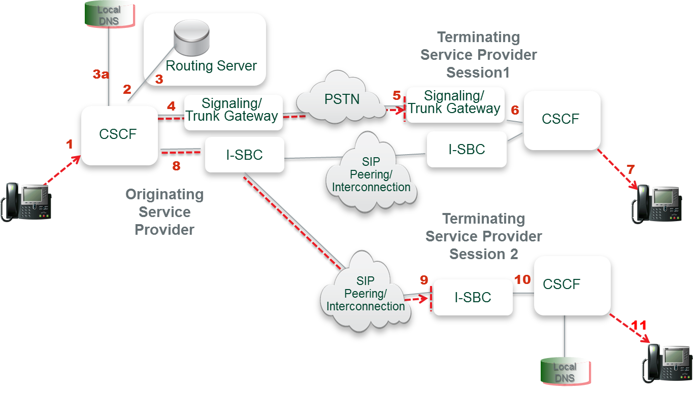
Figure 1 - This figure depicts a high level architectural view of how calls are routed in a Hybrid TDM/IP network and an all IP network.

Session 1 – IP Session via PSTN Interconnection
(1) A session is originated and sent to the Call Session Control Function (CSCF).
(2&3) The CSCF performs an internal query to its routing server to retrieve routing data for the called number.
(4) If the CSCF determines that the called number requires interconnection via the PSTN to Terminating Service Provider 1, then the session is routed to the appropriate trunk gateway where it is converted to TDM.
(5) The session is routed internally to the trunk gateway and point of interconnection for Terminating Service Provider 1. The call is converted back to IP within the terminating service provider network.
(6&7) Terminating Service Provider 1 then signals the terminating CSCF to complete the call. Terminating Service Provider 1 may be an IP network but the means of interconnection is still via the PSTN. It is probable, per the illustration, that the terminating service provider offers both media gateways and I-SBCs to accept sessions during the IP transition phase.
Session 2 – IP Session via IP-IP Interconnection
(1) A session is originated and sent to the Call Session Control Function (CSCF).
(2) The CSCF performs an internal query to its routing server to retrieve routing data for the called number.
(3) The routing server returns a URI and the CSCF determines that the called number can accommodate an IP-NNI to the Terminating Service Provider,
(3a) The CSCF will then query its local DNS to resolve the URI to the IP address of the I-SBC of the terminating network.
(8) A SIP invite is sent to the egress I-SBC of the originating network that has connectivity to the ingress I-SBC of the terminating service provider.
(9) I need to check the correct numbering) A SIP Invite is forwarded to the terminating service providers ingress I-SBC. Route selection is based on IP peering agreement between SPs as well as service attributes, least cost routing, etc.
(10&11) Terminating Service Provider 2 signals to the appropriate CSCF and the end-to-end session is established.

Provisioning Flow

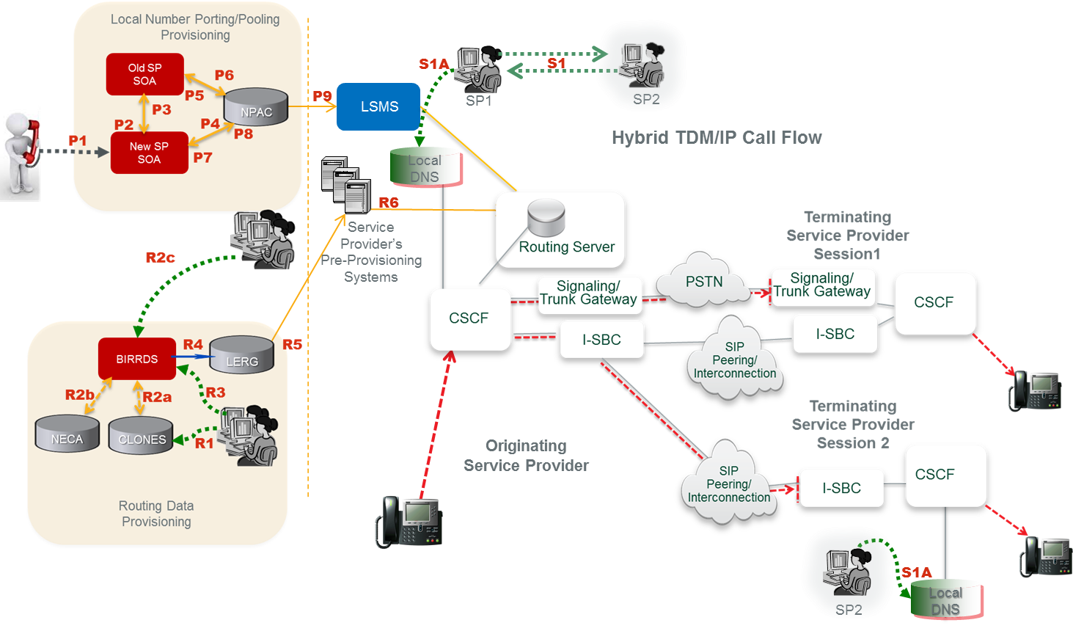
Figure 2 - Depicts the flow of how routing data is currently provisioned and exchanged in industry databases and service providers’ networks. This figure illustrates a logical view that may be realized by different operations systems.

Routing Data Provisioning:
(R1) Service provider develops a switch/point-of-interface (POI) CLLI Code and associated location attributes in the CLONES database.
(R2a) The CLONES database provides newly developed CLLI Code and location reference data to BIRRDS. The location reference information is used by service providers in support of developing new BIRRDS switch/POI records.
(R2b) The National Exchange Carrier Association (NECA), provides new Company Codes (a subset of Operating Company Numbers (OCNs)), as they are assigned, to BIRRDS.
(R2c) National CO Code (NXX) Administrators and the Thousands-Block Pooling Administrator (US only) establish base CO Code and block assignment records in BIRRDS.
(R3) Service provider updates BIRRDS with switch/POI information (e.g. actual switch, points of interface, trunk gateways, call agents, Signaling Transfer Points (STPs), etc.), homing arrangements, Location Routing Numbers (LRNs), and detailed information supporting the CO Code NPA/NXX, NPA/NXX-X. This data is integrated with other BIRRDS data elements (e.g. Rate Centers) maintained by the BIRRDS administrator. URIs can potentially be associated with OCN, at the highest order, or can be associated with other LERG data, e.g., NPA-NXX level. The URI association would need to be agreed upon by the service providers.
(R4) The LERG is generated from current BIRRDS data and is provided to service providers monthly for their pre-provisioning systems. As an option, augmented daily activity may be provided nightly.
(R5) Based on service providers’ local methods and procedures, the LERG data is loaded into service providers’ pre-provisioning systems and is used for switch translations, trunk engineering, numbering administration, legal and regulatory support, forecasting, intercompany billing support, and numerous other functions within the company.
(R6) Based on service providers’ local methods and procedures, the LERG data in service providers’ pre-provisioning systems is made accessible to switch translations engineers to configure the switch translation and routing tables.
Local Number Porting/Pooling Provisioning:
The following process involves a pre-port validation (PPV) process as well as an NPAC Service Order Administration (SOA) process.
(P1) A customer/subscriber requests to port his/her telephone number to the new/recipient service provider.
(P2) Pre-port validation - The new/recipient server provider requests validation of the port from the old/donor service provider.
(P3) Confirmation - verification of subscriber information is sent from the old/donor service provider to the new/recipient service provider.
(P4) The new/recipient service provider sends a creation of a pending port to NPAC.
(P5) NPAC sends a notification of port to the old/donor service provider.
(P6) An approval of the pending port is sent by the old/donor service provider to NPAC.
(P7) NPAC sends a notification of the old service provider’s port approval to the new/ recipient service provider.
(P8) Activation of the port is sent from the new/recipient service provider to the NPAC.
(P9) NPAC broadcasts the new routing information for the port to the Local Service Management Systems (LSMSs) for all service providers to update their local databases – generally a service control point (SCP) or STP.
Service Provider Provisioning:
(S1) Service providers negotiate interconnection and exchange DNS Address (A) records for their ingress interconnection POI’s.
(S1A) Each service provider provisions the records received from the other service provider in its internal DNS. These IP addresses correspond to the destination service provider’s I-SBCs that constitute the application layer POIs.

Summary
As industry requirements develop, and if they direct a solution to utilize existing authoritative and neutrally administered database systems to support IP routing and interconnection information exchange, the capabilities of BIRRDS/LERG and NPAC database systems and their existing processes can be leveraged and enhanced to meet this need. There are several advantages for utilizing the existing database systems and infrastructure to support IP routing and interconnection. In particular, and at a minimum, this approach:
- Retains egress routing policy at the originating provider and allows QoS, least cost routing and other operational and commercial considerations to continue to play a role in determining primary and alternate routes for interconnection.
- Provides simultaneous PSTN and IP routes in an efficient manner should both options be available for a particular session including resiliency during the transition phase should one method be unavailable at a given moment.
- Leverages existing vehicles and processes for industry-wide routing information exchange of new IP parameters, URIs, and locations on a per service type basis.
- Avoids additional carrier overhead and costs that would result from adding network gear (hardware, software, and associated engineering, provisioning, monitoring, and security processes) for external queries (e.g. ENUM) in per call/session setup. Likewise it avoids additional points of network failure and potential performance degradation.
- Can coexist with an ENUM approach to routing data exchange should that be adopted between two service providers who agree to do so.
- Retains and leverages existing process management for the evolution of IP information exchange and is governed by established neutral industry forums and based on specific requirements developed by the industry.

BIRRDS/LERG and NPAC database systems and processes have efficiently evolved to support new network routing and interconnection data exchange for the past many years. These systems are likewise deeply imbedded into service provider operations and business processes for billing, reporting, network engineering, least cost routing, and service activation, among others. Such factors are equally as important to service providers as deploying IP interconnection technology itself. Utilizing existing industry database systems and processes for IP routing data exchange would minimize potentially broad impacts to service providers and will support a more cost effective, reliable, seamless, and accelerated transition from TDM to an all IP environment.

In addition, enhancements allowing SPs the option to mechanize the distribution of their list of IP group identifiers including OCNs, LRN, and NXXs using existing BIRRDS/LERG distribution capabilities is under consideration by the Common Interest Group on Routing and Rating (CIGRR).

Utilizing the NPAC as an ENUM Registry
Consistent with 3GPP IMS recommendations for inter-carrier routing, an ENUM-based architecture is proposed for routing across the IP NNI. The essence of this architecture is a query using the protocol described in RFC 6116. 3GPP recommendations do not specify, however, the details of the ENUM data repository to be queried nor the source of the data in that repository. This document makes recommendations for these matters, the corresponding data formats, and the manner in which the results of ENUM queries are processed to resolve responses to the IP address(es) toward which a SIP INVITE to the destination network Session Border Controller are to be directed.
The classic ENUM “golden tree” architecture assumed a tiered structure in which a Tier 0 registry (such as the one currently managed by RIPE for the e164.arpa user ENUM domain) contained name server (NS) records pointing to the Tier 1 name servers authoritative for individual E.164 country codes. The Tier 1 registries in turn consisted of NS records pointing to the authoritative Tier 2 server for a specific E.164 number. The Tier 2 servers, maintained by or for the service provider of record for the number, contained NAPTR records that resolved to the URIs needed to establish communication to the number in question.
As the industry has yet to establish a universally recognized Tier 0 for infrastructure ENUM (RFC 5067) as opposed to user ENUM, a combined Tier 0/1 registry is proposed for the US portion of Country Code 1. This Tier 0/1 registry is in principle extensible to other portions of Country Code 1 if desired by the competent authorities and may eventually be linked to registries for other country codes or to a global Tier 0 when and if consensus on such a Tier 0 emerges. In the interim the registry simply contains NS records for individual numbers in the US portion of CC1.
To speed deployment and leverage existing infrastructure it is proposed that the Number Portability Administration Center (NPAC), the local number portability database of record, serve as the Tier 0/1 registry. Unlike the Tier 0 and Tier 1 registries in the classic ENUM architecture, the NPAC is not a DNS name server and is not queried during call processing. It can however download data for NS records to service providers or service bureaus for them to provision in their name servers to be queried on call origination.
As in the classic ENUM model, the NS records will point to Tier 2 name servers that respond with NAPTR records containing the actual routing data. Service Providers will maintain themselves or have service bureaus provide for Tier 2 name servers for the numbers they serve. Based on the NS records obtained from the Tier 0/1 query, the originating service provider will query the Tier 2 name server to obtain the NAPTR record for call routing.

Call Flow
The following is the inter-service provider call flow as shown in Figure NPAC-1:
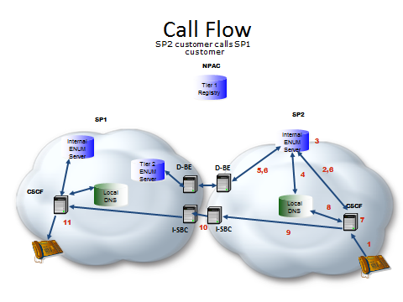
Figure NPAC-1
- SP2 Caller dials destination number
- SP2 S-CSCF queries internal ENUM server
- SP2 ENUM server finds an NS record
- SP2 internal ENUM server resolves the FQDN in the NS record to the IP address of SP1’s Tier 2 ENUM server.
- An ENUM query is forwarded to SP1’s Tier 2 ENUM server.
- SP1’s Tier 2 ENUM server responds with a NAPTR record(s) passed back to S-CSCF
- SP2 S-CSCF processes the NAPTR record set returned resulting in a SIP URI
- SP2 S-CSCF resolves the hostname in the SIP URI to obtain the IP address of an agreed upon SP1 ingress SBC
- A SIP INVITE is sent to egress SBC of SP2 that has layer 3 connectivity to the ingress SBC of SP1
- The SIP INVITE is forwarded to the SP1 ingress SBC.
- SP1 terminates the call to its end user.

Provisioning
Provisioning is shown in Figure NPAC-2:

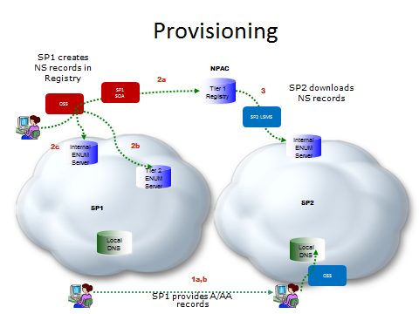
Figure NPAC-2

- Service providers negotiate interconnection and exchange, as part of the interconnect technical negotiation process,
  - Address (A or AA) records for their Tier 2 name servers
  - Address (A or AA) records for the hostname FQDNs in URIs derived from the NAPTR records that will provided in the responses from their Tier 2 name servers. These IP addresses correspond to the destination service provider’s I-SBCs that constitute the application layer POIs.
Each service provider provisions the records received from the other carrier in its internal DNS.
- When new numbers are provisioned or existing numbers made available for IP interconnection by an SP, the SP
  - Provisions NS record information for the number into the NPAC Voice URI field of the subscription version (SV) of the number through its SOA. (If there is no existing subscription version one is added.)
  - Provisions NAPTR records for number in its Tier 2 name server.
  - Provisions internal NAPTR records in its internal ENUM server for use within network calls.
- Service providers download SVs from the NPAC, extract the NS information from the Voice URI field and provision it as NS records into their internal ENUM server. Note that a record is provisioned for each TN.

Summary
A Tiered ENUM approach using the NPAC as the Tier 0/1 registry populates NS records into existing fields in the subscription version that already contains TDM routing elements. SVs are populated in the NPAC for each TN for which IP interconnection is offered. (If a TN is not otherwise ported or pooled an SV with a pseudo LRN is created). This approach simply enhances the existing interfaces (direct or via service bureaus) that all SPs have with the NPAC, requiring no new governance structures.

Utilizing LERG as an ENUM Registry

This section describes provides utilizing the LERG as part of a Tiered ENUM Registry, for the exchange of data for IP routing and interconnection for routing of E.164 Addressed Communications over IP Network-to-Network Interconnection (NNI). See IPNNI-2014-042R1.

This contribution supports that concept and proposes the LERG be utilized to function as the thin Tier 1 Registry. To accommodate this capability the existing LERG would need to be enhanced to include Tier 2 Name Server information.

The LERG was initially designed for routing of interLATA Time Division Multiplex (TDM) calls by interexchange carriers but has effectively evolved since its inception to support new networks and technologies. It continues to evolve with neutral governance processes that allow the industry to facilitate system process enhancements as required by service providers. For example, the LERG has also evolved to provide support for information exchange between all types of service providers including Incumbent Local Exchange Carriers, Competitive Local Exchange Carriers, Wireless Service Providers, Voice over IP (VoIP) Providers, etc. In addition, the LERG evolved to support the exchange of hybrid TDM/IP routing and interconnection architectures, Call Agent/Media Gateway homing arrangements and NPA/NXX assignments, to name a few.
Consequently, a solution to utilize LERG to provision Tier 2 Name Server information as well as any other IP data elements would allow the industry to continue to effectively manage process evolution as it pertains to IP routing and interconnection. This management would reside within interactive industry processes that have proven efficient, cost effective, and balanced in regards to all industry segments.
The LERG, functioning as a Tier 1 Registry, would also maintain consistency of data exchange across the multi-service provider ecosystem as opposed to a third party’s tiered solution that might be difficult to maintain a consistent quality of service benchmark across service providers.
Additionally, a LERG solution would avoid the need for IP enhancements to the SOAs or LSMSs which are used for Number Portability at every service provider. Number portability could function exactly as it does today by continuing to return an LRN where service providers then make use of the prior LERG data exchange to retrieve the associated data for call routing.

Routing Flow
A high level reference architecture is provided below that illustrates how the ENUM Domain Name System (DNS) query sequence would function during a session. In this example a Session Initiation Protocol (SIP) session is depicted.
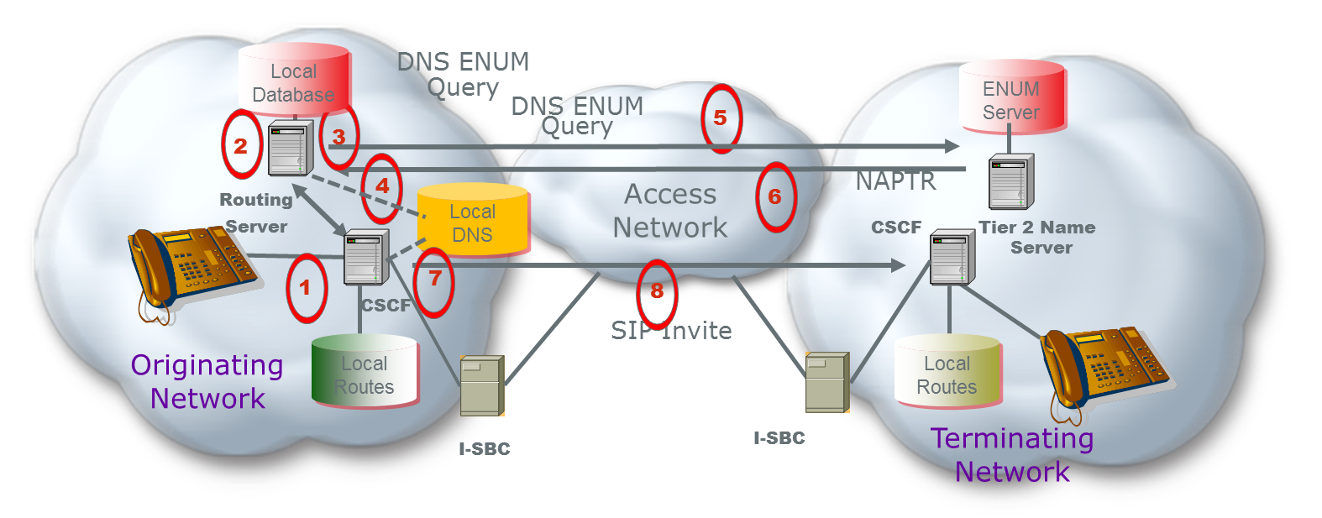
Figure 1 – Session Set-up
1 – A session is initiated
2 – The Call Session Control Function (CSCF) initiates a query to the Routing Server for a routing lookup (potentially using ENUM) in its local database
3 – The local database returns an NS record with the host name of a Delegated Tier 2 Name Server where specific VoIP routing information can be found. The number may need to be port corrected to get the authorized service provider of record. The NS record for that provider was pre-provisioned by the LERG download.
4 - The originating Service Provider resolves the FQDN in the NS record to the IP address of the terminating service provider’s Tier 2 ENUM server
5 – The Routing Server sends an ENUM query to the terminating network’s Tier 2 Name Server
6 – The terminating network’s Tier 2 Name Servicer returns interconnect information in the form of one or more Naming Authority Pointer (NAPTR) records within the ENUM response.
7 - The originating Service Provider resolves the hostname in the SIP URI to obtain the IP address of an agreed upon terminating Service Provider’s ingress SBC
8 – Based in the information received, the originating network initiates a SIP invite to the terminating network to initiate a SIP session
By implementing an ENUM approach, the network infrastructure needs to be enhanced to accommodate the additional queries as depicted in sequences 5-6.
Additionally, the network needs to standardize the information, content, and format in the Uniform Resource Identifier (URI). This includes standardizing the service parameters that are going to be supported for when the originating service provider receives the NAPTR records there is an agreed to and standardized process for how to use them for egress routing and session set up.
It should be pointed out that the initiation of a SIP session, sequence 8 above, has additional cross-network messages that are not depicted in this reference architecture but need to be supported by all service providers. From an originating service provider perspective, there are at least 1 additional ENUM query messages to accompany the 3 or 4 SIP set up messages, meaning the originating CSCF, and likely their I-SBC, must process 50% more messaging in an ENUM architecture.

Provisioning Flow
A high level reference architectures is proposed below that illustrates the provisioning sequence that could be implemented.
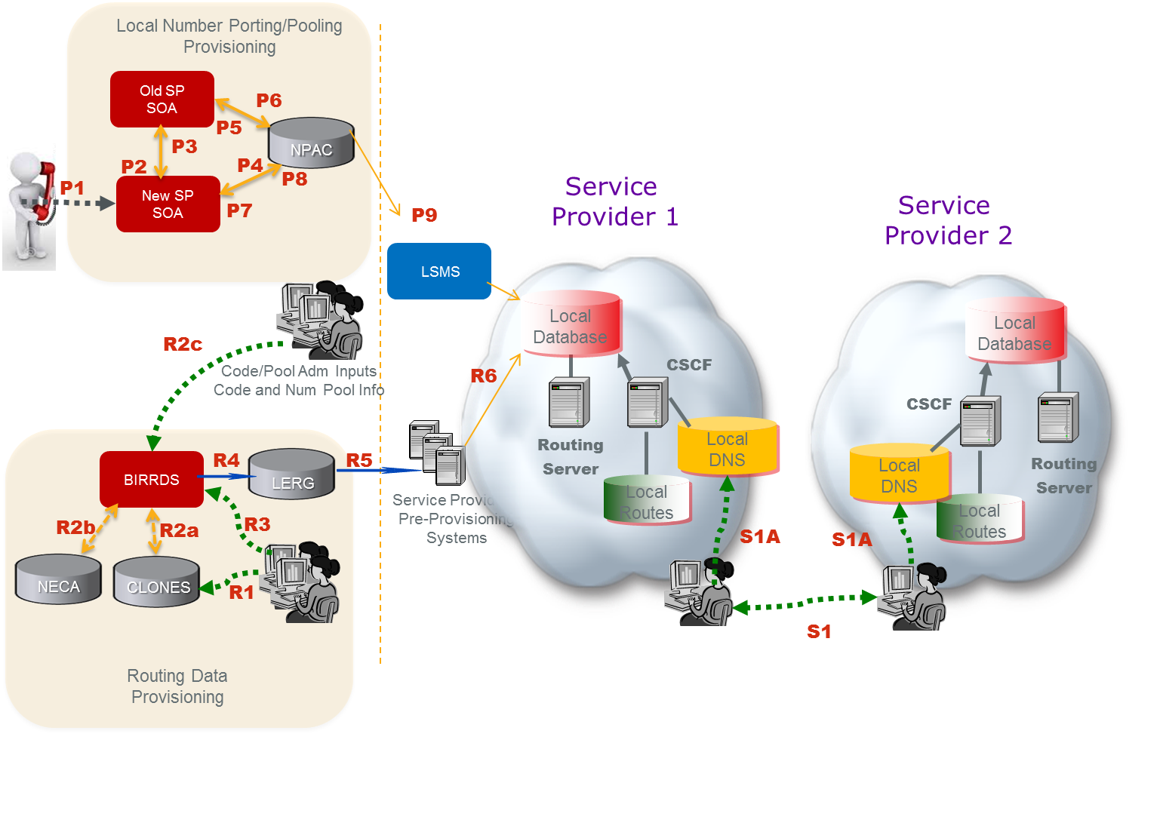
Figure 2 - High Level Provisioning Reference Architecture
As depicted in Figure 2, service providers would obtain the Tier 2 Name Server information from the LERG to enable a functional IP Network to Network Interconnection. This figure illustrates a logical view that may be realized by different operations systems.
Steps R1 and R2 provision Public Switched Telephone Network (PSTN) information while R3 through R6 includes both new IP information (i.e. the Name Server info) and existing PSTN data. Essentially, the current provisioning and routing data exchange systems and methodology for the PSTN can be applied directly to service provider Name Server data exchange. Also note that the number port provisioning flow is unchanged from today’s methodology.
Routing Data Provisioning:
(R1) Service provider develops a switch/point-of-interface (POI) CLLI Code and associated location attributes in the Common Language® CLONES database.
(R2a) The CLONES database provides newly developed CLLI Code and location reference data to the Business Integrated Routing and Rating Database System (BIRRDS). The location reference information is used by service providers in support of developing new BIRRDS switch/POI records.
(R2b) The National Exchange Carrier Association (NECA), provides new Company Codes (a subset of Operating Company Numbers (OCNs)), as they are assigned, to BIRRDS.
(R2c) National CO Code (NXX) Administrators and the Thousands-Block Pooling Administrator (US only) establish base CO Code and block assignment records in BIRRDS.
(R3) Service provider updates BIRRDS with Tier 2 Name Server information, switch/POI information (e.g. actual switch, points of interface, trunk gateways, call agents, signaling transfer points (STPs), etc.), homing arrangements, Location Routing Numbers (LRNs), and detailed information supporting the CO Code NPA/NXX and Thousands-Blocks that they have been assigned. This data is integrated with other BIRRDS data elements (e.g. Rate Centers) maintained by the BIRRDS administrator. At this time, BIRRDS can perform domain validations to validate Tier 2 Name Server accuracy. Name Server records can potentially be associated with OCN, at the highest order, or can be associated with other LERG data, e.g., CO level. That Name Server association would need to be agreed upon by the service providers.
(R4) The LERG is generated from current BIRRDS data and is provided to service providers monthly for their pre-provisioning systems. As an option, augmented daily activity may be provided nightly.
(R5) Based on service providers’ local methods and procedures, the LERG data is loaded into service providers’ pre-provisioning systems and is used for both PSTN and IP interconnection and routing covering switch translations, trunk engineering, numbering administration, legal and regulatory support, forecasting, intercompany billing support, and numerous other functions within the company.
(R6) Based on service providers’ local methods and procedures, the LERG data in service providers’ pre-provisioning systems is made accessible to switch translations engineers to configure the switch translation, routing tables and data elements used for both PSTN and IP interconnection and routing, e.g., Tier 2 Name Server information for IP.
Local Number Porting/Pooling Provisioning:
The following process involves a pre-port validation (PPV) process as well as a Number Pooling Administration Center (NPAC) Service Order Administration (SOA) process
(P1) A customer/subscriber requests to port his/her telephone number to the new/recipient service provider.
(P2) Pre-port validation - The new/recipient server provider requests validation of the port from the old/donor service provider.
(P3) Confirmation - verification of subscriber information is sent from the old/donor service provider to the new/recipient service provider.
(P4) The new/recipient service provider sends a creation of a pending port to NPAC.
(P5) NPAC sends a notification of port to the old/donor service provider.
(P6) An approval of the pending port is sent by the old/donor service provider to NPAC.
(P7) NPAC sends a notification of the old service provider’s port approval to the new/ recipient service provider.
(P8) Activation of the port is sent from the new/recipient service provider to the NPAC.
(P9) NPAC broadcasts the new routing information for the port to the Local Service Management Systems (LSMSs) for all service providers to update their local databases likely a Routing Server.
Service Provider Provisioning:
Service providers negotiate interconnection and exchange and provide Address records for their Tier 2 name servers (S1). In addition, address (A) records for the hostname FQDNs in URIs derived from the NAPTR records that will be provided in the responses from their Tier 2 name servers. These IP addresses correspond to the destination service provider’s I-SBCs that constitute the application layer POIs. Each service provider provisions the records received from the other service provider in its internal DNS (S1A).
In this reference architecture, BIRRDS/LERG would need to be modified/enhanced to allow the administrators to provide the registration of the Tier 2 name server information.

Summary
A solution that utilizes the LERG as the thin Tier 1 Registry would allow the industry to continue to leverage existing processes for data exchange of the ENUM Name Server records with caching in local databases to avoid external NS queries. Furthermore, the industry could manage routing evolution for IP under the governance of a neutral body with existing linkages to other fora.
The existing industry framework supports the exchange of TDM and IP routing and interconnection, however, existing database systems would need to be enhanced according to the industry requirements in order to exchange Tier 2 NS records and other IP routing information. The following items are possible areas of enhancement to LERG functioning as the Tier 1 Registry for IP routing and interconnection:
- Adopt an ENUM architecture but avoid the overhead and complexity of external NS queries by supporting service provider exchange (i.e. local downloads) of Tier 2 Name Server information.
- Assign and exchange a single Name Server record for a given service provider (e.g. an OCN) or a set of Name Server Records depending on the NPA/NXX or other considerations (such as East vs. West). It is worth discussing what granularity a Name Server will need to support including what requirement would drive Name Servers at a full 10 digit TN level.
- Validate Domain Names and potentially full URIs associated with a Name Server address prior to accepting such routing information for exchange.
- Support more frequent routing data exchanges than daily.
- Global access to the NS information requires further evaluation.

Independent ENUM Registry

This section describes an independent ENUM Registry, for the exchange of data for IP routing and interconnection for routing of E.164 Addressed Communications over IP Network-to-Network Interconnection (NNI). See IPNNI-2014-043R1.

An ENUM Tier 1 Registry can enable authorized Service Providers of Record (SPRs) to start directly exchanging routing information dynamically to enable session setup end-to-end over IP networks. Listed below are some requirement considerations and benefits of having a Registry:
- The Tier 1 Registry could vastly reduce the NS record set by supporting policy-based NS provisioning. For example, an NS record value could be assigned to each Operating Company Number (OCN) rather than to each telephone number or, to each unique Service Provider ID (SPID) and/or NPA/NXX or Location Routing Number (LRN). This could also differ by TN and be at the discretion of the number holder.
- The Tier 1 Registry needs to incorporate the existing NPAC Local Service Management System (LSMS) feed to provide Tier 2 NS records that are corrected for porting and pooled numbers when applicable.
- Optimize session setup time; the Tier 1 ENUM query to the external registry could be avoided by using Zone Transfer protocol to download the NS records to local cache at each originating service provider. If this results in too many NS records for a simple Zone Transfer, then the NS data could be transferred in stages using a series of Zone Transfers.
- Support service providers who did not have the capability for locally caching the Tier 1 NS records, then ENUM or another query protocol could be used by originating service providers to request the NS record from the Tier 1 Registry.
- Optimize external queries whenever possible, then the Tier 0/1 Registry could optionally be used by service providers to capture and exchange NAPTR records instead of NS records thereby combining Tier 2 functionality in the Tier 1 Registry. This could be optional according to terminating service provider discretion and would be transparent to the originating service provider.
- Allow for different NS records depending on the originating & terminating service provider combination, then the Tier 0/1 Registry could be configured with policy for source based resolution using a “Recipient Group” feature. For example, some authorized Service Providers of Record might input Name Server information for the same TN that in one case refers to the Tier 2 Name Server of a transit operator or Internetwork Packet Exchange (IPX) and in another case refers to their own terminating Tier 2 Name Server when they are peering or interconnecting directly with the originating service provider. While more powerful in the Tier 2 Name Server platform, this feature has potential application at the Tier 0/1 Registry level and could be used for either per session queries as well as to customize the data download to local cache.
- Accommodate ENUM on a global basis, such as for incoming and outgoing international calls, then the Registry addresses for each country could be communicated to the global service provider community.
- Support multiple Tier 0/1 Registries in order to avoid a sole supplier environment, then a mechanism, system processes and interfaces could be established to replicate data across participating registries. Technology exists to support such a requirement. Database peering has been formally endorsed by the FCC to support a competitive market of TV Whitespace geolocation databases. A peered iconectiv TV Whitespace database has been certified by the FCC and operational since March 2012.

Routing Flow
A session set-up is shown in Figure 1 that illustrates how the ENUM query sequence would function during a session. In this example a SIP session set up is depicted.

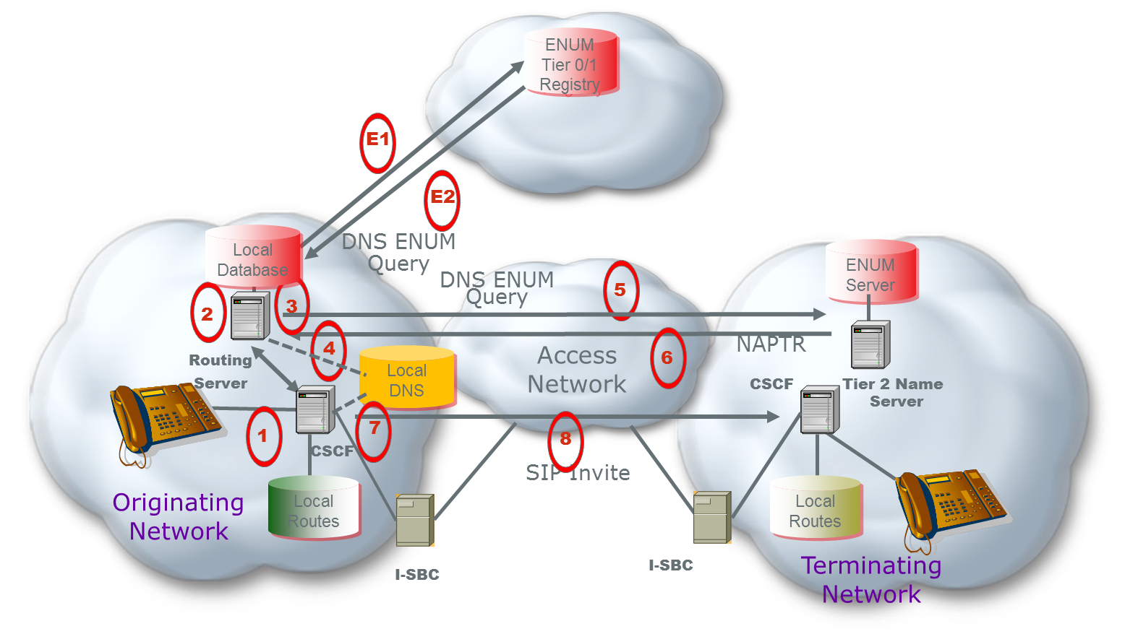
Figure 1 – Session Set-up Reference Architecture
In Figure 1 a call is being initiated (1). The Call Session Control Function (CSCF) initiates a query to the Routing Server for a routing lookup (potentially using ENUM) in its local database (2). The local database returns an NS record with the host name of a Delegated Tier 2 Name Server where specific VoIP routing information can be found (3).
If not cached locally, the CSCF would initiate an ENUM DNS Query to the Tier 0/1 Registry (E1). The Tier 0/1 Registry returns an NS record (E2) for the service provider that holds the number. Steps (E1) and (E2) allow for the case where an originating service provider does not support receiving the Tier 0/1 Registry data in a local cache and must send a query to request the NS record at call setup.
The NS record indicates the host name of a Delegated Tier 2 Name Server where specific VoIP routing information can be found. The originating service provider resolves the FQDN in the NS record to the IP address of the terminating Service Provider’s Tier 2 ENUM server (4). This NS information is used by the originating network to send a query to the terminating network’s Tier 2 Name Server (5). The DNS resolution of the Tier 2 Name Server is via normal DNS since each service provider provisions the resolution of their Tier 2 Name Server domain names into DNS.
The terminating network’s Tier 2 Name Server returns specific routing information identifying the I-SBC in the form of one or more Naming Authority Pointer (NAPTR) records (6). The originating service provider resolves the domain name from the NAPTR URI to obtain the IP address of an agreed upon terminating network’s ingress I-SBC (7). Based on the information received, the originating network initiates a SIP invite (8) to the terminating network I-SBC in order to initiate a SIP session. .
By implementing an ENUM approach, the network infrastructure needs to be enhanced to accommodate the additional queries as depicted in sequences 2-6 as well as potentially E1 and E2. Additionally, the network needs to standardize the information, content, and format in the URI including what service parameters are going be supported so when the originating service provider receives the NAPTR records there is an agreed to and standardized process for how to use them for egress routing and session set up.
It should be pointed out that the initiation of a SIP session, sequence 8 above, has additional cross-network messages that are not depicted in this reference architecture but need to be supported by all service providers. A representative example of the message set, presuming the calling and called devices are SIP end-points, is shown in Figure 2 below. From an originating service provider perspective, there are at most 2 additional ENUM query messages to accompany the 3 or 4 SIP set up messages, meaning the originating CSCF, and likely their I-SBC, must process 50% more messaging in an ENUM architecture.

Provisioning Flow
A high level provisioning reference architecture is shown in Figure 2 below to illustrate the high level process that would be required for service providers to configure the ENUM Tier 0/1 Registry to support routing data exchange.

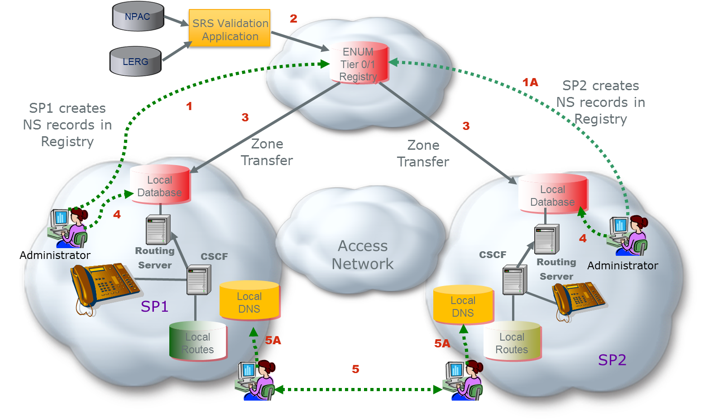

Figure 2 - High Level ENUM Provisioning Reference Architecture
As depicted in Figure 2, the ENUM Tier 0/1 Registry can obtain data from all authorized Service Providers to enable routing data exchange for a functional IP Network to Network Interconnection service. A Managed Shared Registration System (SRS) Service allows authorized Service Providers of Record to create, change, and/or modify ENUM domain name registrations in the Tier 0/1 Registry Database (1 and 1A).
The Managed SRS Service also validates registrations through the Validation Application via access to the authoritative LERG and Number Portability Administration Center (NPAC) data sources (2).
The NS records (Authoritative Name Server, DNS records), are sent via Zone Transfer protocol to local cache at all service providers (3). The local administration also provisions internal routing information into its own database (4). This includes providing the NS record resolution to an IP address. Service providers negotiate interconnection and exchange and provide Address (A) records for their Tier 2 name servers (5). In addition, address records for the hostname FQDNs in URIs derived from the NAPTR records that will be provided in the responses from their Tier 2 name servers. These IP addresses correspond to the destination service provider’s I-SBCs that constitute the application layer POIs. Each service provider provisions the records received from the other service provider in its internal DNS (5A).

Summary
This option proposes using a purpose-built ENUM solution as the data exchange mechanism for an IP routing industry framework. An ENUM Tier 1 Registry can enable authorized Service Providers of Record (SPRs) to start directly exchanging routing information dynamically to enable session setup end-to-end over IP networks.

Appendix B - Routing Criteria Tables

Appendix C – Data Exchange Worksheet Example

Recall that SBCs may not be co-located with the PE routers connected at the exchange point and the layer 3 path between them may involve other routers.
Layer 3 routes for these IP addresses will generally be exchanged between the PE routers via BGP.
If routing is on a 10-digit basis, the intermediate step of deriving portability corrected digits is not required.
There may be alternate approaches to combining the bilaterally exchanged URI-IP address mappings and the TN-URI mappings obtained from the Registry and combining them in a routing server for session establishment.
Resolution is shown in recursive mode. It could also take place in iterative mode with the NS record being returned to the S-CSCF for the S-CSCF to resolve the FQDN in the NS record and then issue a query to the SP1 Tier 2.
Use of separate Data Border Element is shown.
There are alternate approaches to the resolution of Tier 2 name servers and interconnection URI FQDNs. These include a) exchange of SRV instead of A/AA records, b) resolution in the internet DNS, c) sharing through some controlled access industry system including but not necessarily limited to a private DNS.
The VOICE URI field was originally defined to contain a URI that would be used to provide for IP routing of voice calls, but it is currently little used and has no explicit typing. It simply allows up to 255 characters. It is proposed that NS record information be populated in the VOICEURI field in the form tier2enum.serviceprovider.com (i.e., just the nameserver name as an FQDN) as opposed to the full NS form: 3.8.0.0.6.9.2.3.6.4.1.e164enum.net IN NS tier2enum.serviceprovider.net The full record form would be reconstituted by the service provider for provisioning in its ENUM server. Note that an NS record or records are generally provisioned for each individual number. Multiple NS records could be populated in the NPAC VOICEURI field through the use of some agreed upon separator character. This would allow for redundancy as it is expected that carriers would want to have multiple name server instances. Note that an apex domain, for example, e164enum.net, needs to be agreed upon.
The ENUM query may return multiple NAPTR records with different order, preference, and enumservice fields as defined in RFC 6116. Thus multiple options for interconnection can be provided including different gateways for different service types (e.g., voice versus video) where appropriate. A NAPTR for general SIP interconnection might look like NAPTR 10 100 "u" "E2U+sip" "!^.*$!sip:\1@gw02.serviceprovider.net; user=phone!" . its resolution would result in the URI sip:+14632963800@gw02. serviceprovider.net; user=phone The querying service provider would then resolve the hostname gw02.serviceprovider.net to obtain an IP address for the terminating provider’s ingress SBC.
FCC 14-5, released January 31, 2014.

