ATIS/SIP Forum NNI Task Force
August 7, 2014

Contribution
TITLE: Technical versus Vendor Solutions
SOURCE*: Verizon

_______________________________
ABSTRACT
This document discusses references of technical versus vendor based solutions within the IP-NNI Task Force Routing Document.

NOTICE

This is a draft document and thus, is dynamic in nature. It does not reflect a consensus of the ATIS-SIP Forum IP-NNI Task Force and it may be changed or modified. Neither ATIS nor the SIP Forum makes any representation or warranty, express or implied, with respect to the sufficiency, accuracy or utility of the information or opinion contained or reflected in the material utilized. ATIS and the SIP Forum further expressly advise that any use of or reliance upon the material in question is at your risk and neither ATIS nor the SIP Forum shall be liable for any damage or injury, of whatever nature, incurred by any person arising out of any utilization of the material. It is possible that this material will at some future date be included in a copyrighted work by ATIS or the SIP Forum.

* CONTACT: Mark Desterdick; email: desterdick@verizon.com ; Tel: +1212-681-5626

Discussion
It is appropriate that the IP-NNI Task Force focus on documenting technical solutions and potential architectures and not vendor solutions. Mention of a particular vendor for descriptive purposes relative to existing solutions currently implemented by the industry is also appropriate as it serves to document the status quo and not promote any one particular vendor over another. Section 5.2 of the current version of the baseline routing document, IPNNI-2014-00064R002, refers to a registry instantiated in the NPAC and acknowledges that alternate registry implementations are possible. It is not appropriate for the task force to mention or promote any one vendor over another where alternate registry implementations are possible.

Proposal
Section 5.2 of the current baseline, IPNNI-2014-00064R002, should be updated (as shown below) to simply state: “This provisioning process is illustrated in Figure 1 below.” and the figures shown for Provisioning and Call Flow should be updated to eliminate the label “NPAC” on the registry.

Per-TN Routing Implementation
Service providers wishing to provide per-TN routing perform the following provisioning activities:
- As part of bilateral interconnect negotiations provide mappings for SIP URI hostnames to SBC IP addresses.
- Populate registry records for TNs available for IP interconnection with the appropriate SIP URI. The URI will be a full SIP URI (e.g., sip:+13036614567@example.mso-a.com;user=phone ) but without number portability information.
The registry must insure that only the provider of record for the number as defined by LERG/NPAC can populate a corresponding record.
Service providers electing to use the per-TN routing information will:
- Provision the hostname – IP address mappings into their internal DNS (A or AA records).
- Provision TN-URI mappings from the Registry into their internal routing servers. If the routing server is accessed via a SIP query, the SIP URI may be directly populated. If the routing server is accessed via an ENUM query, the SIP URI is encapsulated into a NAPTR record.
This provisioning process is illustrated in Figure 1 below.
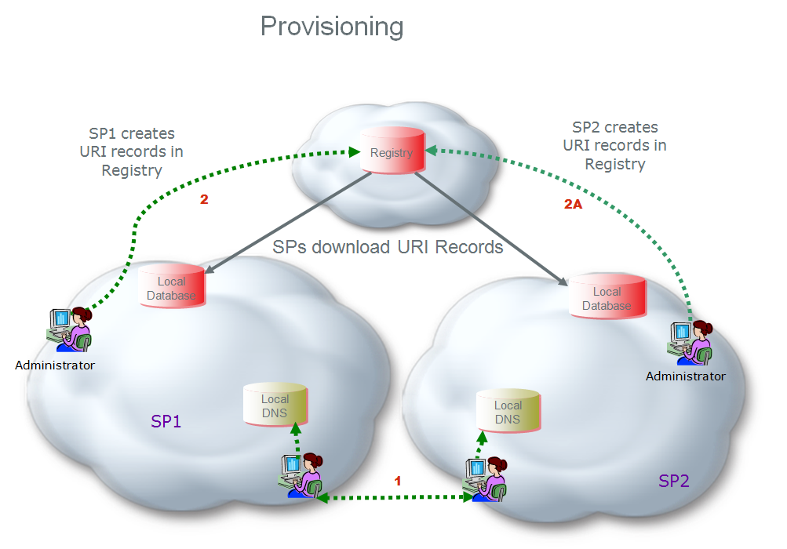

Figure 1

On call origination, the originating service provider will query their routing server and obtain the corresponding SIP URI for numbers available for IP interconnect. They will resolve the hostname from the URI in their internal DNS to obtain the IP address of the terminating provider’s ingress SBC. The call flow is shown in Figure 2 below:

- SP2 Caller dials destination number
- SP2 S-CSCF queries internal route server and SP2 route server responds with a URI passed back to S-CSCF
- SP2 S-CSCF resolves the hostname in the SIP URI to obtain the IP address of an agreed upon SP1 ingress SBC
- A SIP INVITE is sent to egress SBC of SP2 that has layer 3 connectivity to the ingress SBC of SP1
- The SIP INVITE is forwarded to the SP1 ingress SBC.
- and 7. SP1 terminates the call to its end user.

There may be alternate approaches to combining the bilaterally exchanged URI-IP address mappings and the TN-URI mappings obtained from the Registry and combining them in a routing server for session establishment.

